


Review of Adult
Decision-Making Capacity Law – Overview of final report


Published: June 2026

Before you start


This is a long document.


It can be hard for some people to read a document this long.

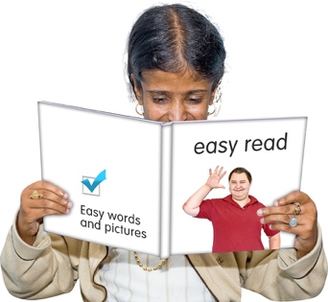
Some things you can do to make it easier are:
read it a few pages at a time
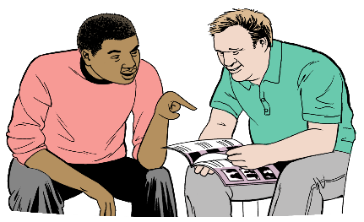
set aside some quiet time to look at it
have someone read it with you to support you to understand it.

What you will find in here

Page number:


About this Easy Read 4


Problems with the PPPR Act 13

Key recommendations 19


Key recommendation 1:
The new law needs a clear purpose 21


Key recommendation 2:
Supporting people to make
decisions 24

Page number:


Key recommendation 3:
Making decisions for a person 31


Key recommendation 4:
General duties 45


Key recommendation 5:
Decision-making capacity 51


Key recommendation 6:
Checking the new law is working 56

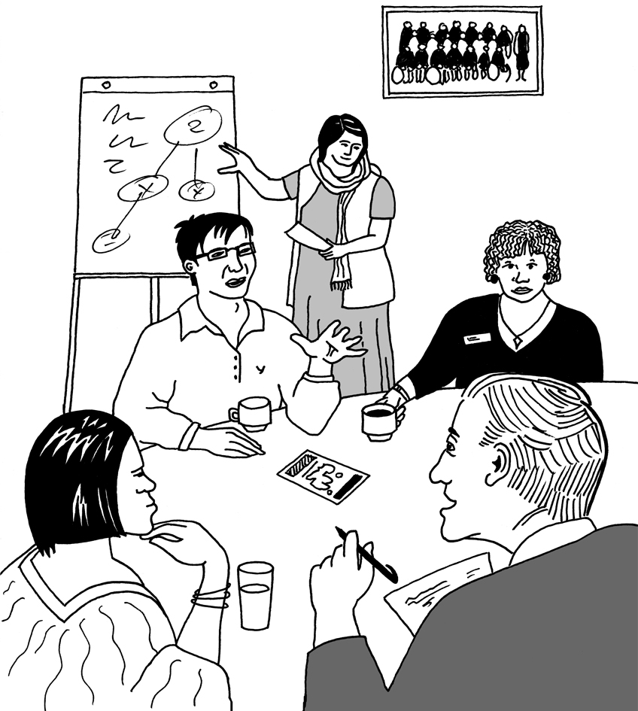
Key recommendation 7:
Other things to review 58

About this Easy Read

This Easy Read is from Te Aka Matua o te Ture | Law Commission.

Te Aka Matua o te Ture | Law Commission is an organisation that:
does reviews of the law
uses what it finds out in the reviews to tell the Government how to make the law better.

When you see the words we / our in this Easy Read they mean Te Aka Matua o te Ture | Law Commission.


Here a review is when we:
look carefully at a part of the law

talk to people who know a lot of things about that part of the law

ask people what they think about that part of the law
write a report about what we think would make the law better.

We have done a review of the law about when adults can make their own decisions.
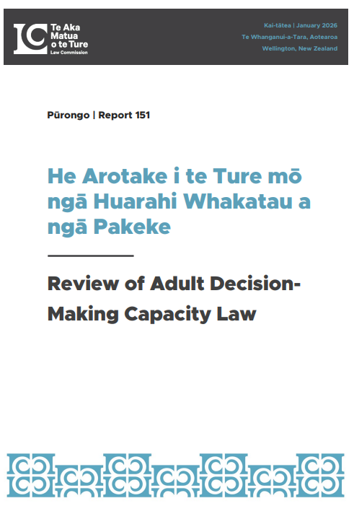

Our review is called He Arotake i te Ture mō ngā Huarahi Whakatau a ngā Pakeke | Review of Adult Decision-Making Capacity Law.


Having decision-making capacity for a decision means you can:

- make it
and
- understand it.

This Easy Read is a summary of some of the key things in our final report about this review.


A summary:
is shorter than the full report
tells you the main ideas.


You can read the full report on our website at:

https://tinyurl.com/NZLC-R151


The full report is not in Easy Read.

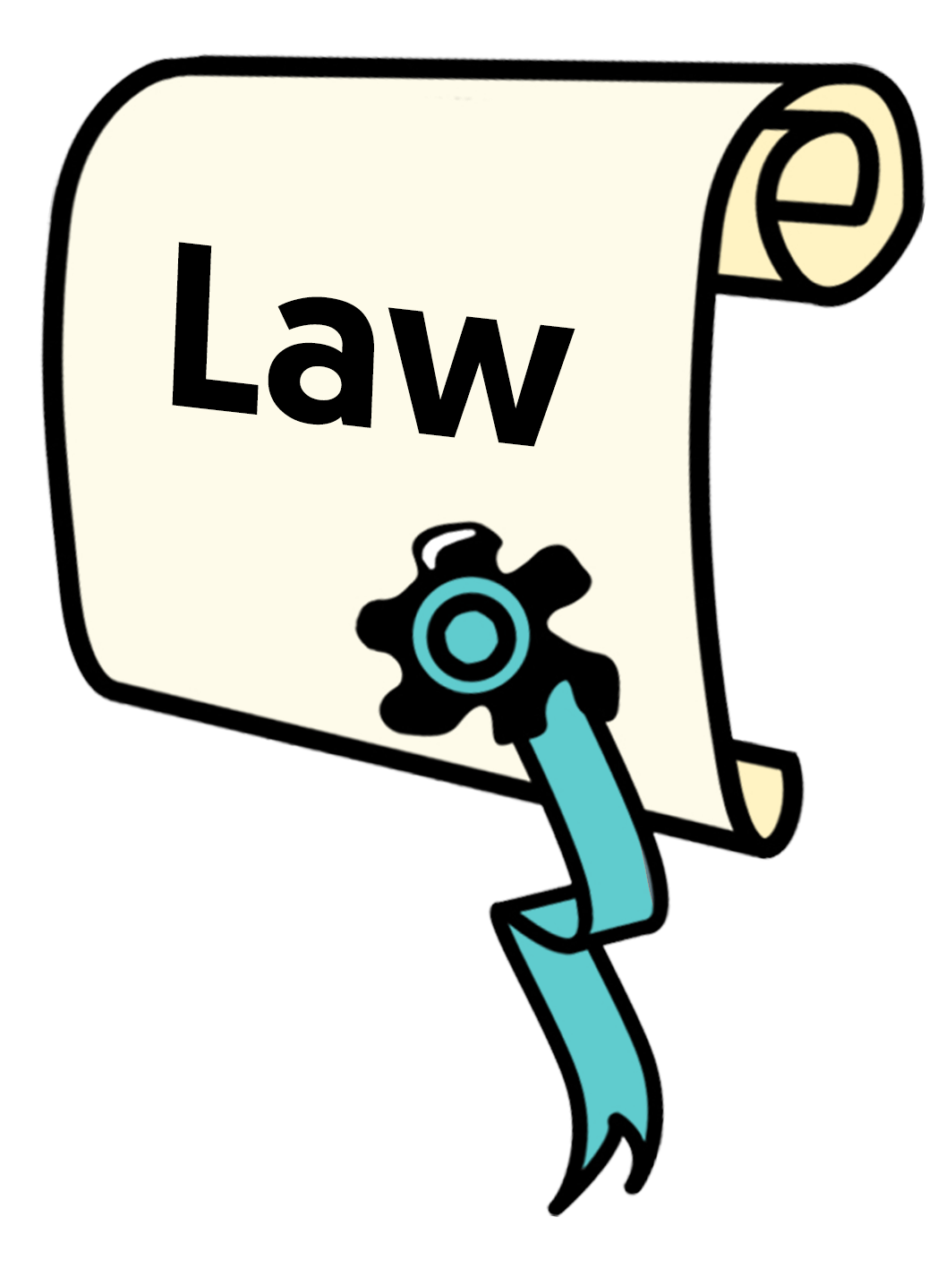
The law we reviewed is the Protection of Personal and Property Rights Act 1988.


The Protection of Personal and Property Rights Act 1988 is the law that says when someone else is allowed to make decisions for you when you cannot:

- make decisions
- understand decisions.


The person who makes decisions for you could be:

- a Court
or

someone called
  - an attorney
  - a welfare guardian
  - a property manager.

The Protection of Personal and Property Rights Act 1988 is called the PPPR Act for short.


An attorney is someone who you
say can make decisions for you if
you cannot:
- make decisions for yourself
- understand decisions.


You use an enduring power of attorney to say who you want your attorney to be.

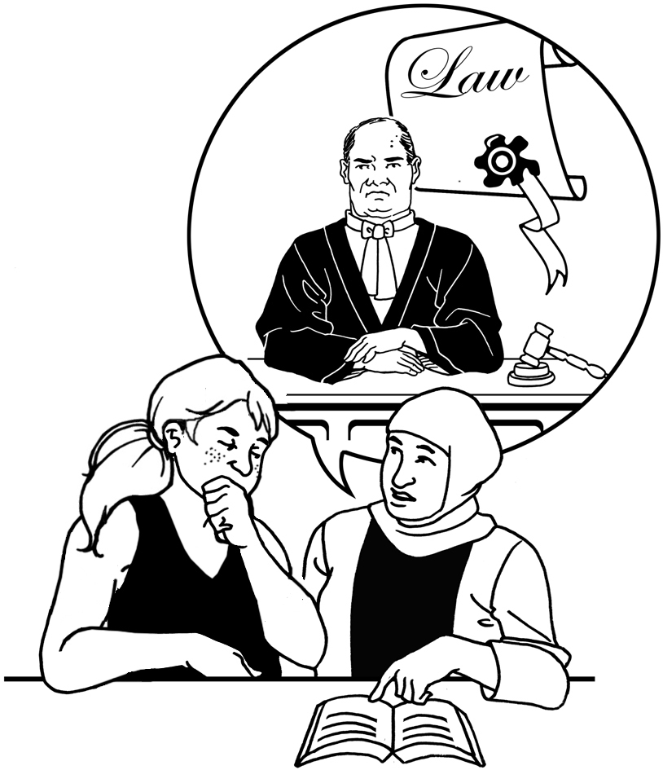
An enduring power of attorney is a legal document that says who you want to have as your attorney.

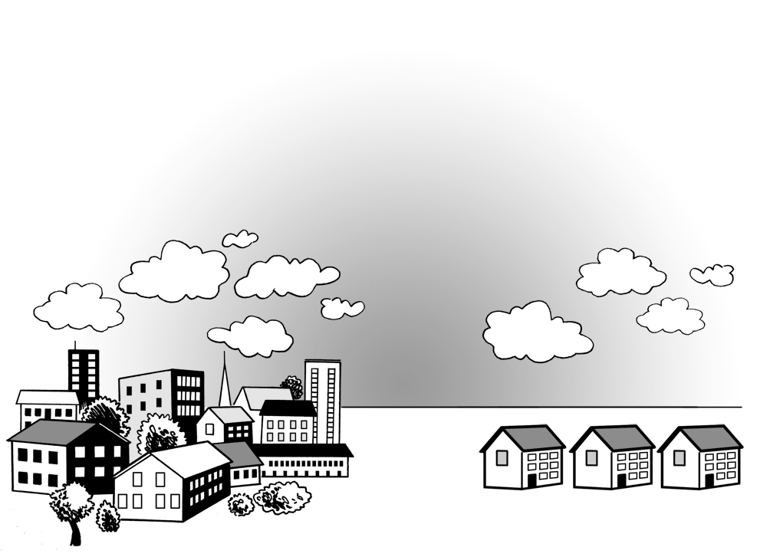
A welfare guardian is someone
who decides things like:
where you live
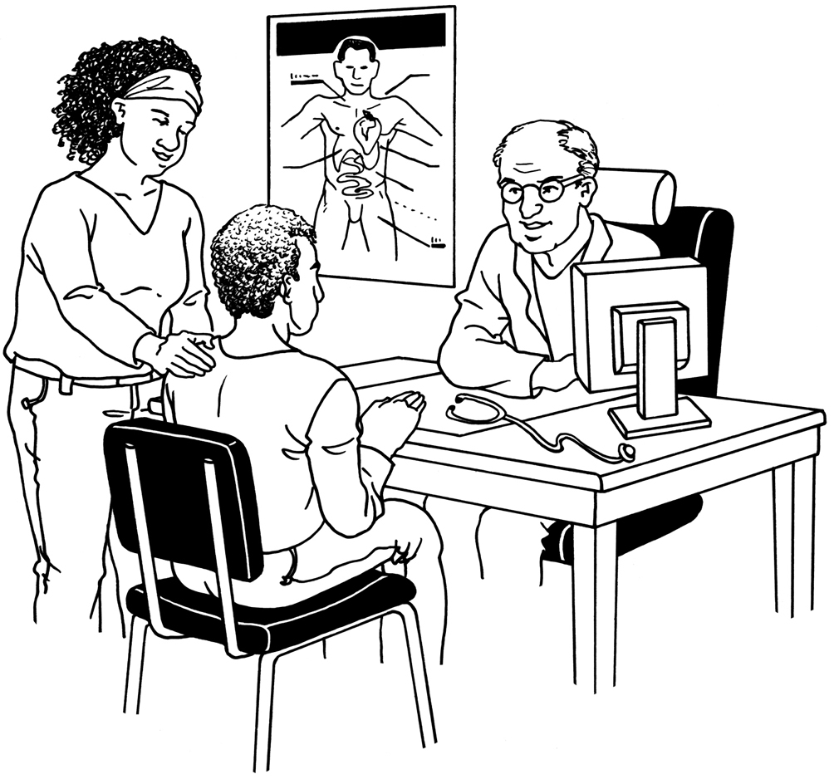
who looks after you
what medical treatment you
need to have.

You get a welfare guardian if the Court decides that you need a welfare guardian.

The Court decides who your welfare guardian should be.


The Court will only say you need a welfare guardian if you cannot make your own decisions / understand decisions.


A property manager is someone who makes decisions
about things like:
your money
the things you own.


You get a property manager if the Court decides that you need a property manager.

The Court decides who your
property manager should be.

The Court will only say you need a property manager if you cannot
make your own decisions / understand decisions.


When you see the words
decision-maker in this Easy Read they mean anyone who is allowed to make decisions for another person.

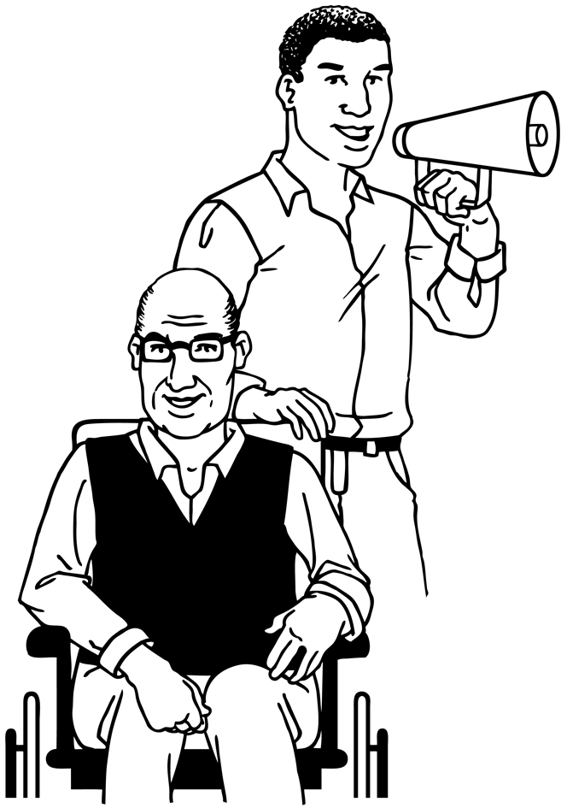
When you see the words represented person in this Easy Read they mean a person a
decision-maker can make decisions for.

Problems with the PPPR Act

There are 3 main problems with the PPPR Act.


Problem 1: The PPPR Act does not say that people should be supported to make decisions

Many people can make their own decisions if they get the right support.


The United Nations Convention on the Rights of Persons with Disabilities says supporting people to make their own decisions is important.


The United Nations Convention on the Rights of Persons with Disabilities is a law lots of countries have agreed to.

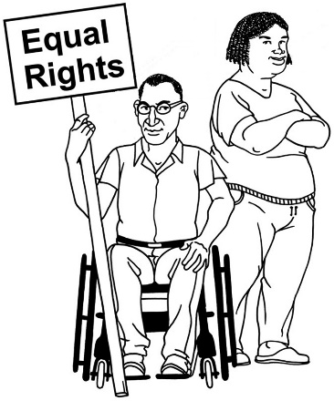
The United Nations Convention on the Rights of Persons with
Disabilities is also called the Disability Convention.

It says what governments must do to make sure disabled people get the same rights as everybody else.

The PPPR Act does not say that people must be supported to make their own decisions.

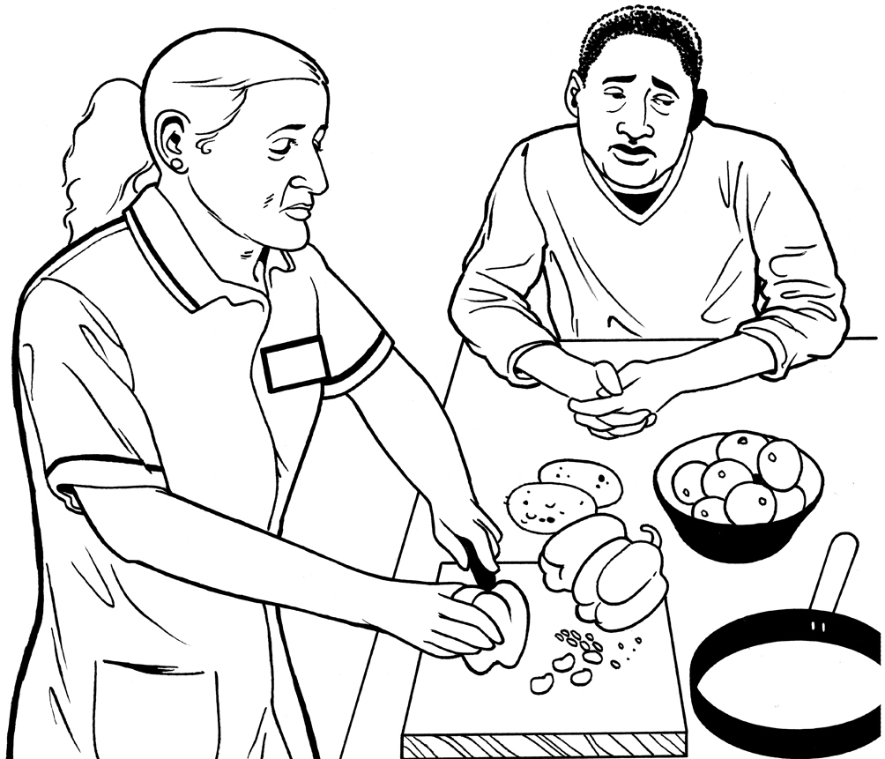
This means other people can make decisions for a person even if the person could make / understand those decisions themselves with support.

Problem 2: Best interests is not the right way to think about making decisions for another person anymore
The PPPR Act says that decision-makers should make decisions in the best interests of the represented person.


Here making decisions in the best interests of the represented person means making decisions the decision-maker thinks are best for
the represented person.


This means that decisions can be made for a represented person even if they do not like the decisions.


The Disability Convention says that decisions should be based on the:
wishes of the represented person
values of the represented person.


Here wishes means what the represented person says they want.


Here values means things that are important to the represented person like what they:
like

do not like
want to do in the future.


The PPPR Act does not say that decision-makers must think about the:
wishes of the represented person
values of the represented person.


The PPPR Act does not tell decision-makers how to think about the:
wishes of the represented person
values of the represented person.

Problem 3: The PPPR Act is hard to understand


It does not clearly say what the purpose of the law should be.

Here the purpose is what the law wants to make happen.
Sometimes there are different rules for things that are almost the same.


There is often not a good reason for the different rules.

This makes it hard for people to:

understand the law

know what they need to do.

Key recommendations

We think the Government needs to write a new law to replace the PPPR Act.

A new law will:

do more to help people be supported to make their own decisions
mean better decisions are made for people who cannot make / understand decisions themselves.


We have 175 recommendations about what should be in the new law.

Here recommendations means what we think should be in the new law.


This Easy Read explains our 7 most important recommendations.

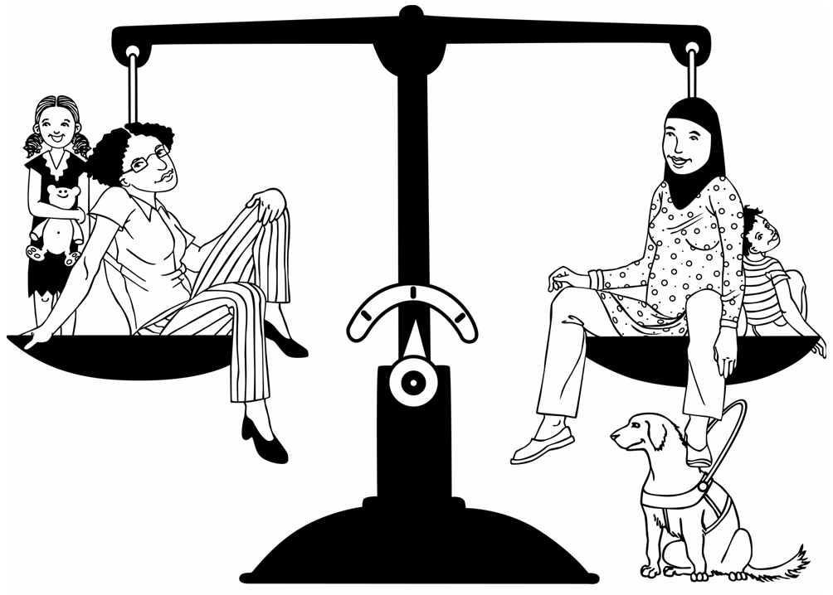
We think our recommendations mean a new law will help:
people live in the way they want to
keep them safe.

Key recommendation 1:

The new law needs a clear purpose

The new law should clearly say what its purpose is.

The purpose of the law should be to help people who:
need support to make decisions
cannot make / understand their own decisions.


The law should:
help people live the way they want to
help keep them safe
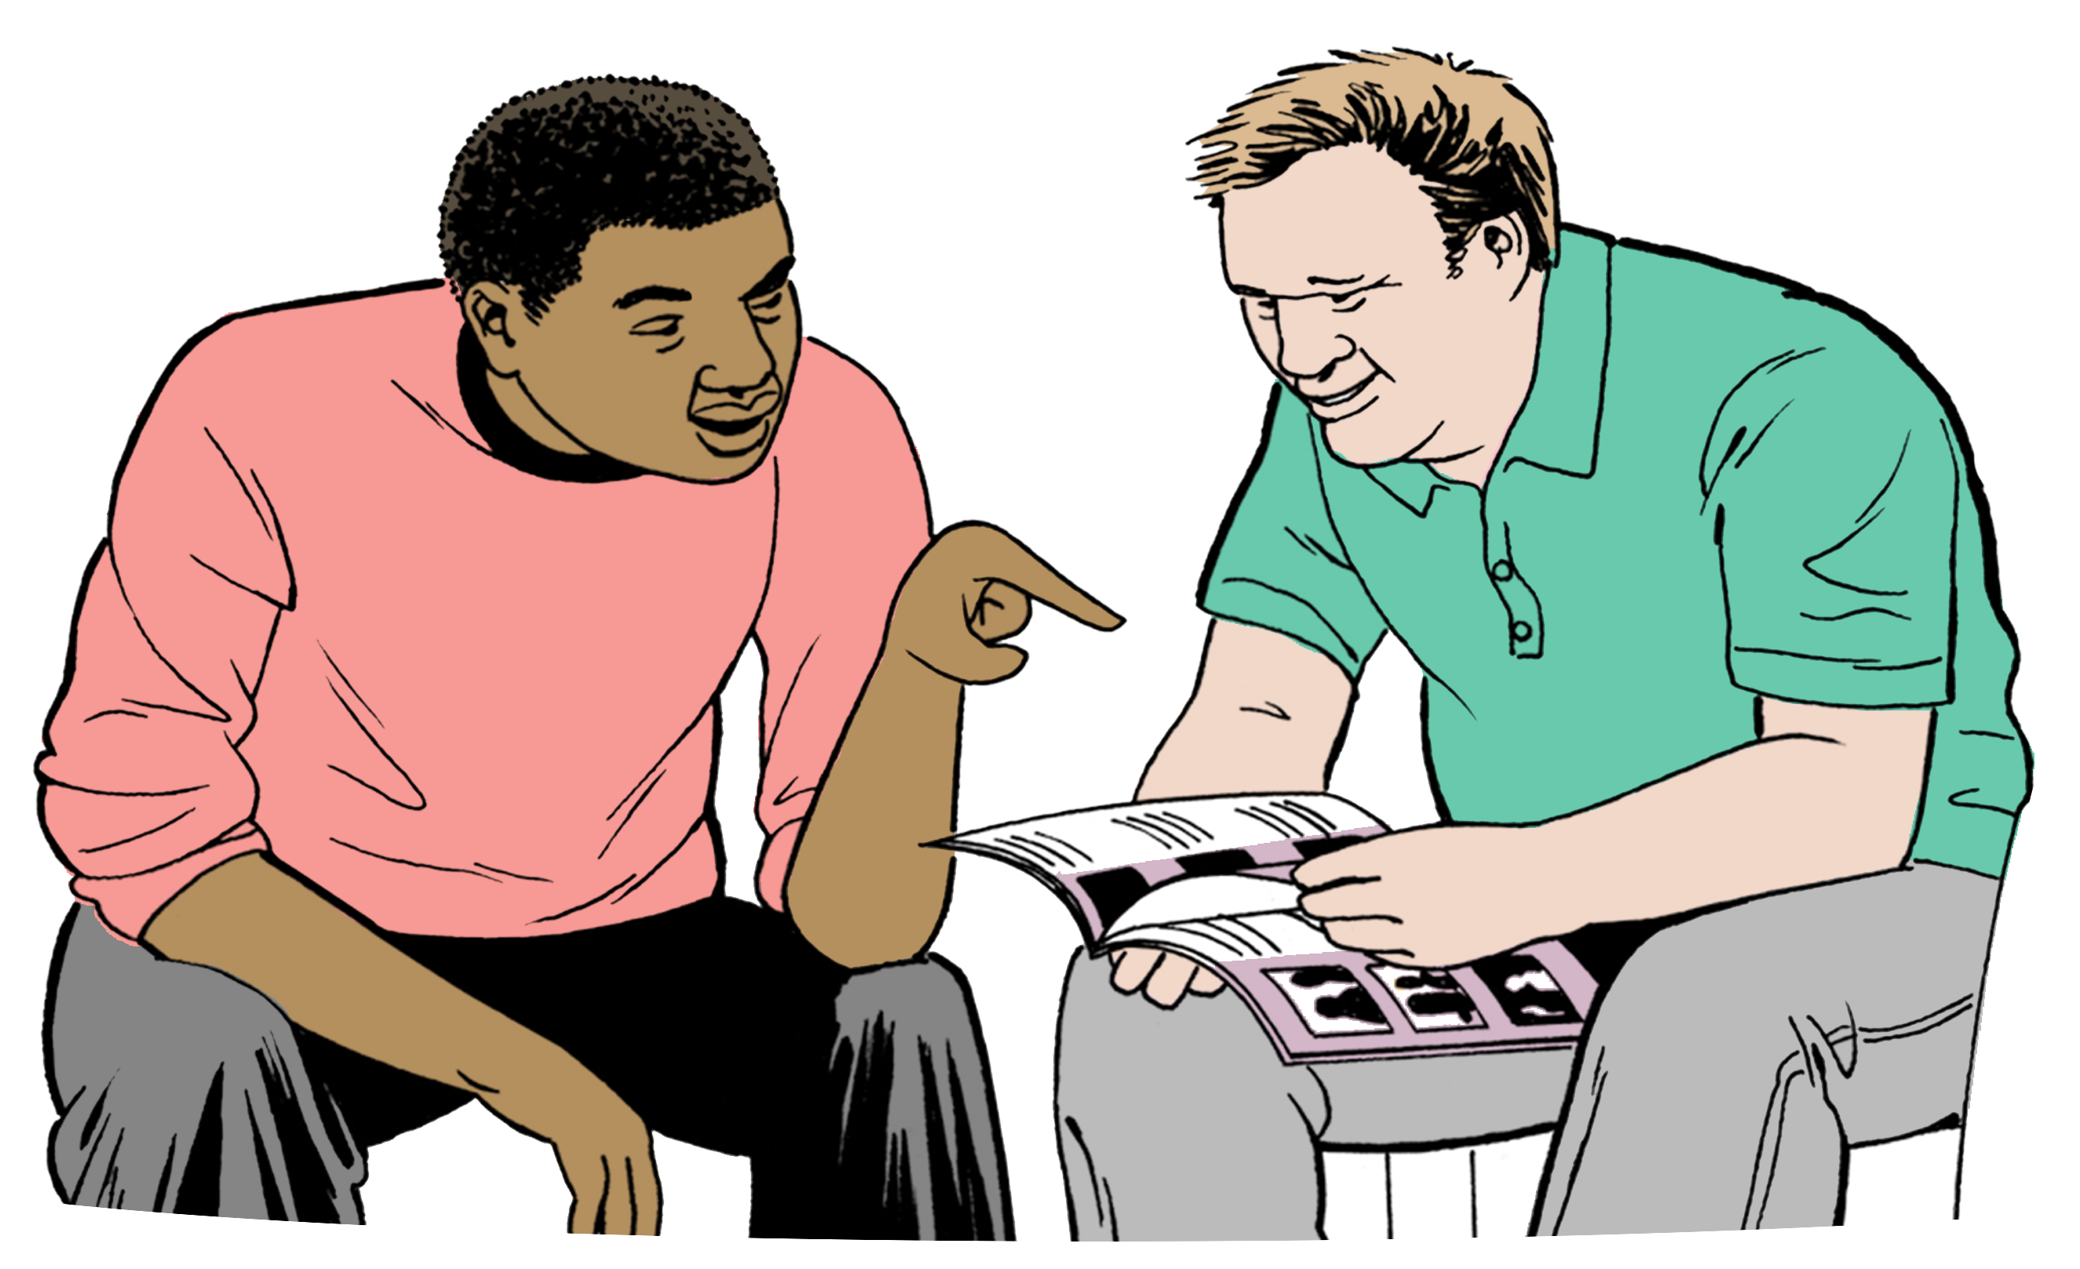
support people to make / understand the decisions they can make / understand with support
make sure Aotearoa New Zealand is doing the things:
- the Disability Convention says Aotearoa New Zealand needs to do
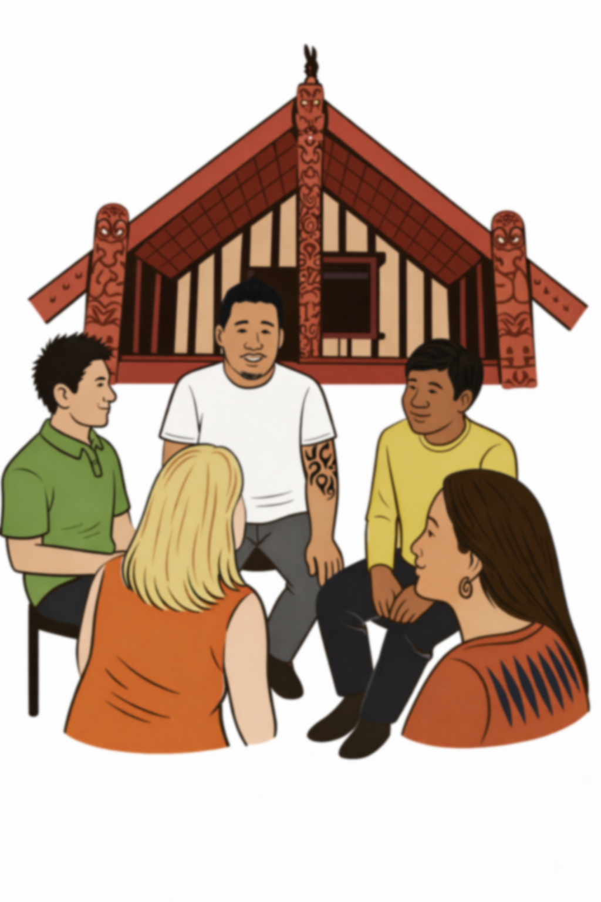
- other laws lots of countries have agreed to say Aotearoa New Zealand needs to do
say decision-makers sometimes need to think about tikanga.


Tikanga means Māori ways of doing things.

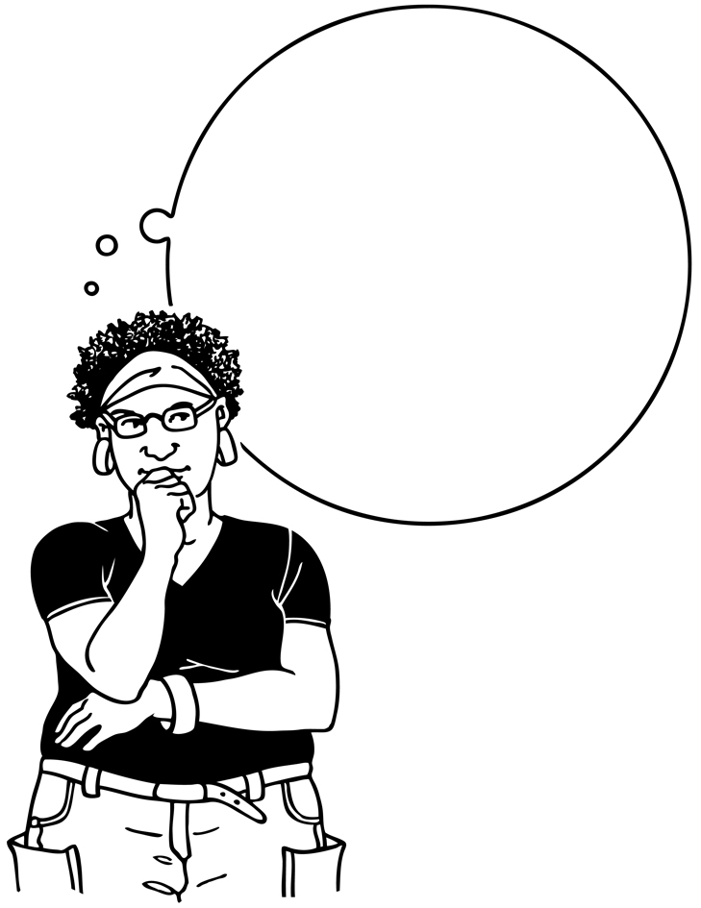

Some people will not know when they need to think about tikanga.

The law should have examples of times when people need to think about tikanga.
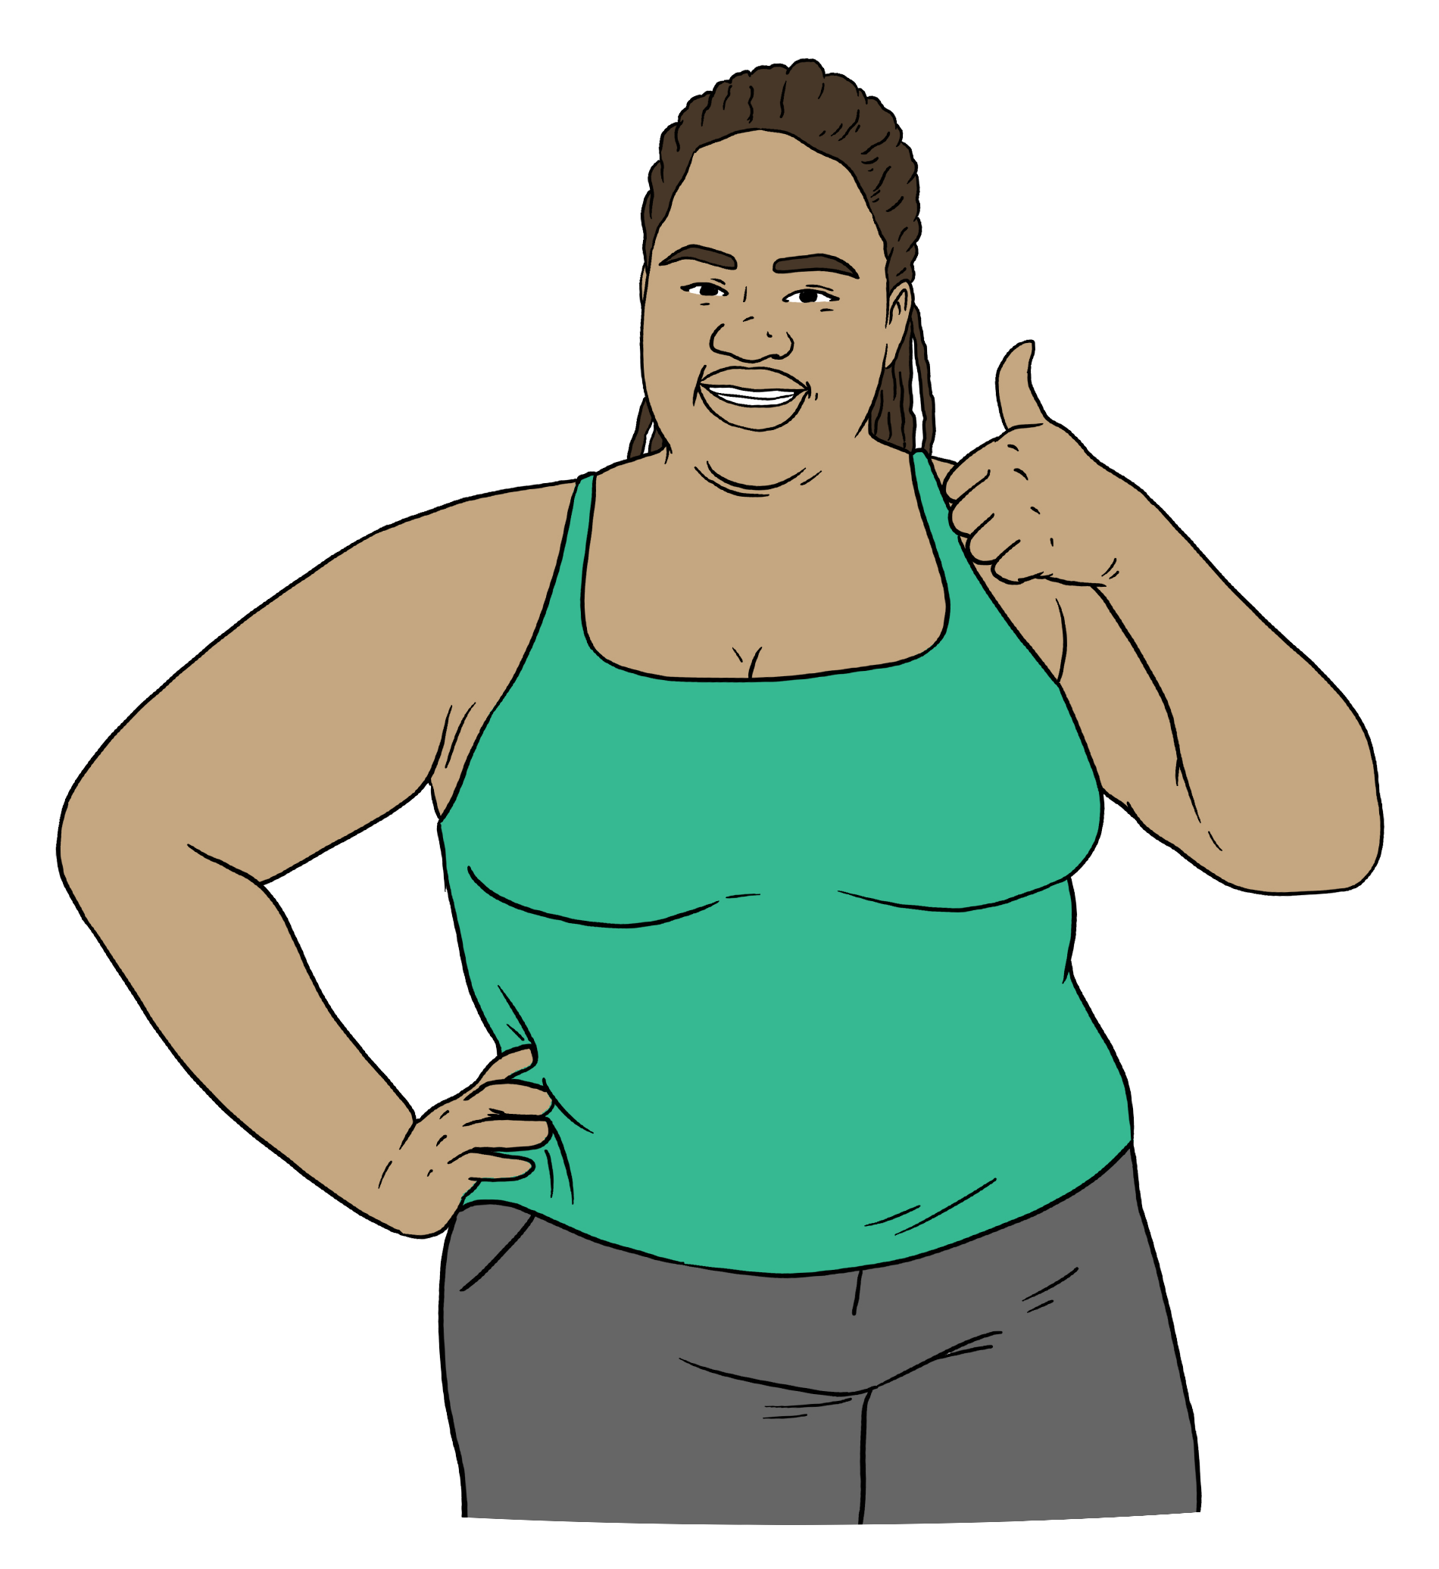

This will support everyone to understand when they need to think about tikanga.

Key recommendation 2:

Supporting people to make decisions

The new law should focus on supporting people to make decisions.

This is important when:
the person is making their own decisions
someone else is making decisions for the person.
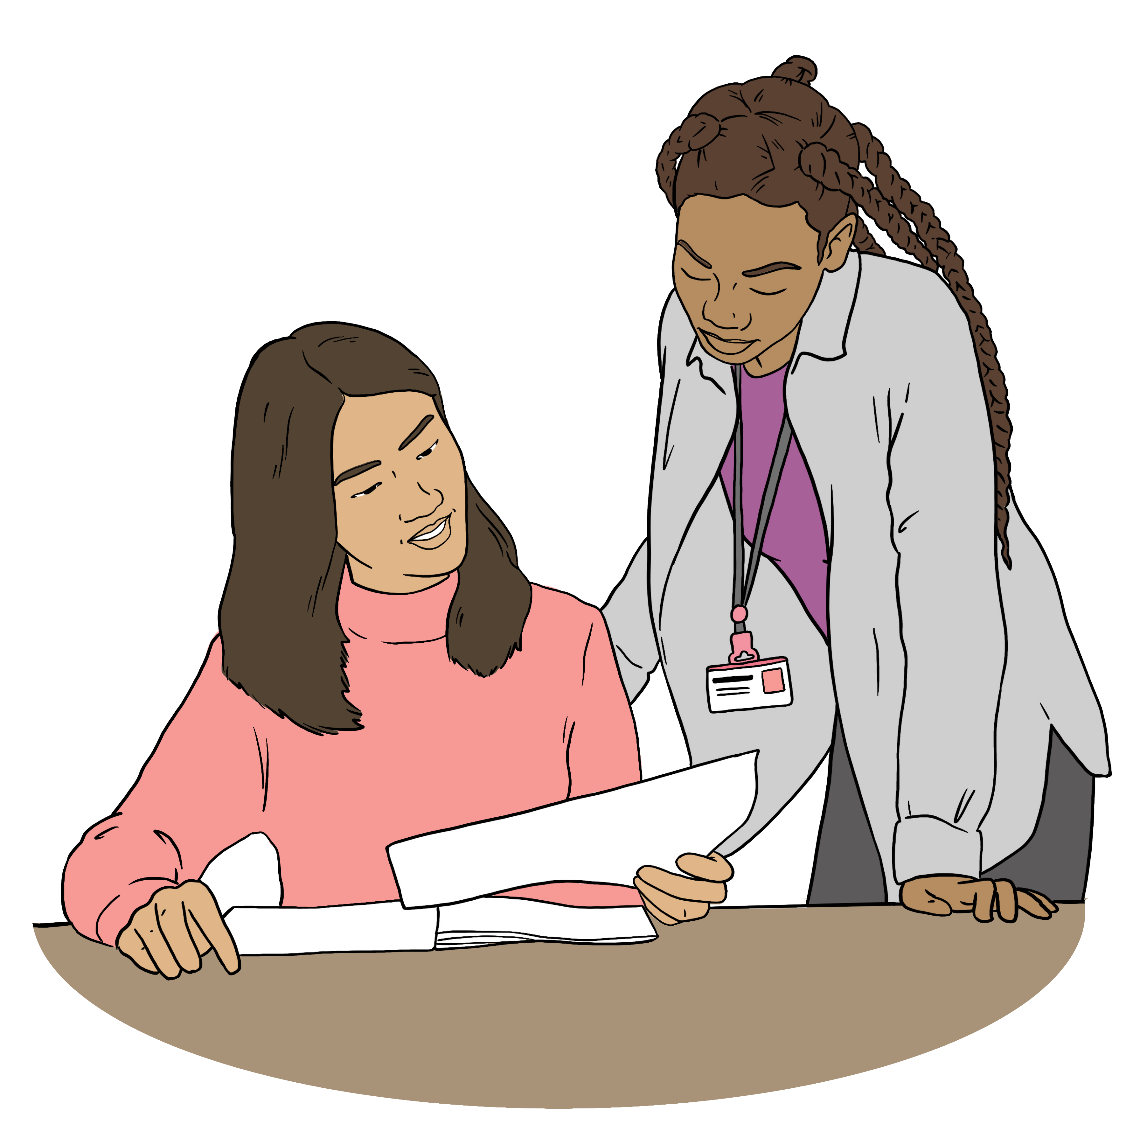

The new law should clearly say what supporting a person to make decisions means.

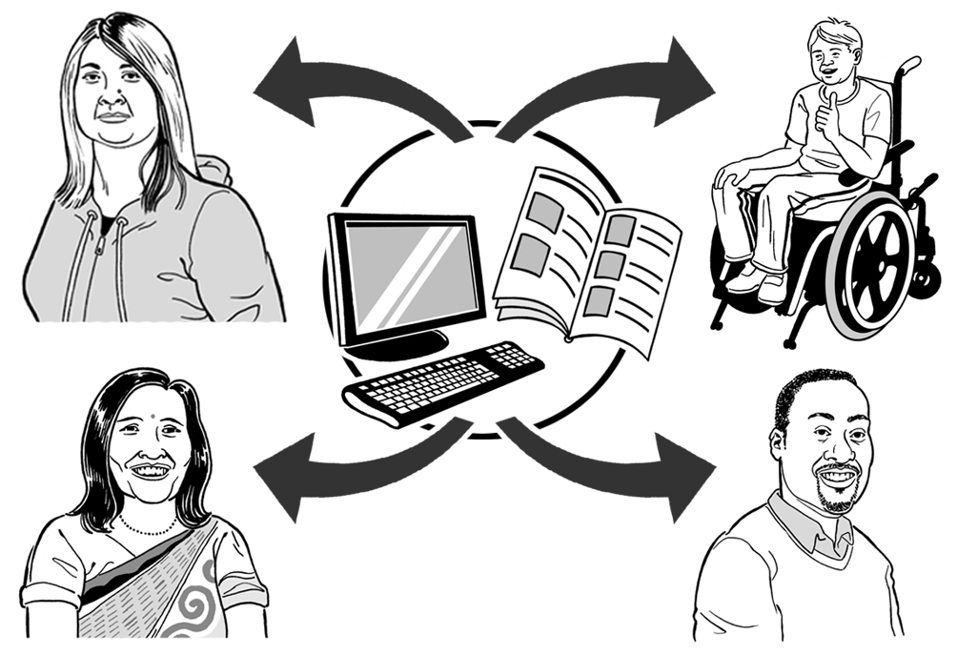
The law should say supporting a person to make decisions means supporting them to:

get the information they need
work out what choices they could make

think about which choice would be best
be part of making decisions

get assistive equipment to support them to be part of making decisions
use assistive equipment to support them to be part of making decisions

tell other people what they have decided
make sure the thing they have decided happens.
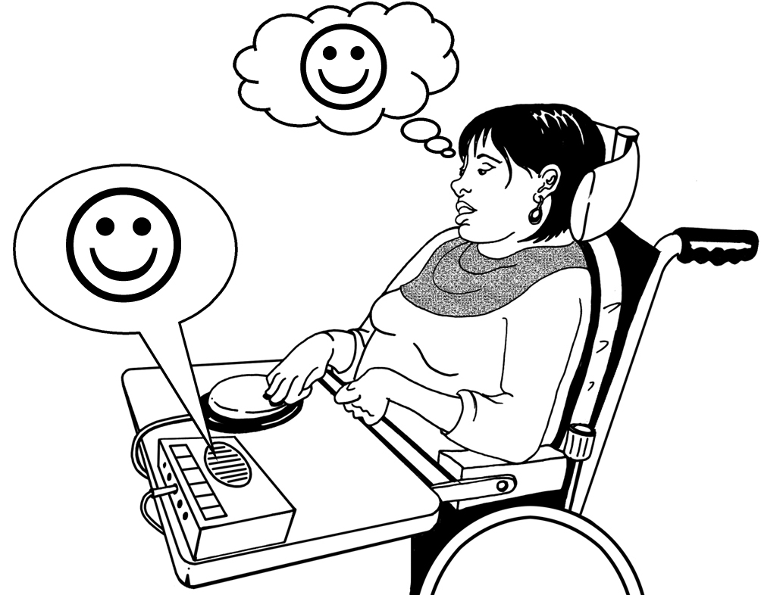
Assistive equipment means tools that support disabled people like a computer the person uses to talk.

The law should say that supporting a person to make decisions does not mean:
making the decisions for the person
telling other people what the person has decided.


The new law should set up a job called a formal supporter.

A formal supporter is someone
who:
- supports another person to make their own decisions
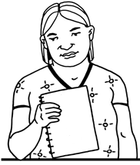
- the law says can get private information of the person which is needed to support them to make their own decisions
- the law says must act in the right way.


Private information is information only you and a few other people should know such as:

- your health information
- how much money you have in the bank.

People should be able to decide who their formal supporter is.

The way someone says who their formal supporter is should be like the way people write enduring powers of attorney.

The Family Court should also be able to decide who will be the formal supporter for a person.

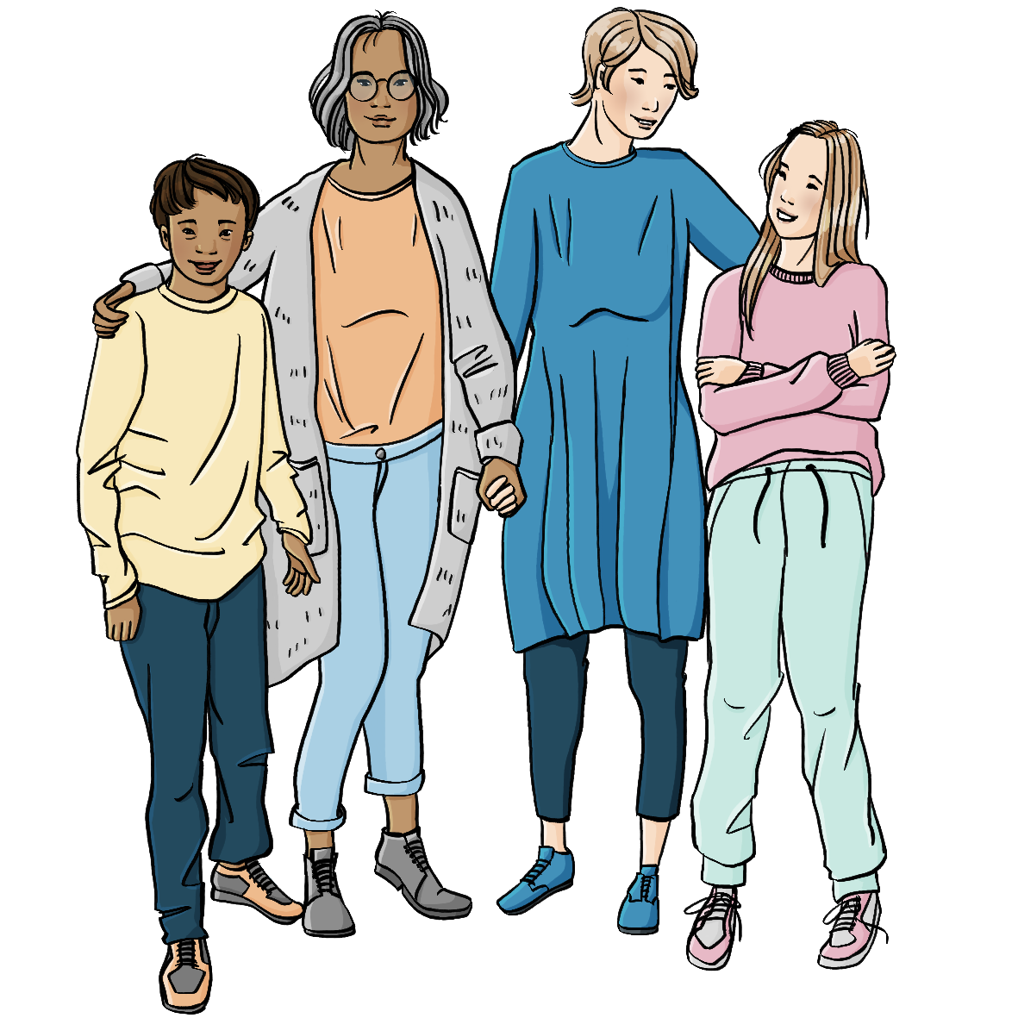
The Family Court is a Court that makes decisions about things such as who can make decisions for a person if they cannot make / understand their own decisions.


The person will need to say they are happy for the person the Family Court decides to be their formal supporter.



The written document about the formal supporter should say what kinds of decisions they can support the person with.


The formal supporter should be able to get the private information they need to support the person to make these kinds of decisions.


The formal supporter should not be able to get other private information that is not part of the decisions being made.


The job of the formal supporter should end if the person is no longer able to:

understand what a formal supporter does
decide who their formal supporter should be.

Key recommendation 3:

Making decisions for a person

Sometimes a person cannot make / understand their own decisions even if they have support.

This means someone else needs to make decisions for the person.

At the moment people can use an enduring power of attorney to say who can make decisions for them if they cannot make / understand their own decisions.

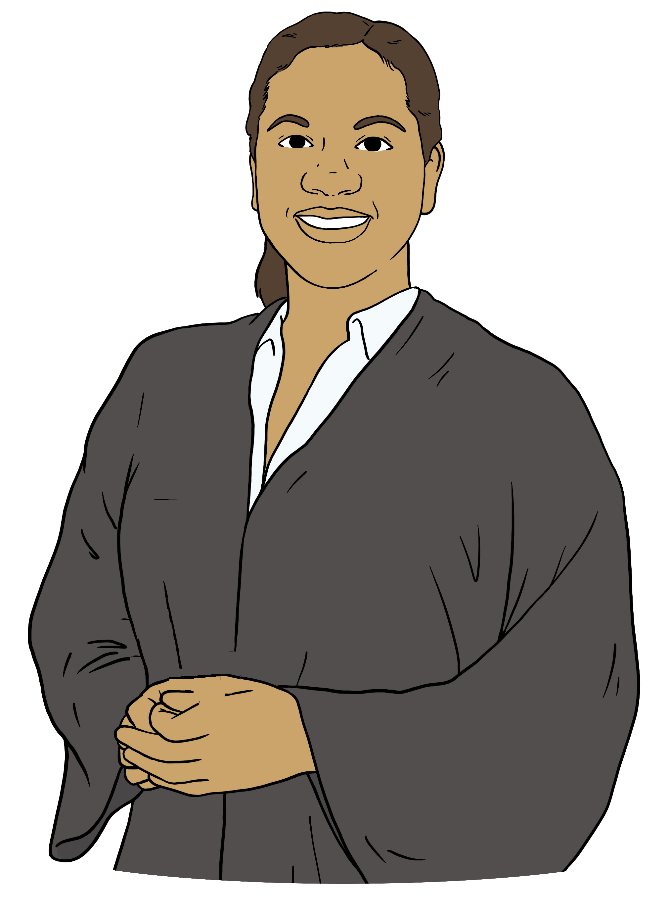
At the moment the Family Court can also:
make decisions for a person who cannot make / understand their own decisions
say who can make decisions for a person who cannot make / understand their own decisions.


These things should not change.

The new law should have rules that decision-makers have to follow.

We think there should be 3 rules.


The Family Court should only have to follow the first rule when it makes a decision for a person.

The Family Court should be able to use the other two rules if it wants to.

Other decision-makers should have to do their best to follow all 3 rules.

Rule 1

Decisions should be based on:

the wishes of the represented person
the values of the represented person
rights.


Rights are things that everyone should:
have
be able to do.


Some examples of rights are the
right to:
have a religion
say what they like
own things.


Sometimes there might be a difference between the:
wishes of the represented person
values of the represented person.


The decision-maker will need to think about how important the values are to the person to work out how to make the right decision.


Sometimes the decision-maker might not know much about the:
wishes of the repesented person
values of the represented person.


They should use what they do know to work out what the right decision to make is.


If that is not enough then they should also think about what would be best for the wellbeing of the represented person.

Wellbeing means having a good life.

Wellbeing looks different for different people.


It could mean things like:
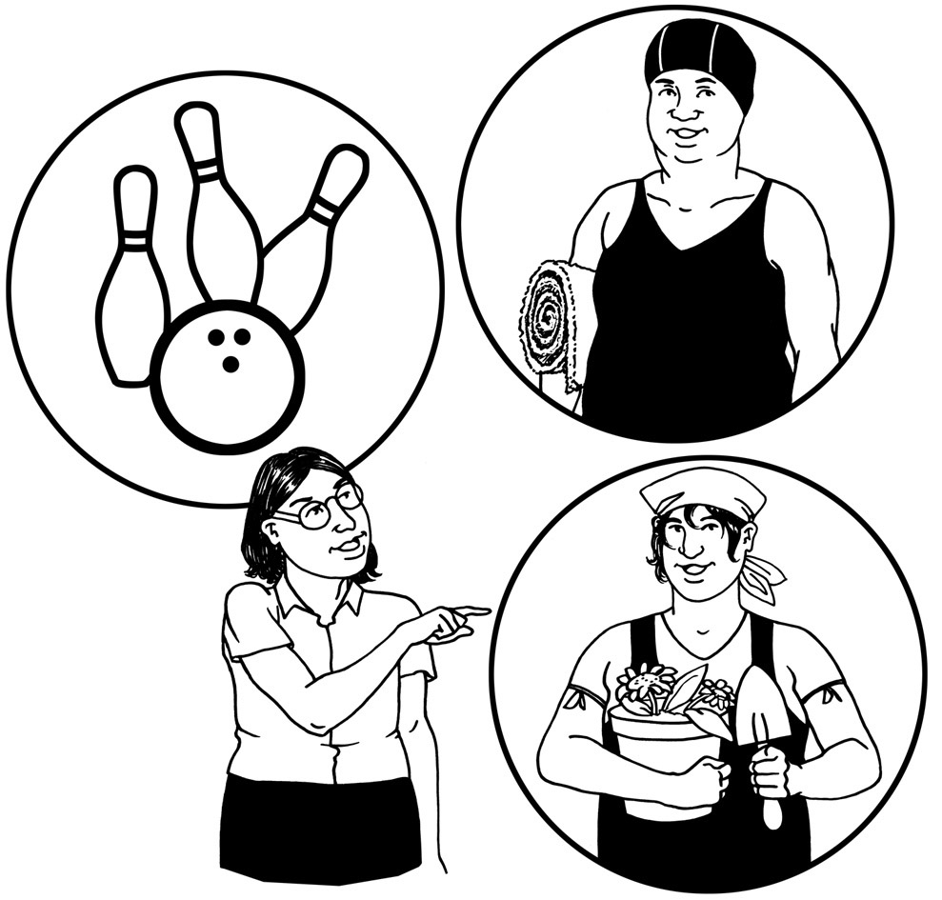
having a place to live where you feel happy
being able to do things you
enjoy.

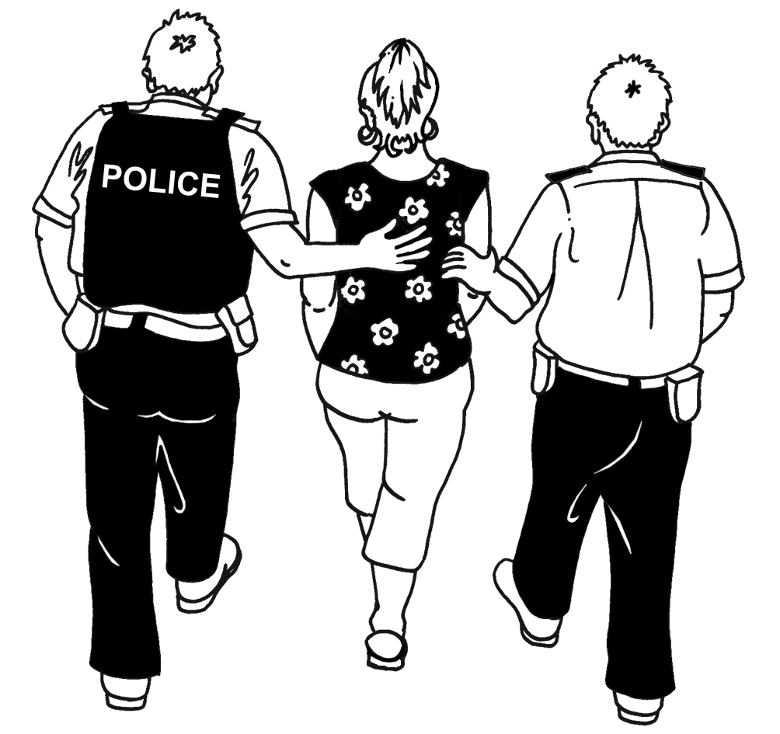
The decision-maker should not make a decision that:
is a crime

cannot actually happen
might cause a lot of harm to the represented person.

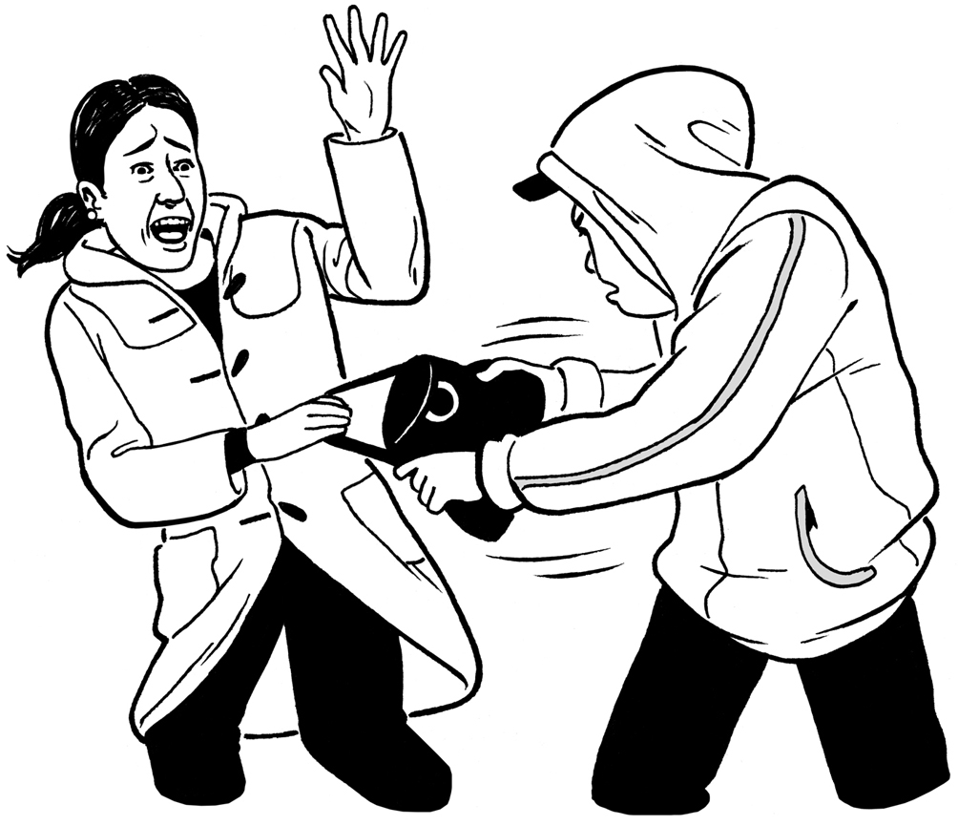
A crime is something that breaks the law.

For example stealing things is a crime.

Rule 2

Many people can make / understand some of their own decisions.
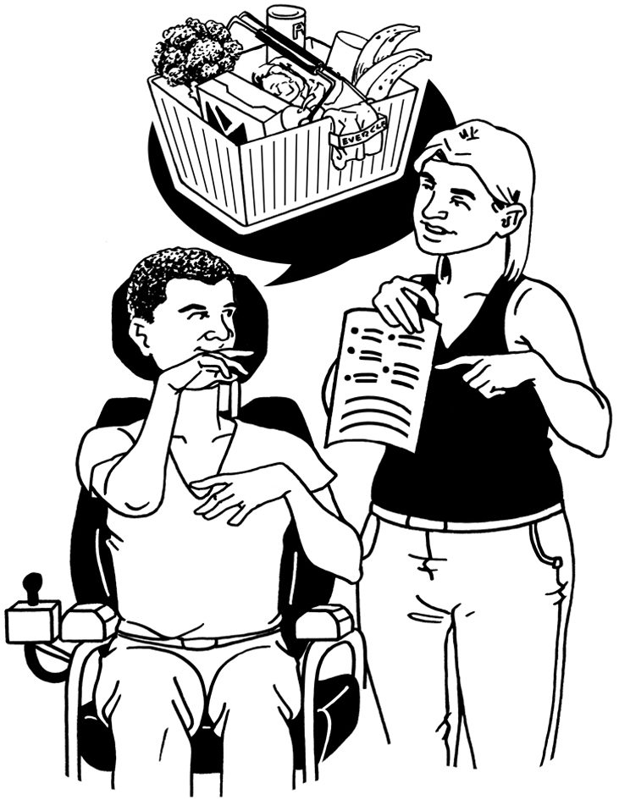

The decision-maker should not make a decision for the represented person if they can make / understand their own decision.


However someone else can make the decision for the represented person if the represented person wants them to.

The represented person should get support to help them make a decision if that is what they want.


If someone else is making a decision for a represented person they should:
talk to the represented person about the decision
ask what the represented person wants
try to get the person the support they want.

The decision-maker should not have to talk to the represented person about the decision if the represented person says they do not want to be part of making the decision.

Rule 3


The decision-maker should make sure they have the information they need.

They should make sure they know about:
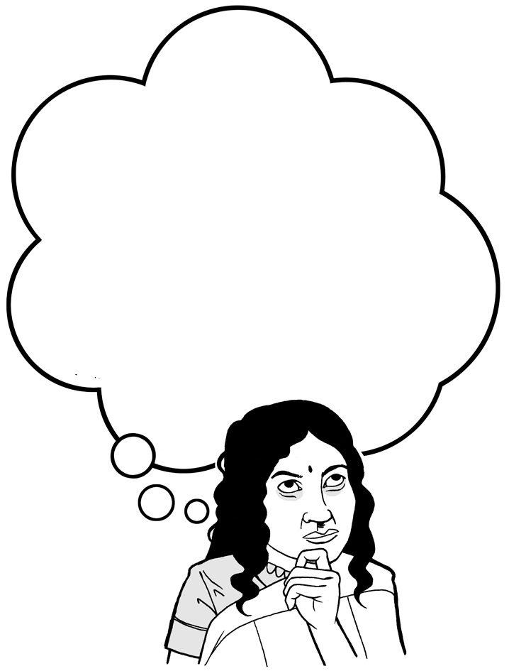
decisions the represented person has made in the past
if the represented person has said anything about what they would like to happen.

The decision-maker should try to find any extra information they need to help them to make the decision.

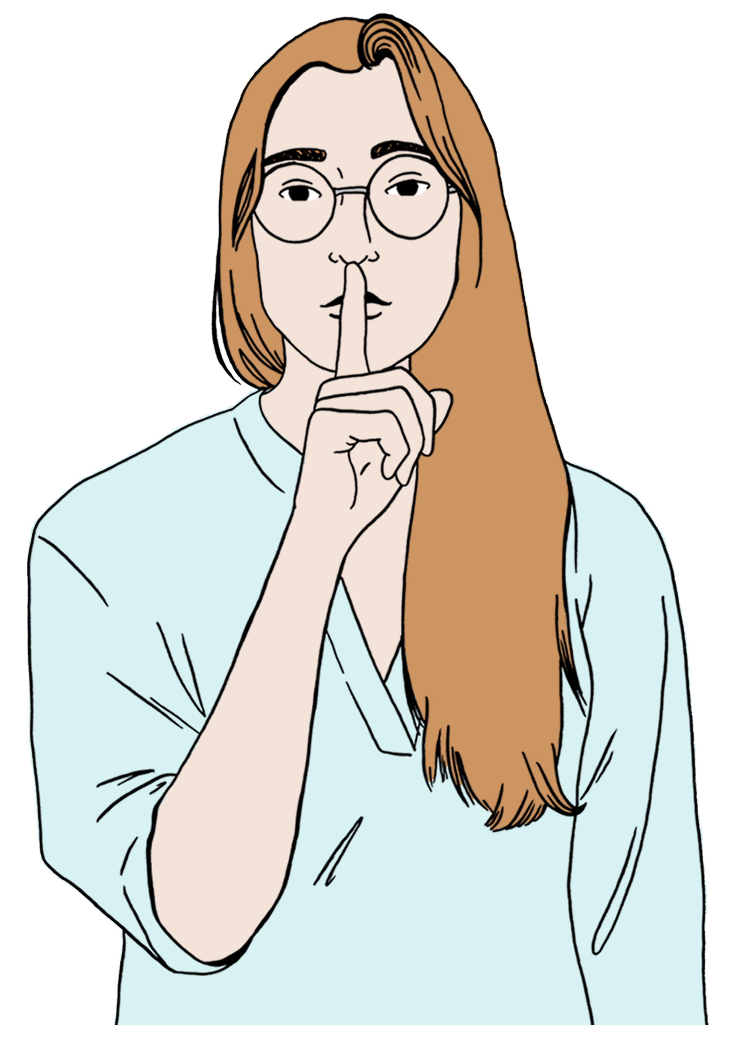
Sometimes the represented person might not want the decision-maker to get some information.

The decision-maker should only get this information if not having the information means the represented person might be badly harmed.

The Family Court
The new law should clearly say when the Family Court can:
make a decision for a person
say who can make decisions for a person.

The Family Court should only make decisions for a person / say that someone else can make the decisions for the person if the:
  - person cannot make / understand their own decisions
  - Family Court needs to decide what should happen.

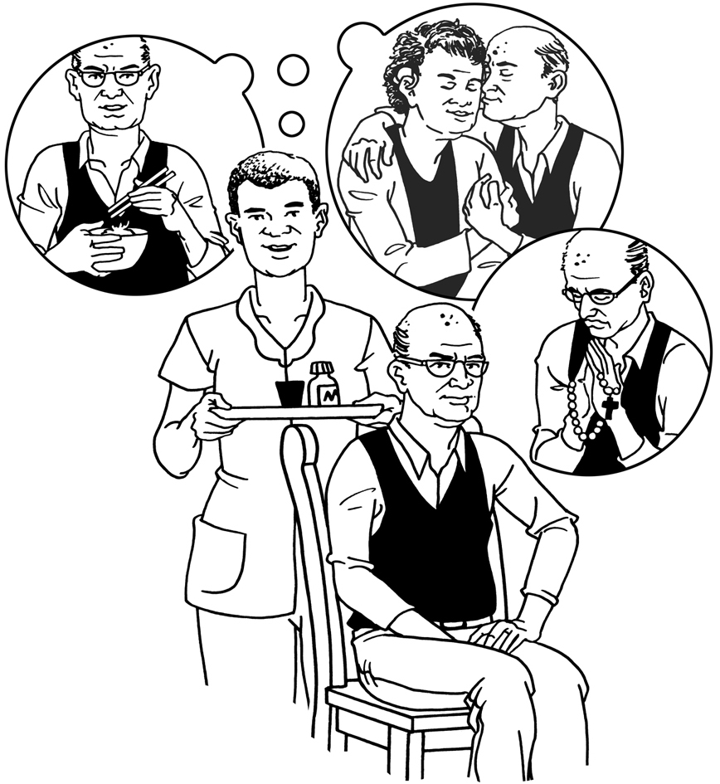
The Family Court only needs to decide what should happen if:
the decision of the Family Court is needed to make sure that the person’s wishes / values are respected
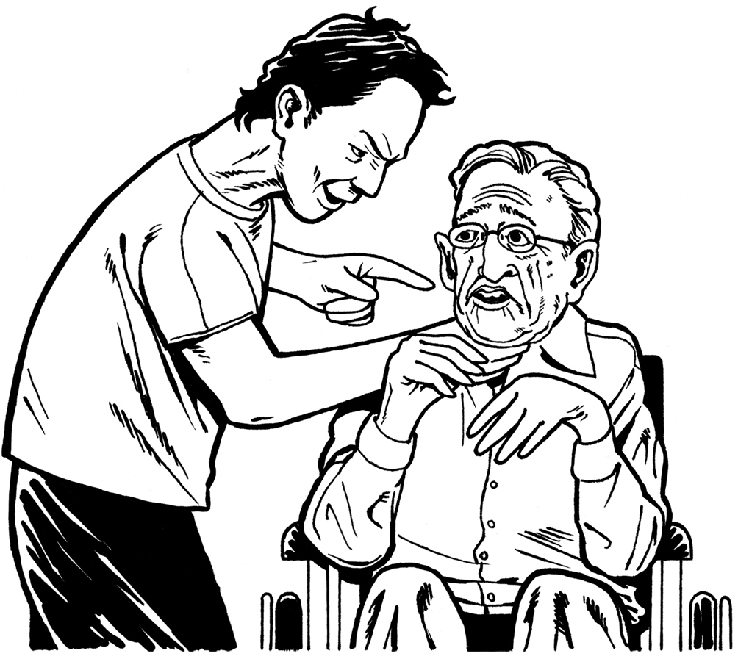
or
- the person might be badly harmed if the Family Court does nothing.

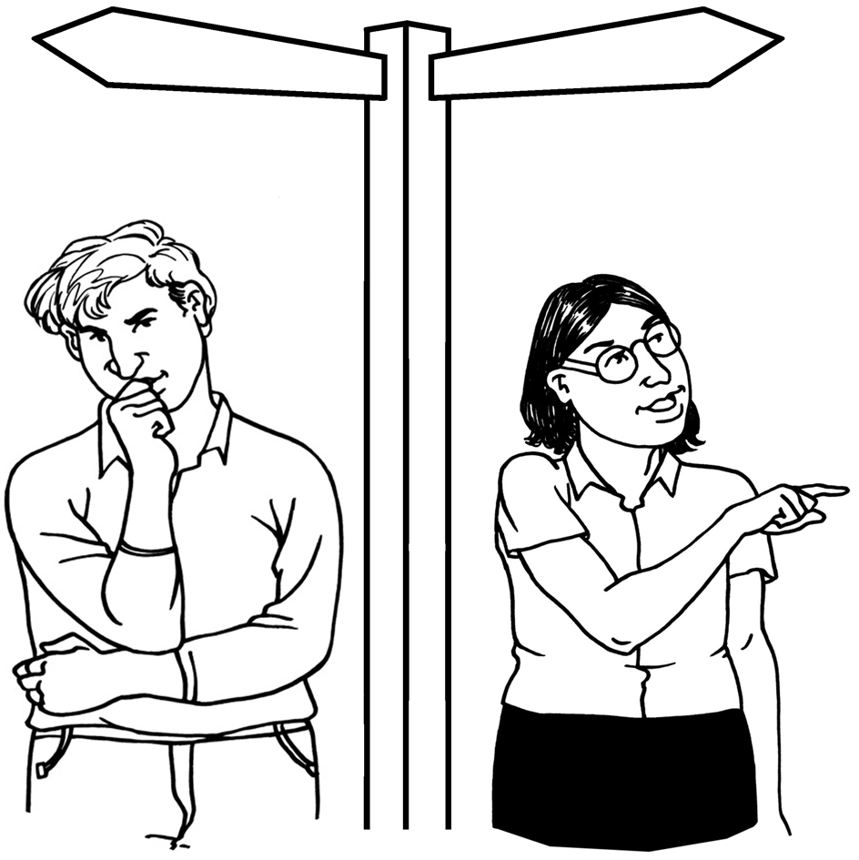
The Family Court should not decide what should happen if there is a better way to make a good decisions for the person.

We also recommend other changes to the rules about when someone else can make decisions for a person.

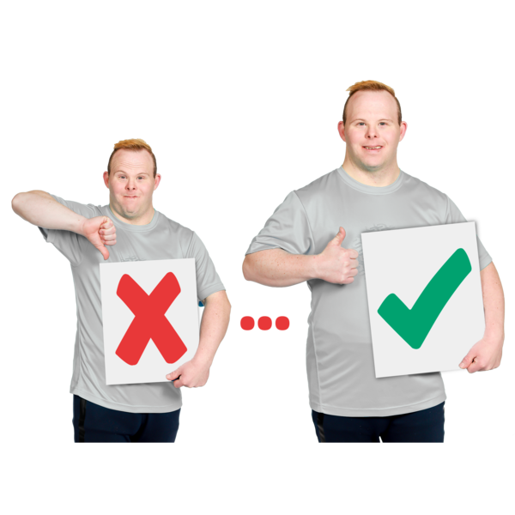
These changes will:
make the law work better

help keep people safe.

Key recommendation 4: General duties

The new law should have duties for:
decision-makers
formal supporters.

Here duties are things that people have to do.

Decision-makers should have to:
follow the rules about making decisions

be honest / tell the truth
make the best decisions they can.


Decision-makers should also have to:
do their best to:
- know what is going on in the life of the represented person
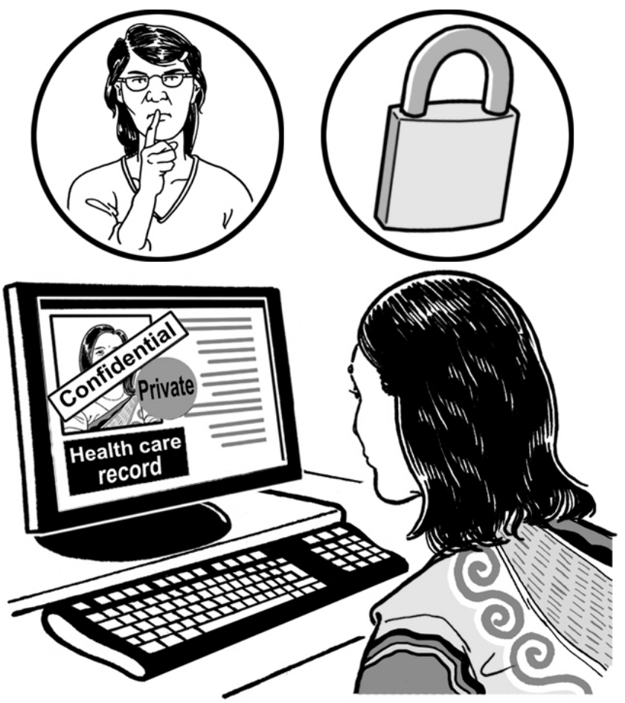
- make decisions based on what they know about the represented person
- keep private information private
- know if there is a conflict of interest
- make sure the conflict of interest does not stop them making a good decision for the represented person.

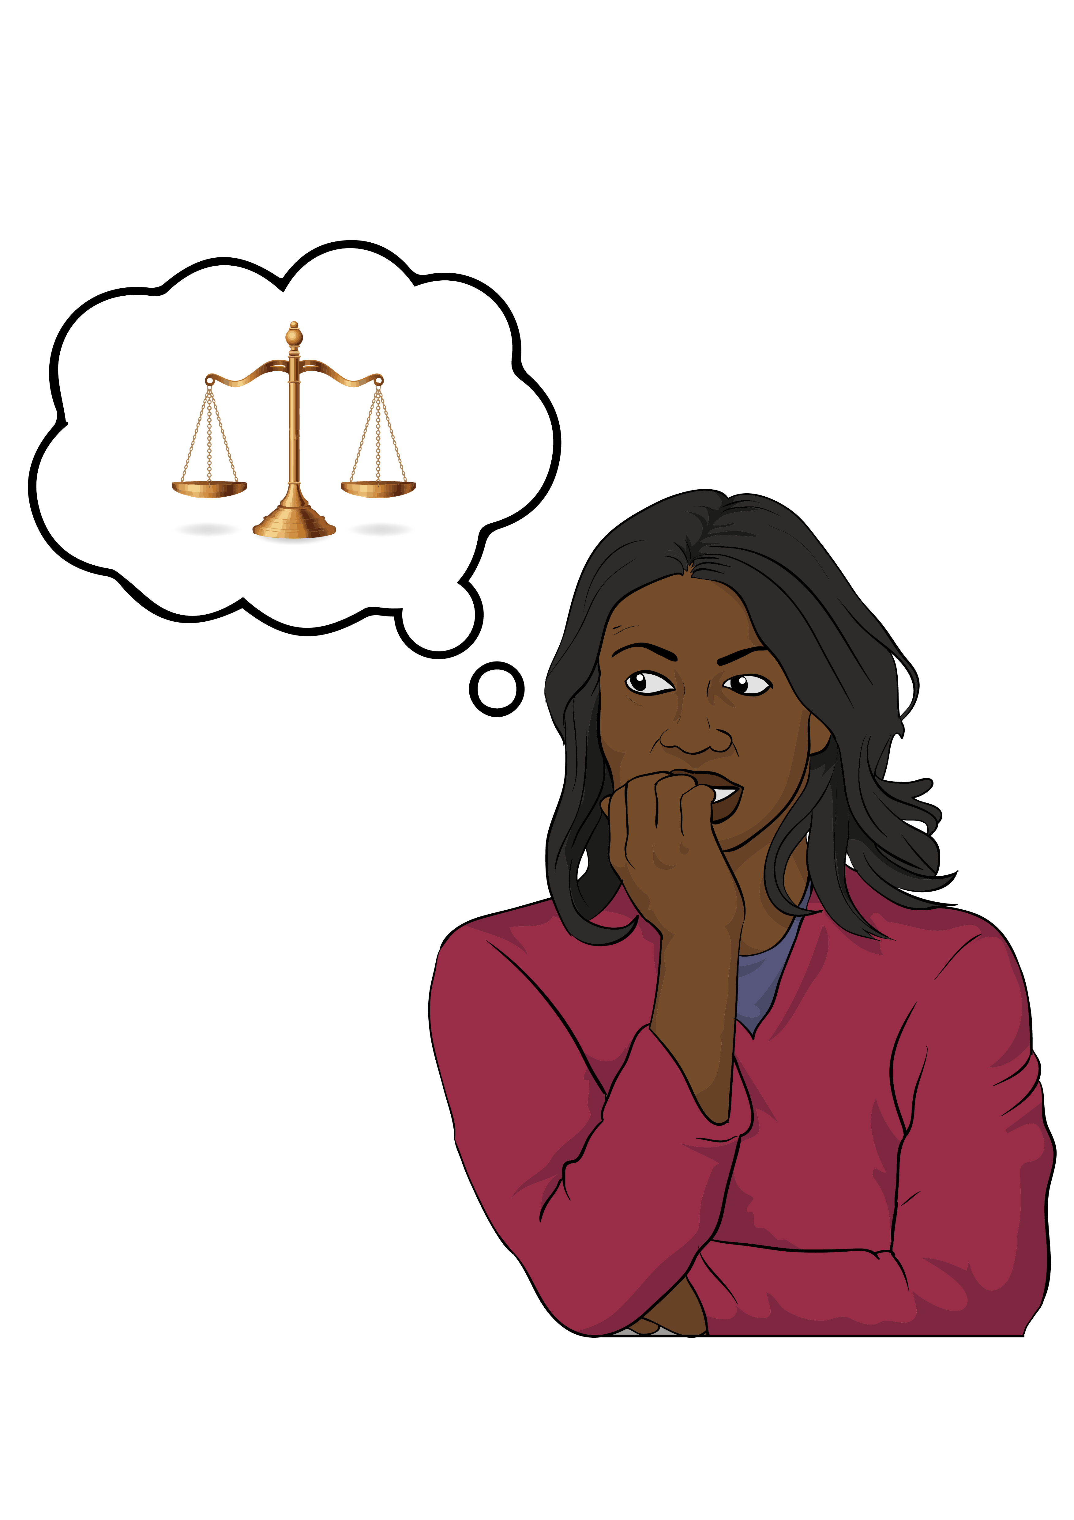
A conflict of interest happens when something about a person makes it harder for them to make a fair decision.


For example a decision-maker might want to rent a house they own to the represented person.


This means the decision-maker would get money if they decided to rent the house to the represented person.
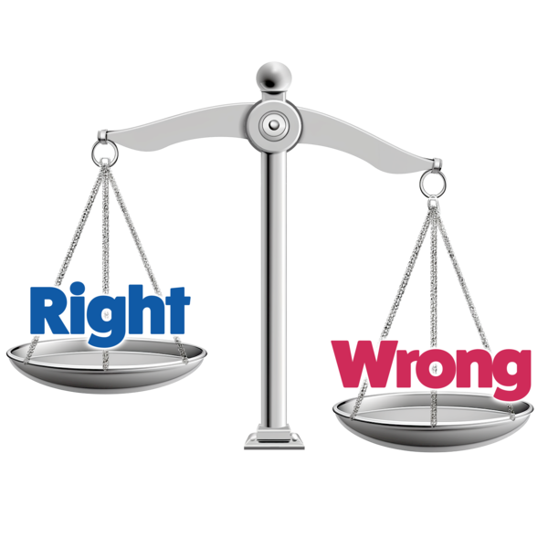

This makes it harder for the
decision-maker to make a fair decision.

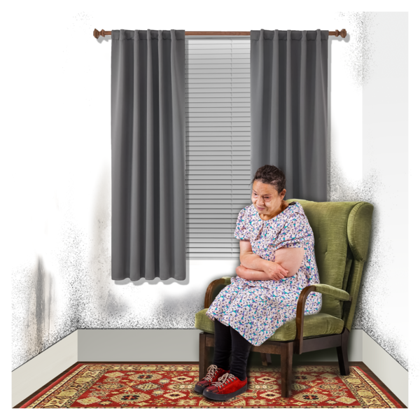
The decision-maker might decide to rent the house to the represented person even if the house is not the best place for the represented
person to live.
Decision-makers should also have to:
try to make sure the represented person gets any support they want to support them to:

- understand what decisions the decision-maker is allowed to make for them
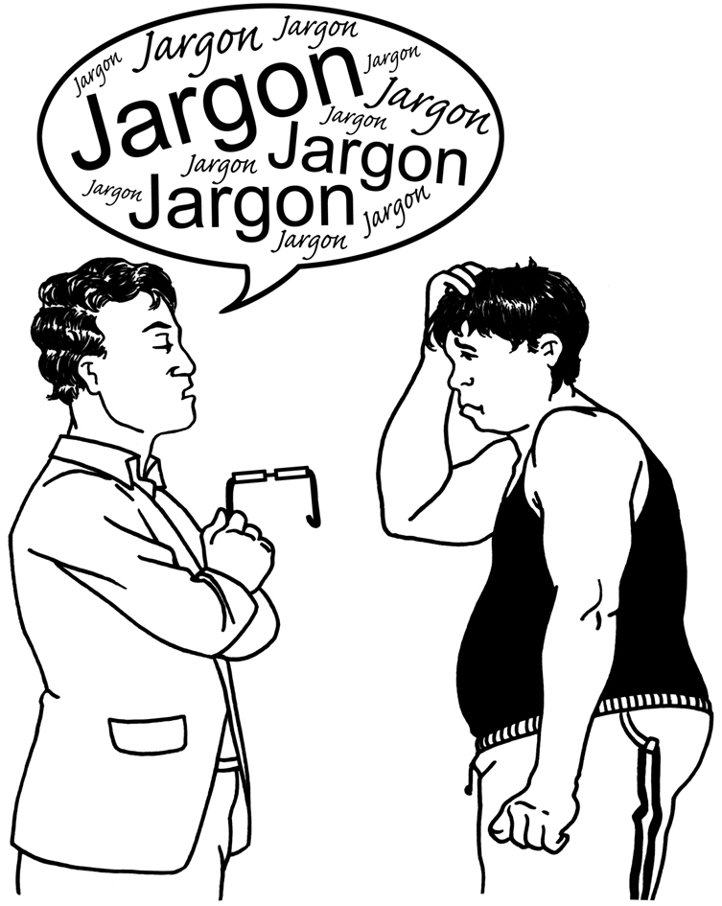
- make the decisions they can make / understand
try to:

- talk to the represented person in a way the represented person understands
- tell the represented person about the decisions that get made for them.

Formal supporters should have duties like the duties decision-makers have.

Formal supporters cannot make decisions for another person so their duties will be a bit different.

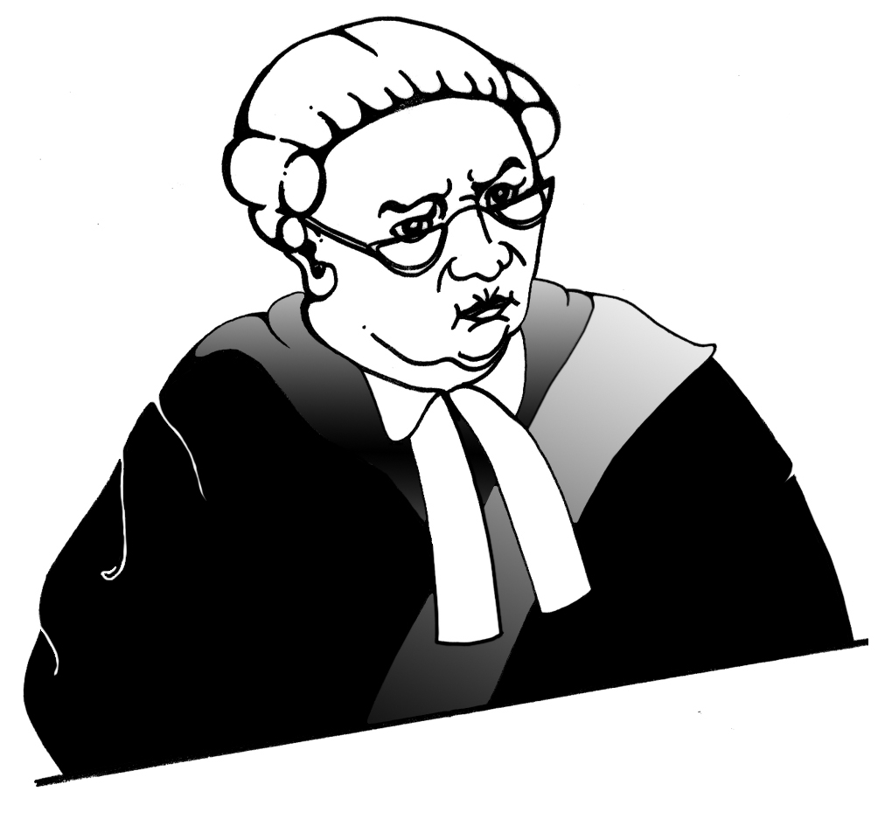
Normally people should not get in trouble if they do not do one of their duties.


They should get in trouble if they are not:
honest
careful.


Sometimes a decision-maker / formal supporter might get things they would not otherwise have gotten when they:

make decisions for another person
support another person to make their own decisions.

If this happens the decision-maker / formal supporter might have to pay back the person they:
make decisions for
support to make decisions.

Key recommendation 5:

Decision-making capacity

The PPPR Act talks about decision-making capacity.


The new law should also talk about decision-making capacity.

The new law should have:

a better definition of
decision-making capacity
better ways of deciding if someone has decision-making capacity.

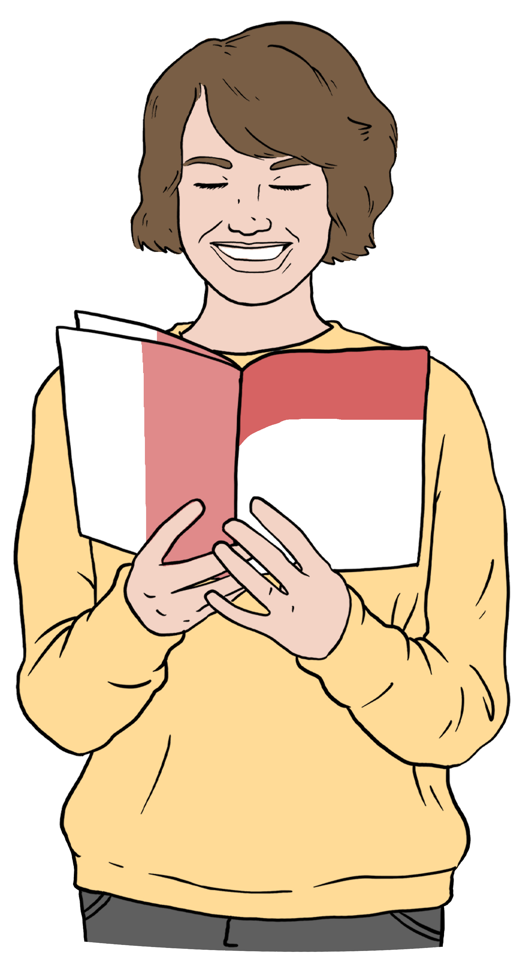
The new law should use the same definition of decision-making capacity everywhere in the law.

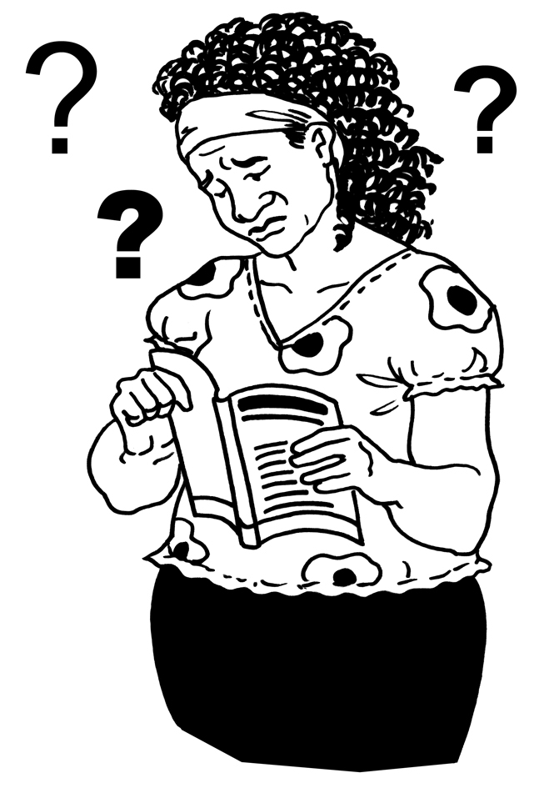
The new law should say that a person does not have
decision-making capacity if they cannot:
understand information about the decision
remember information so they can make the decision

use information to make the decision
tell other people what they have decided.

If a person cannot do all of these things then they do not have decision-making capacity for the decision.

People must think about what support the person will have when they are deciding if the person has decision-making capacity.

People who are deciding if someone has decision-making capacity should also remember that:

people can have the decision-making capacity to make some decisions but not others
decision-making capacity can change over time.

The new law should talk about 3 different ways of deciding if a person has decision-making capacity.

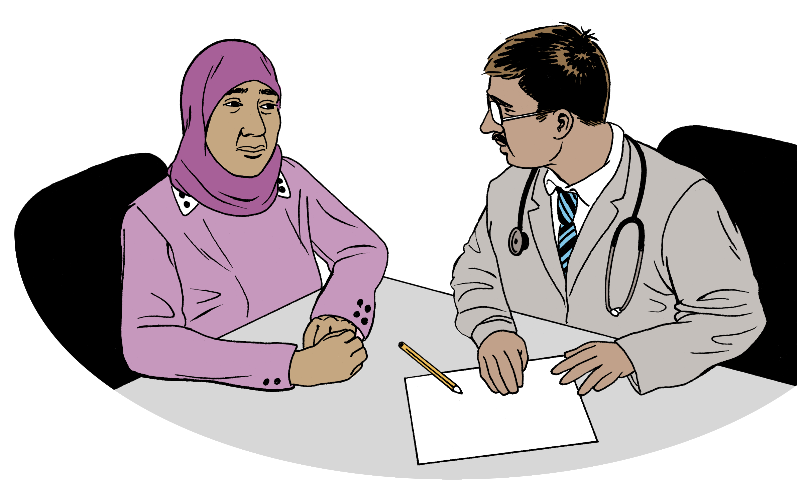
These ways are:
a professional like a doctor deciding if the person has decision-making capacity
the Family Court deciding if the person has decision-making capacity
someone else deciding if the person has decision-making capacity like a:
- decision-maker
- formal supporter.


The new law should have rules that professionals like doctors have to follow when they are deciding if someone has decision-making capacity.

Key recommendation 6:

Checking the new law is working

One part of the Government should be in charge of making sure the new law is working.

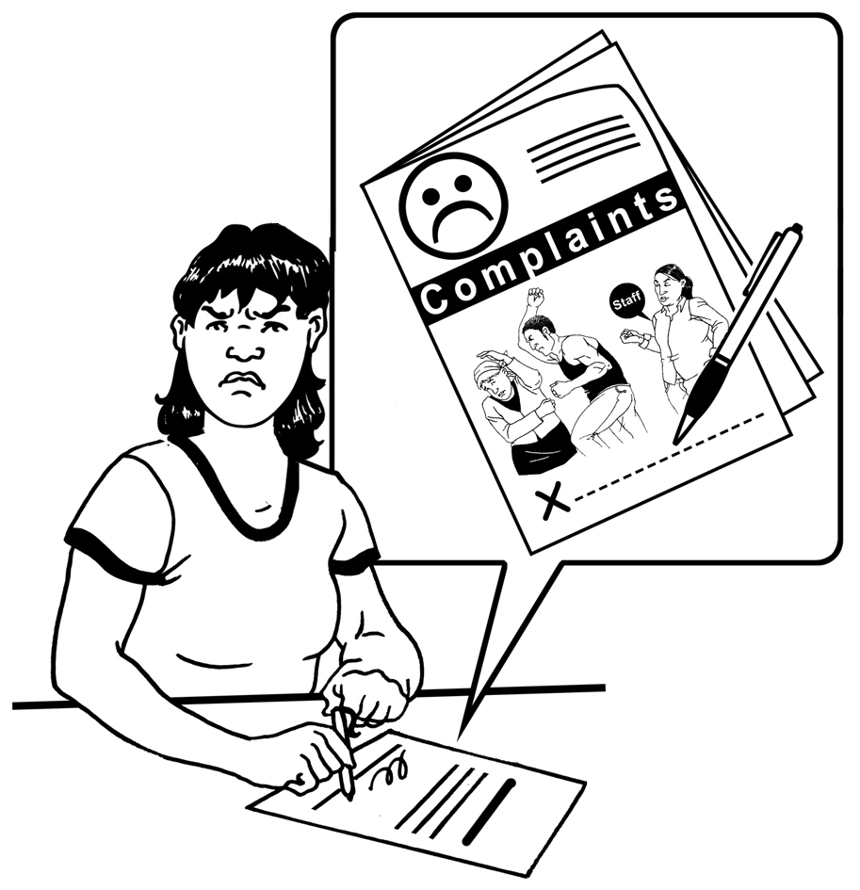
This part of the Government should:
set up a way people can complain if they do not like the decisions that are being made for them
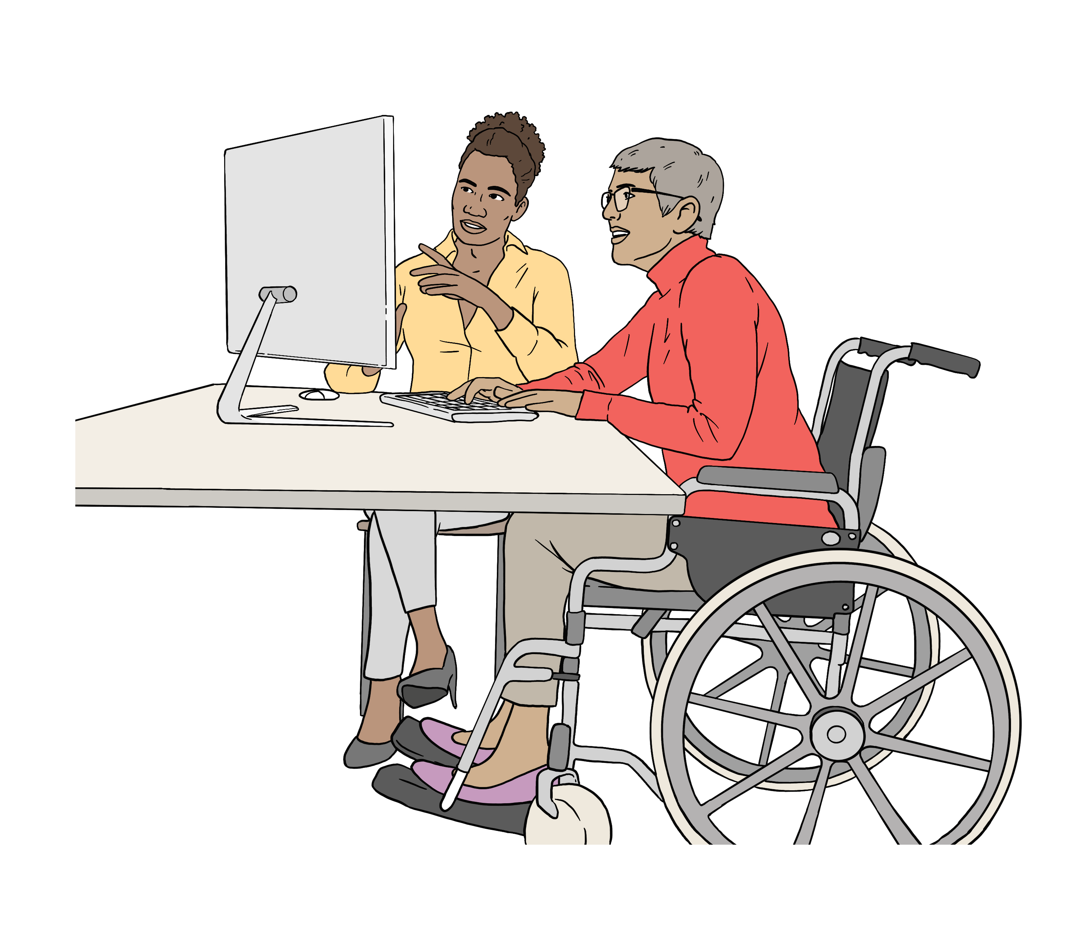
have information about the new law
support people to understand the new law.

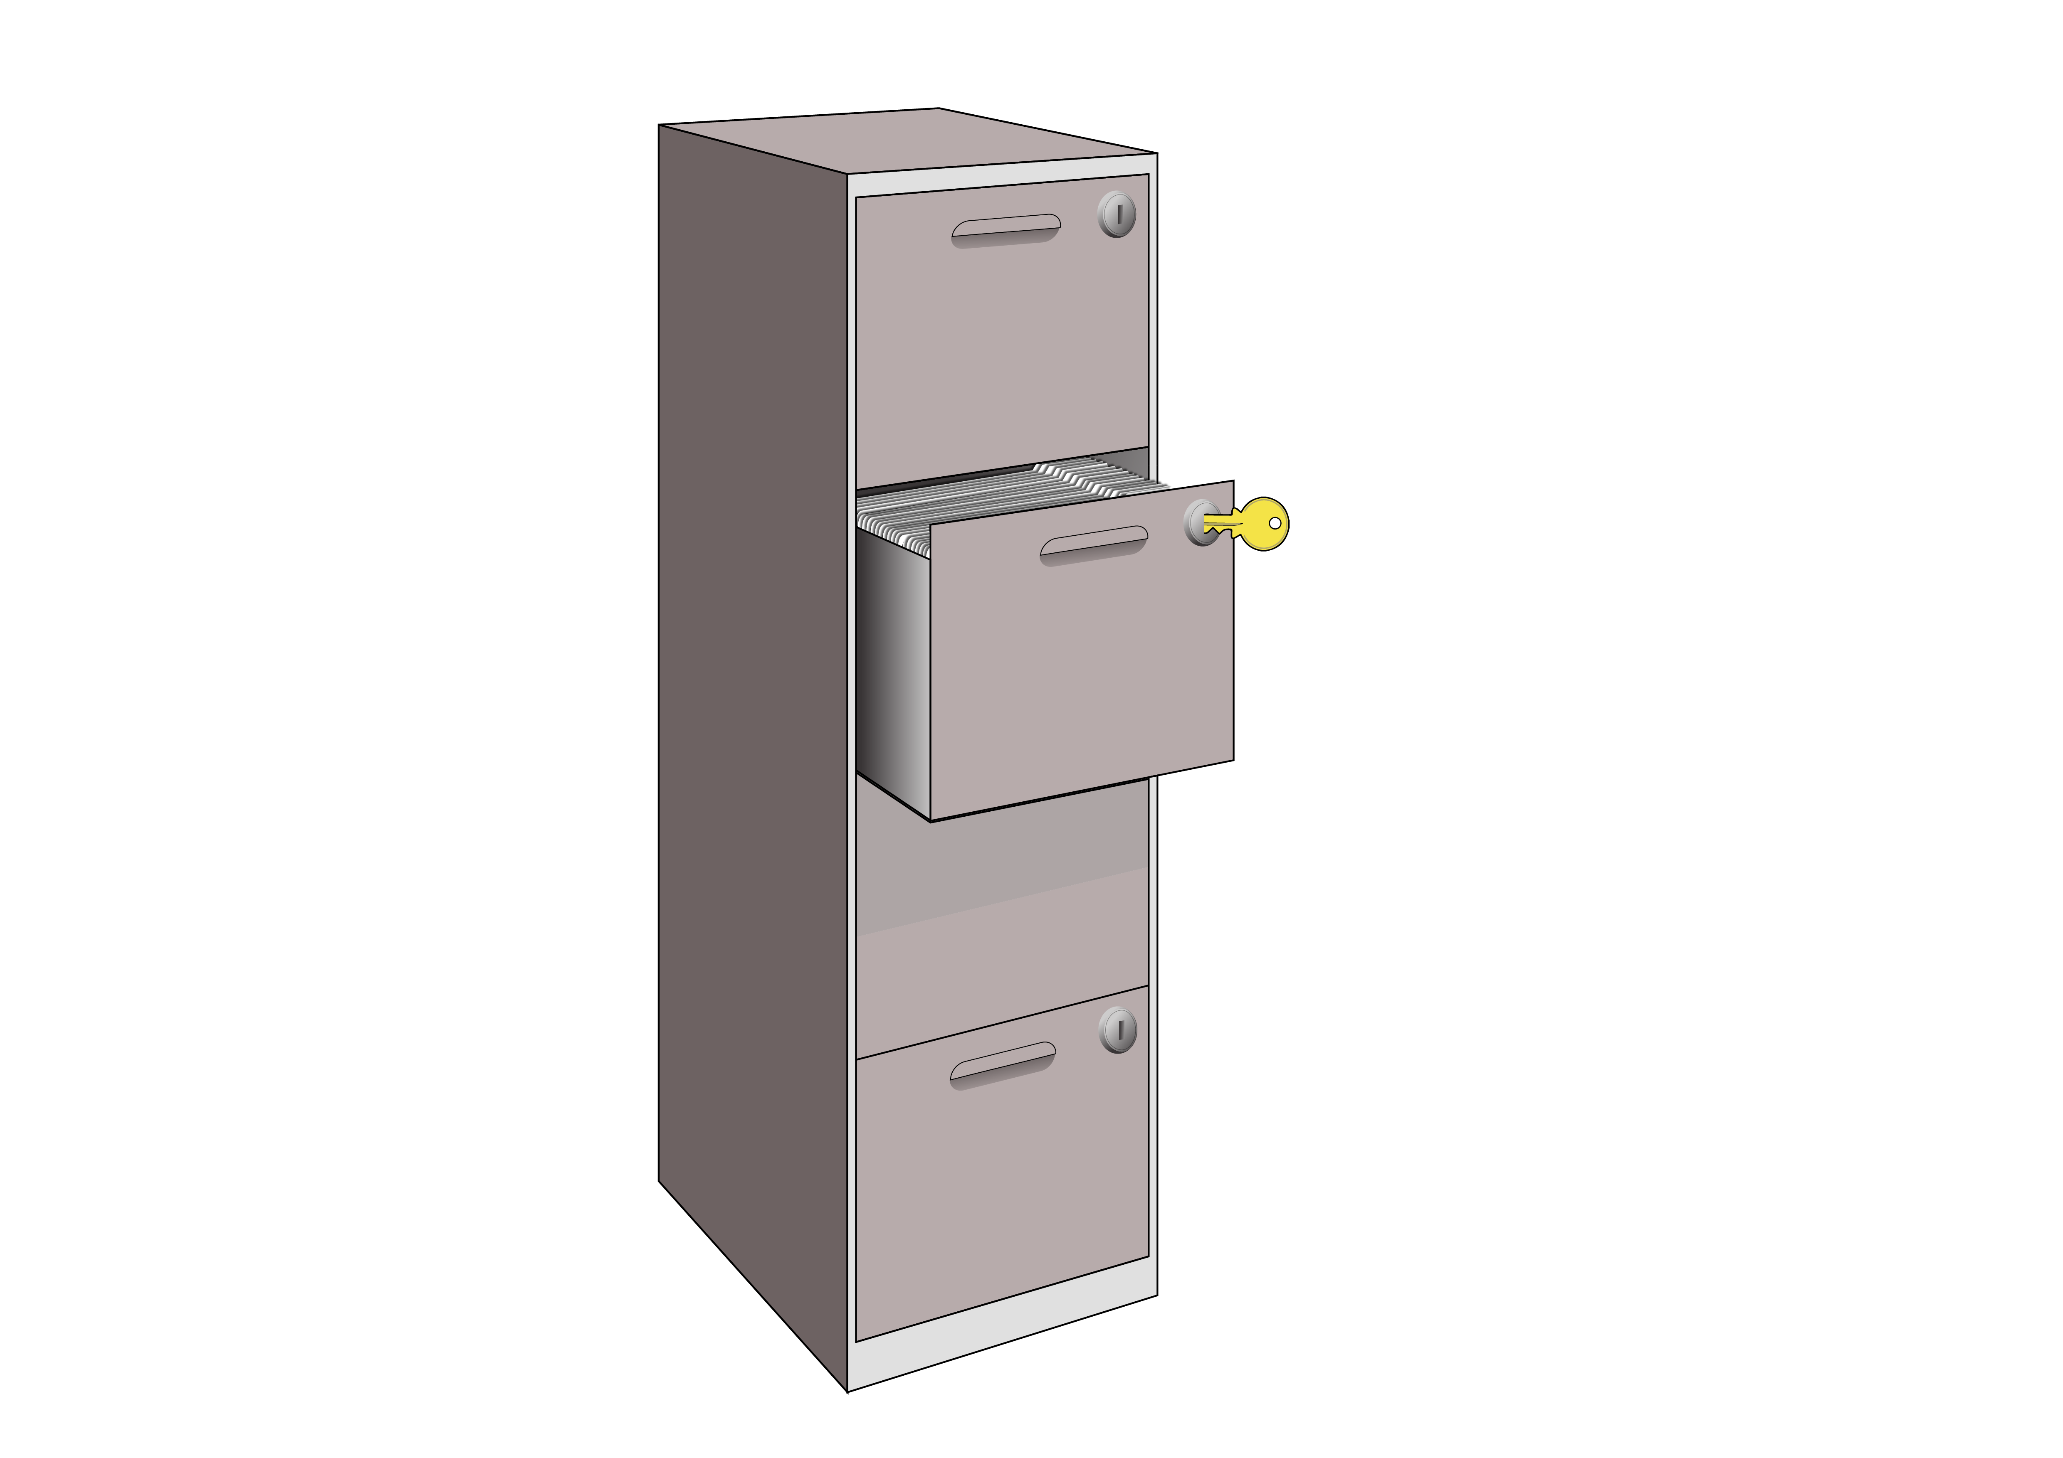
This part of the Government should also keep a list of enduring powers of attorney.


People will only have to add their enduring power of attorney to the list if they want to.

The list will make it easier to know:
if someone has an enduring power of attorney

where to find their enduring power of attorney.

The Family Court should still be in charge of checking that good decisions are being made for people.

Key recommendation 7:

Other things to review

We think there are 2 other parts of the law the Government needs to review.

The Government should review the law about advance directives.


An advance directive says:
- if there is any medical treatment you do not want to get in the future
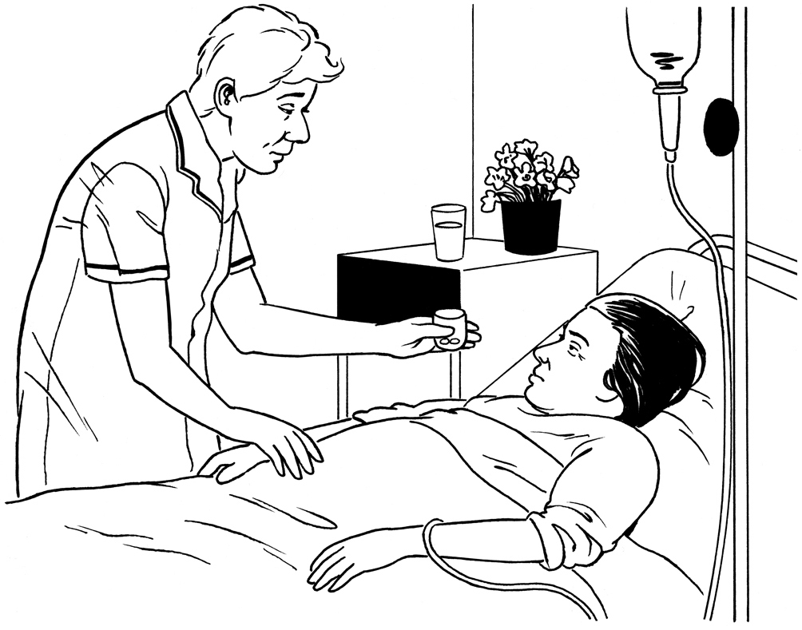
- what treatment you would be happy to get in the future.


The doctors will use the advance directive to decide what medical treatment to give you if you are not able to make / understand your own decision about getting the medical treatment.

At the moment the rules about advance directives are not clear.


A review should look at whether there needs to be a law about advance directives.


The Government should also review the law about:

use of force against people who cannot make / understand their own decisions
restricting the liberty of people who cannot make / understand their own decisions.

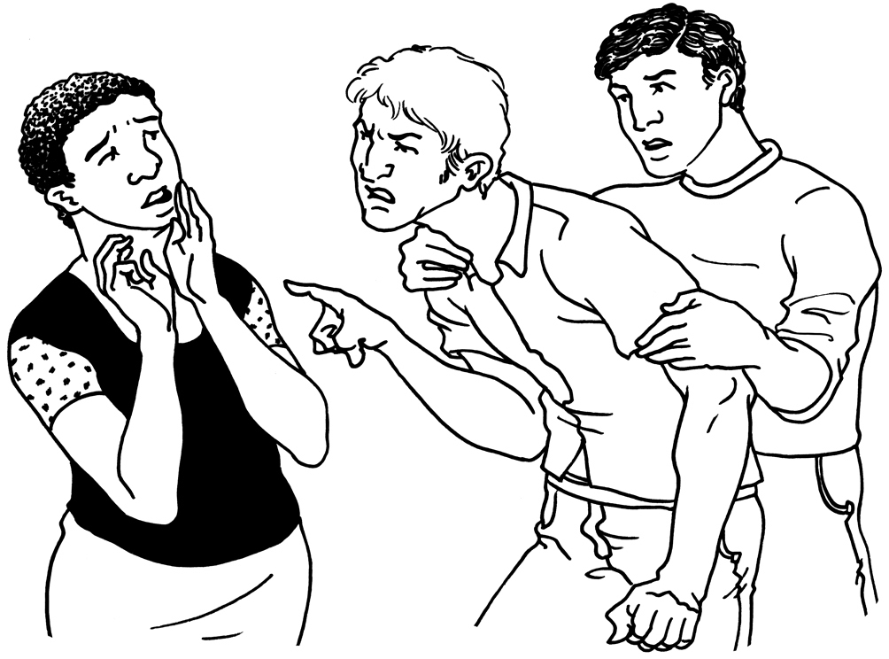
Use of force means doing
something that might hurt a person.


Holding someone still if they are throwing things is an example of use of force.

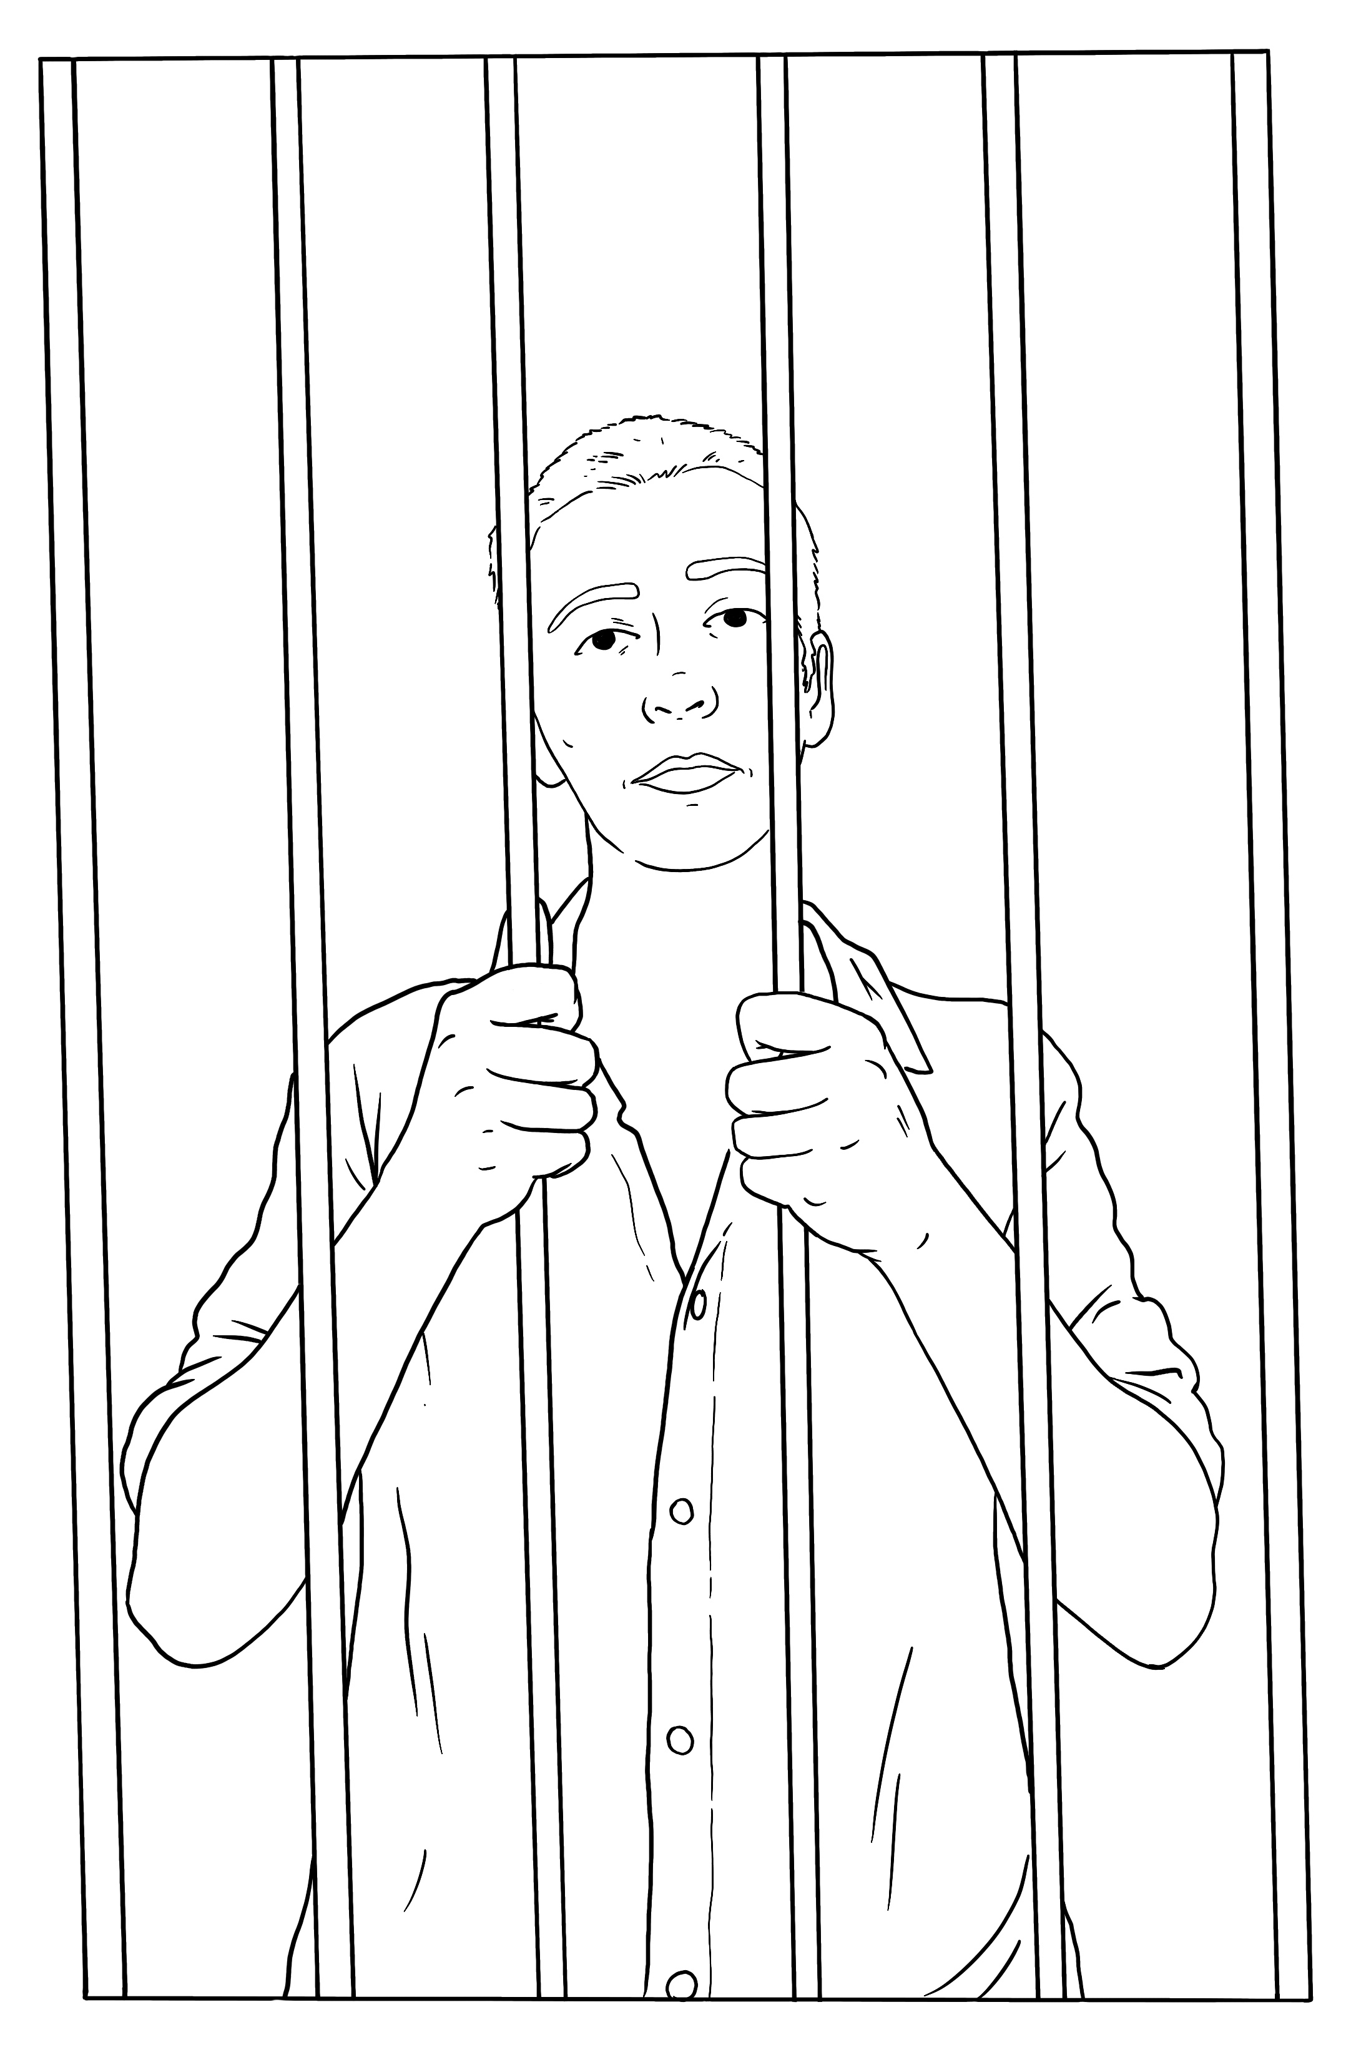
Restricting the liberty of a person means keeping them somewhere they cannot leave on their own.

For example if you are in jail your liberty is restricted.

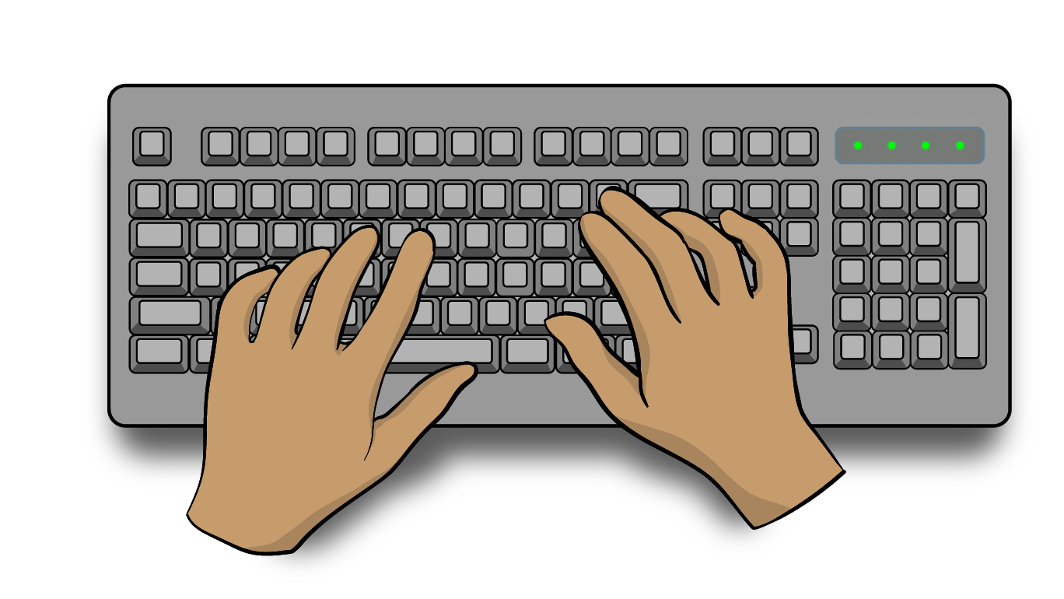
The Government can write a new law to replace the PPPR Act before it does these other reviews.

This information has been written by Te Aka Matua o te Ture | Law Commission.


It has been translated into Easy Read by the Make it Easy Kia Māmā Mai service of People First New Zealand Ngā Tāngata Tuatahi.

The ideas in this document are not the ideas of People First New Zealand Ngā Tāngata Tuatahi.

All images used in this Easy Read document are subject to copyright rules and cannot be used without permission.


Make it Easy uses images from:


- Photosymbols

- Change Images


- Huriana Kopeke-Te Aho

- SGC Image Works

- T Wood


- Studio Rebeko

- Inga Kramer.

