


How the law in Aotearoa

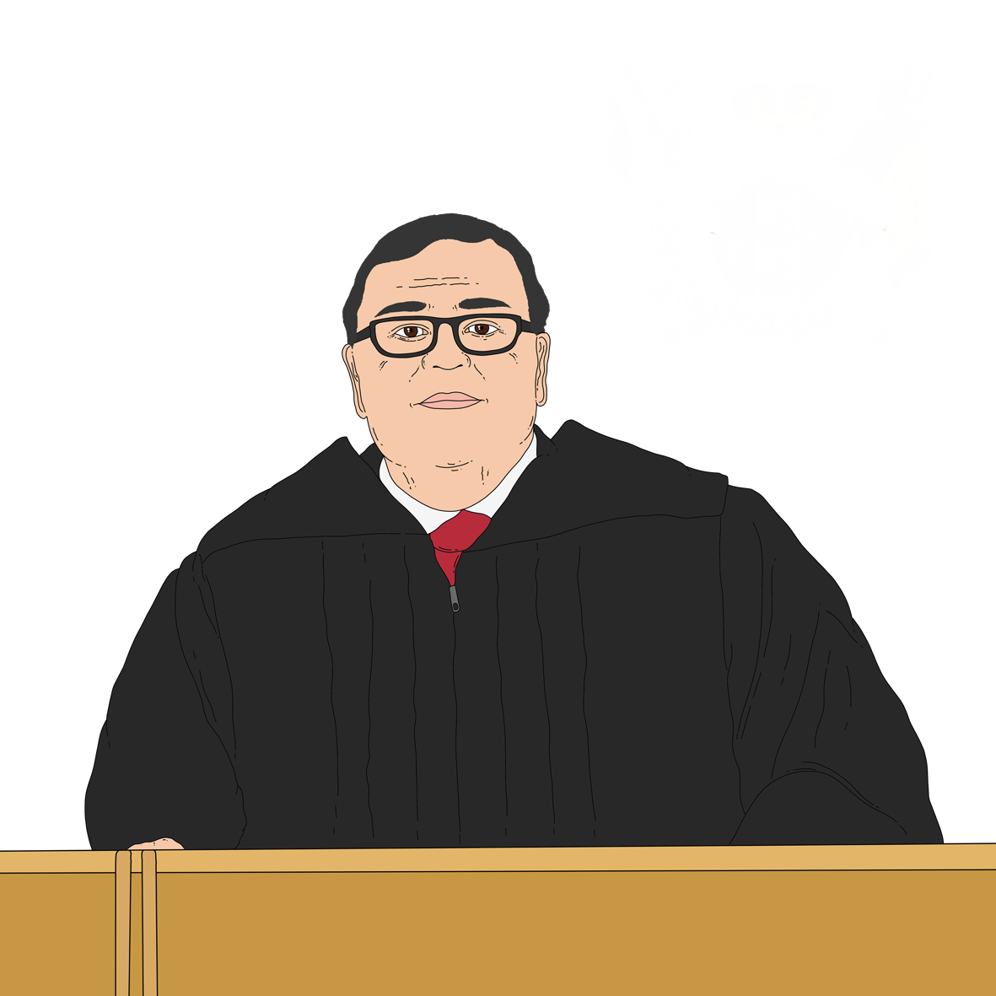
New Zealand should respond to
hate crime

Published: August 2026

Before you start


This information may upset some people when they are reading it.


If you are upset after reading this document you can talk to your:
whānau / family
friends.

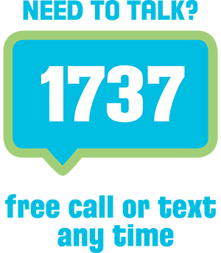
You can also contact Need to Talk by:
calling 1737


texting 1737

It does not cost any money to
call / text 1737.

This is a long document.

It can be hard for some people to read a document this long.

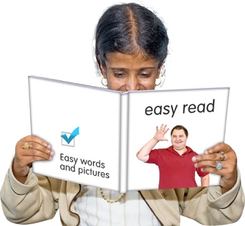
Some things you can do to make it easier are:
read it a few pages at a time
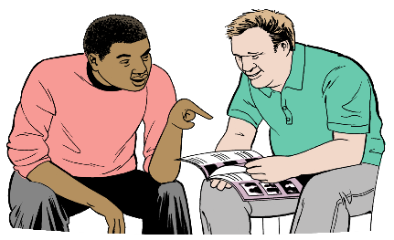
set aside some quiet time to look at it
have someone read it with you to support you to understand it.

What you will find in here


Page number:

About this Easy Read 5


What is hate crime? 8

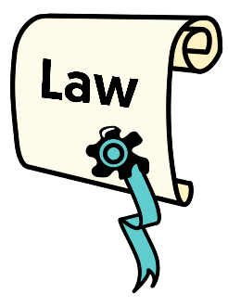
What the law says about hate
crime in Aotearoa New Zealand 17


What we know about hate crime
in Aotearoa New Zealand 21


Why we did this review 26


Page number:

What the review looked at 31


What problems did we find? 36
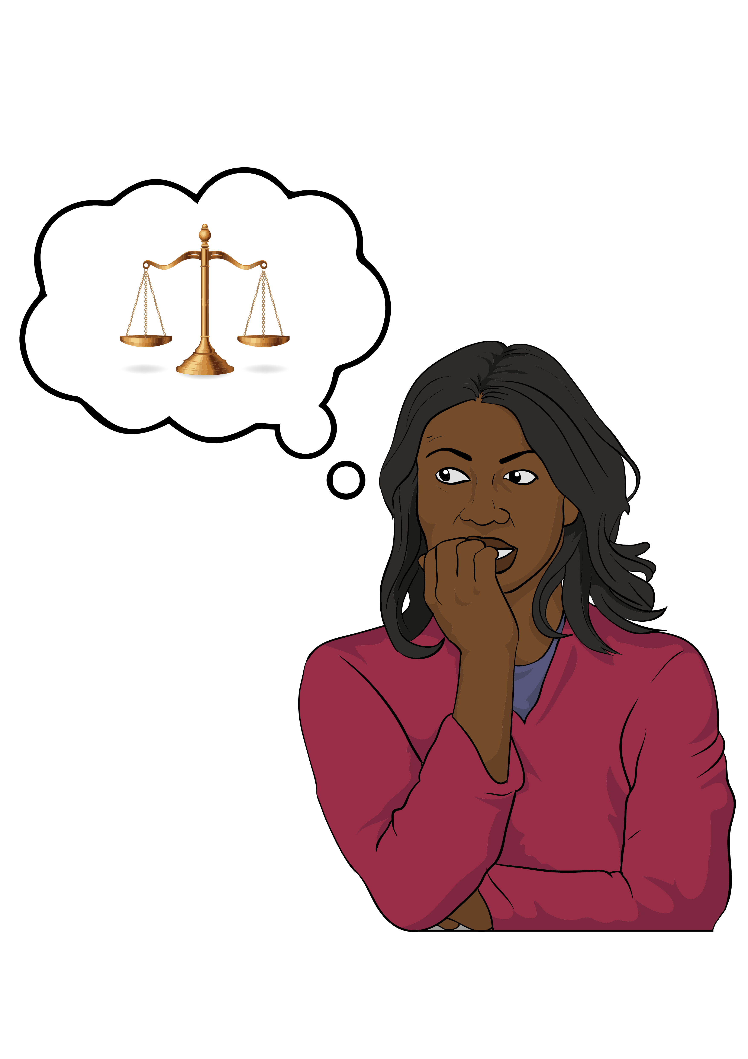

Why we do not think Aotearoa
New Zealand needs new
hate crime offences 40


Our recommendations 51


What happens next 62

About this Easy Read

This Easy Read is from Te Aka Matua o te Ture | Law Commission.

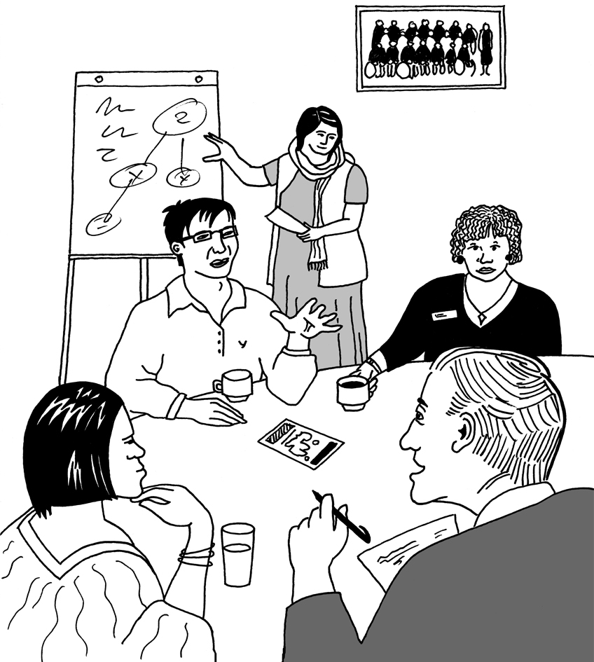
Te Aka Matua o te Ture | Law Commission is an organisation that:
does reviews of the law
tells the Government how to make the law better.

When you see the words
we / our / us in this Easy Read they mean Te Aka Matua o te Ture | Law Commission.

Law means the rules of Aotearoa New Zealand.


Here a review is when we:
look carefully at a part of the law

talk to people who know a lot of things about that part of the law
ask people what they think
about that part of the law
write a report about what we have found out.
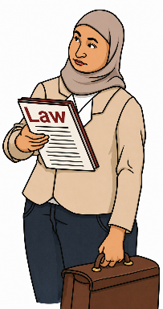

We have done review of the laws about hate crime in Aotearoa New Zealand.
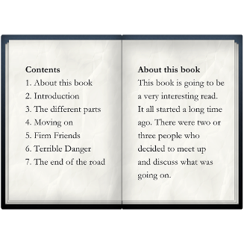

Pages 8 to 16 of this Easy Read tell you what hate crime is.

This Easy Read is a summary of the report we wrote about our review.


A summary:
is shorter than the full report
tells you the main ideas.


You can read the full report on this website:

https://tinyurl.com/2ptm22fe


The full report is not in Easy Read.

What is hate crime?

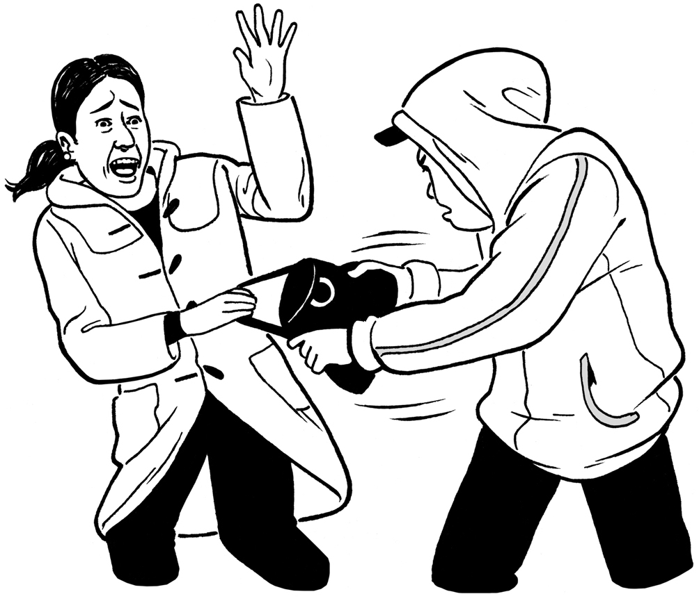
A crime is something that breaks
the law.

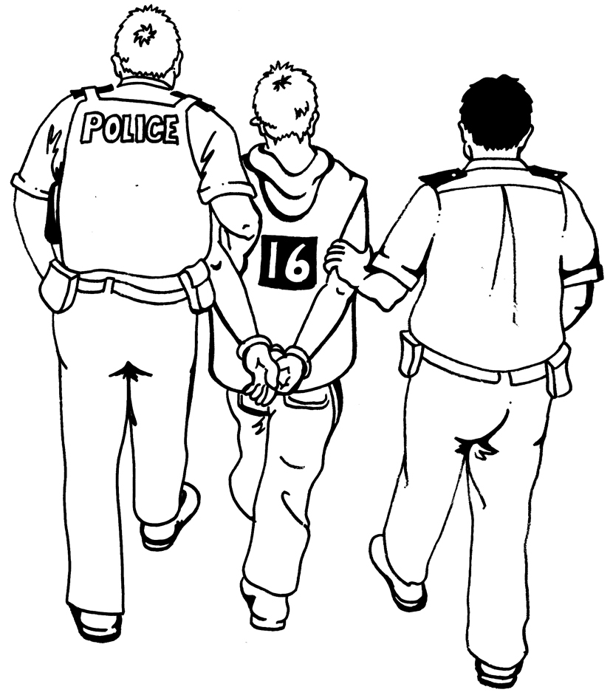
For example stealing things is a crime.

When someone does a crime this is called committing a crime.

A hate crime is when:
someone commits a crime
because
they have hostility towards a group of people with a
protected characteristic.

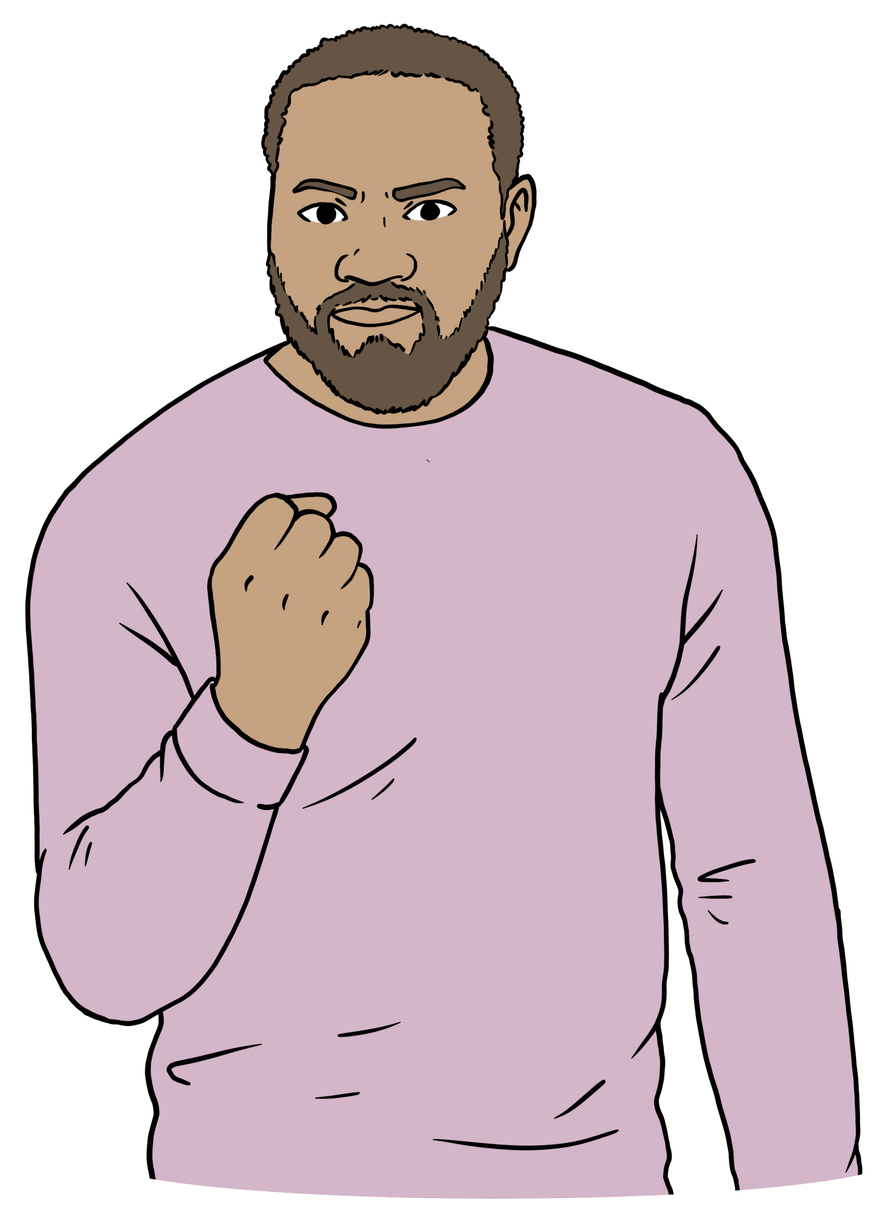
Having hostility towards a group of people means hating that group of people.


Here a protected characteristic is something that is the same about a group of people like their:
race

religion
sexual orientation
gender
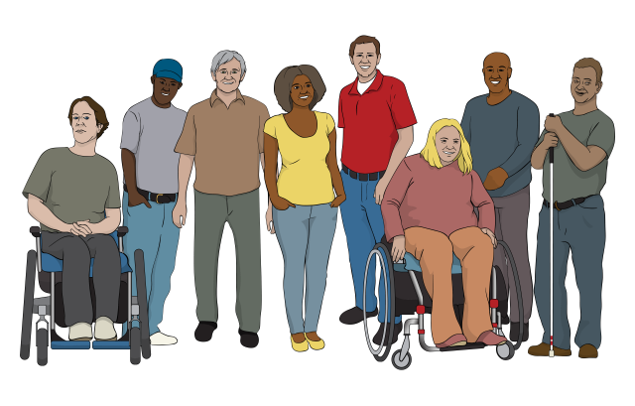
age
disability.


Race is a way of talking about a group of people whose bodies are the same in some way like having
the same skin colour.

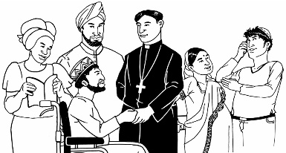
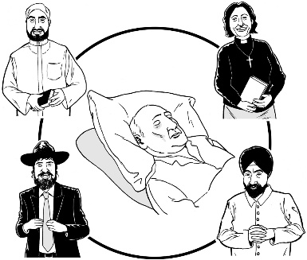
A religion is a group of people who believe similar things about ideas like:
if there is a god or gods
what happens after we die.


Some examples of religions are:
Christianity
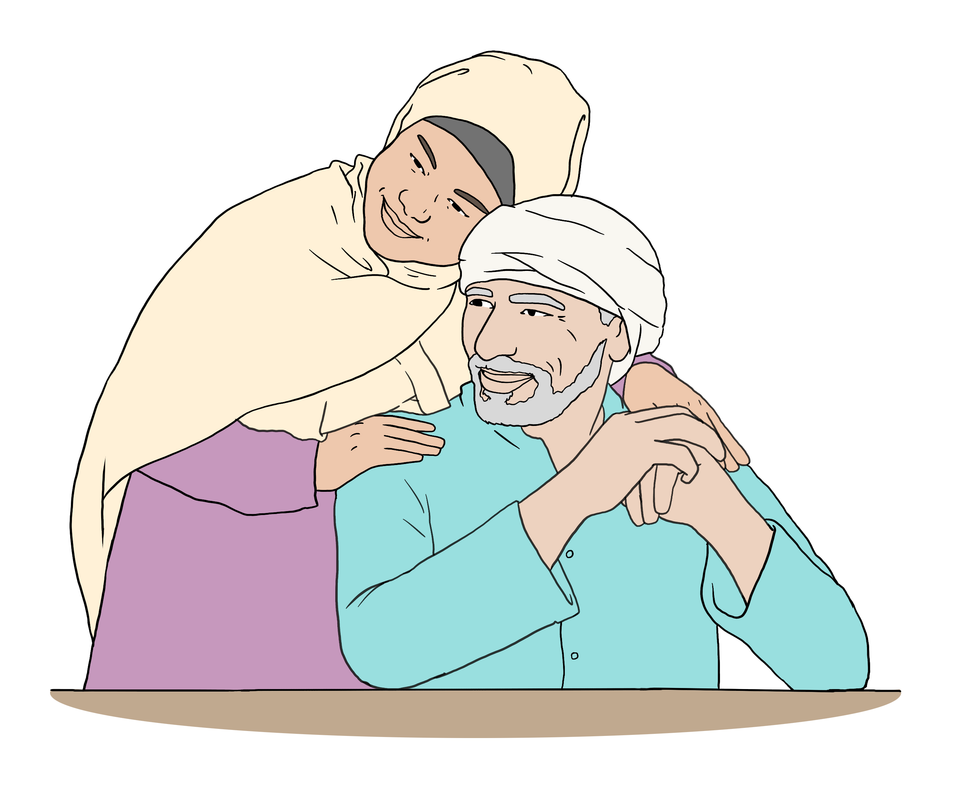
Hinduism
Islam.


Your sexual orientation is things like:
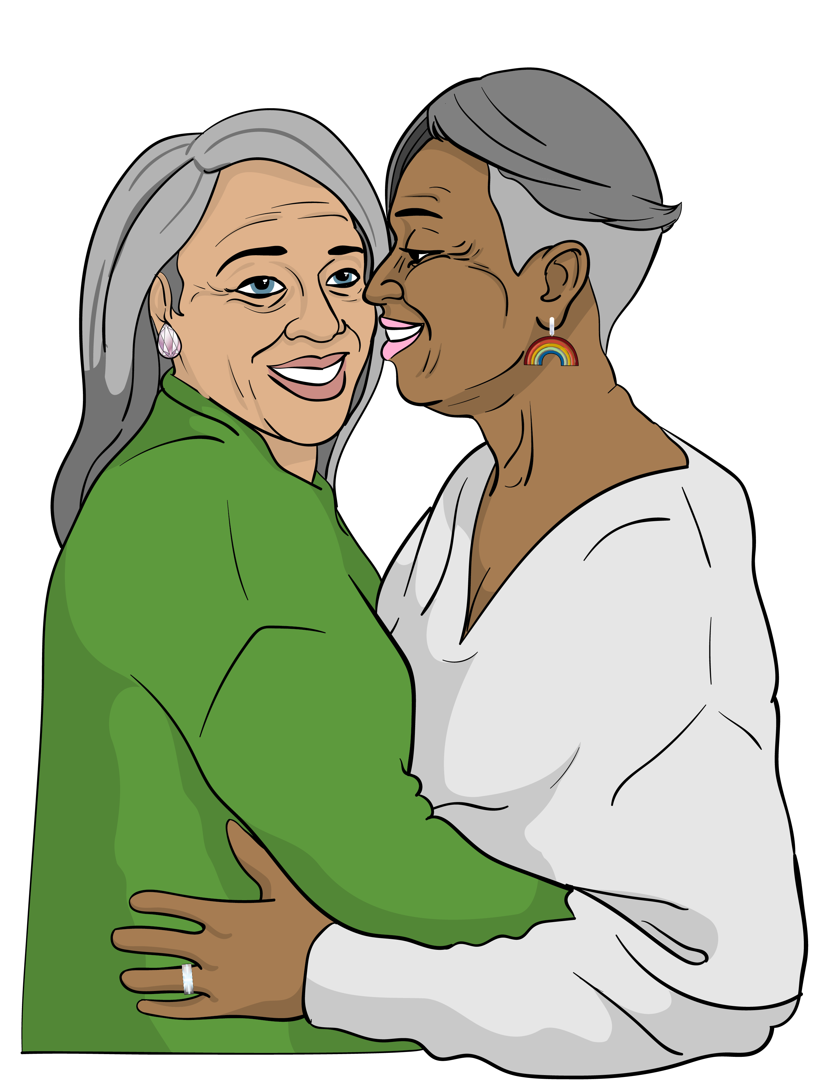
who you are attracted to
who you want to be in a relationship with
if you want to be in a
relationship or not.


Gender is if you are:
a man
a woman
another gender like nonbinary.


Some examples of hate crimes are someone:
hurting you because of your religion
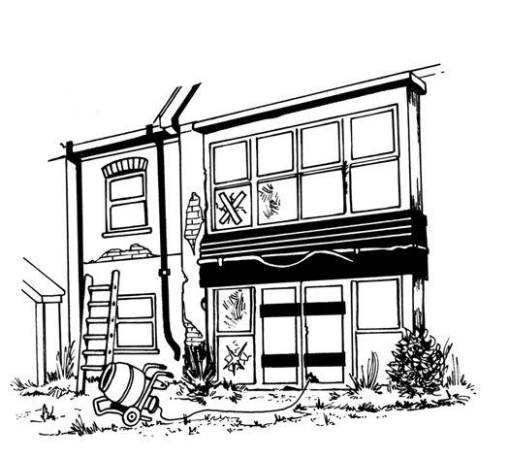
hitting you because you are disabled
damaging your house because you are gay.


Hate crime causes harm in lots of ways.

This is why the law sees hate crime as worse than other crimes.
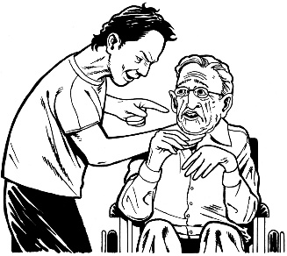

Hate crime harms the victim of the crime.

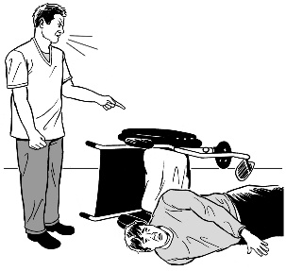
A victim is the person a crime was done to.

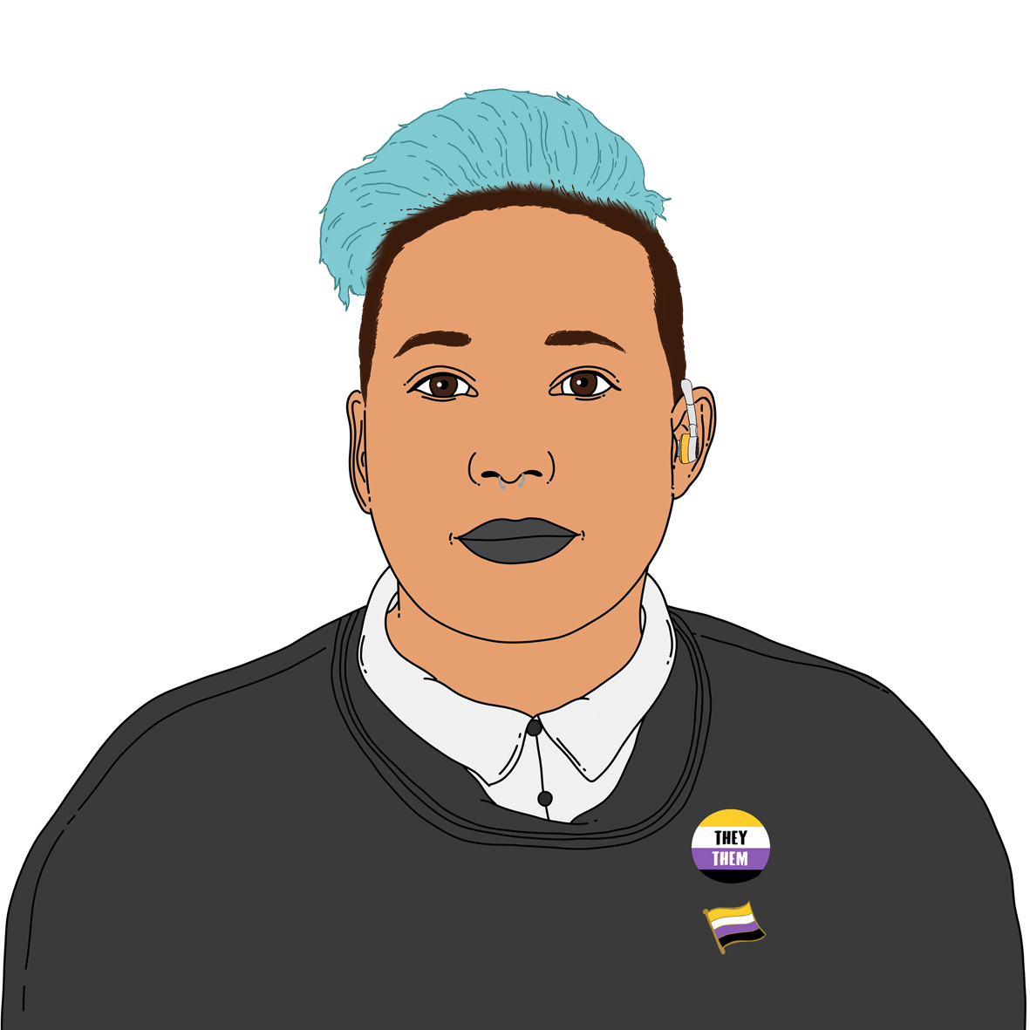
People who commit hate crimes hurt their victims because of things that make a person who they are like their:

religion
gender
race.


Victims of hate crime often feel scared for a long time after the crime happens.
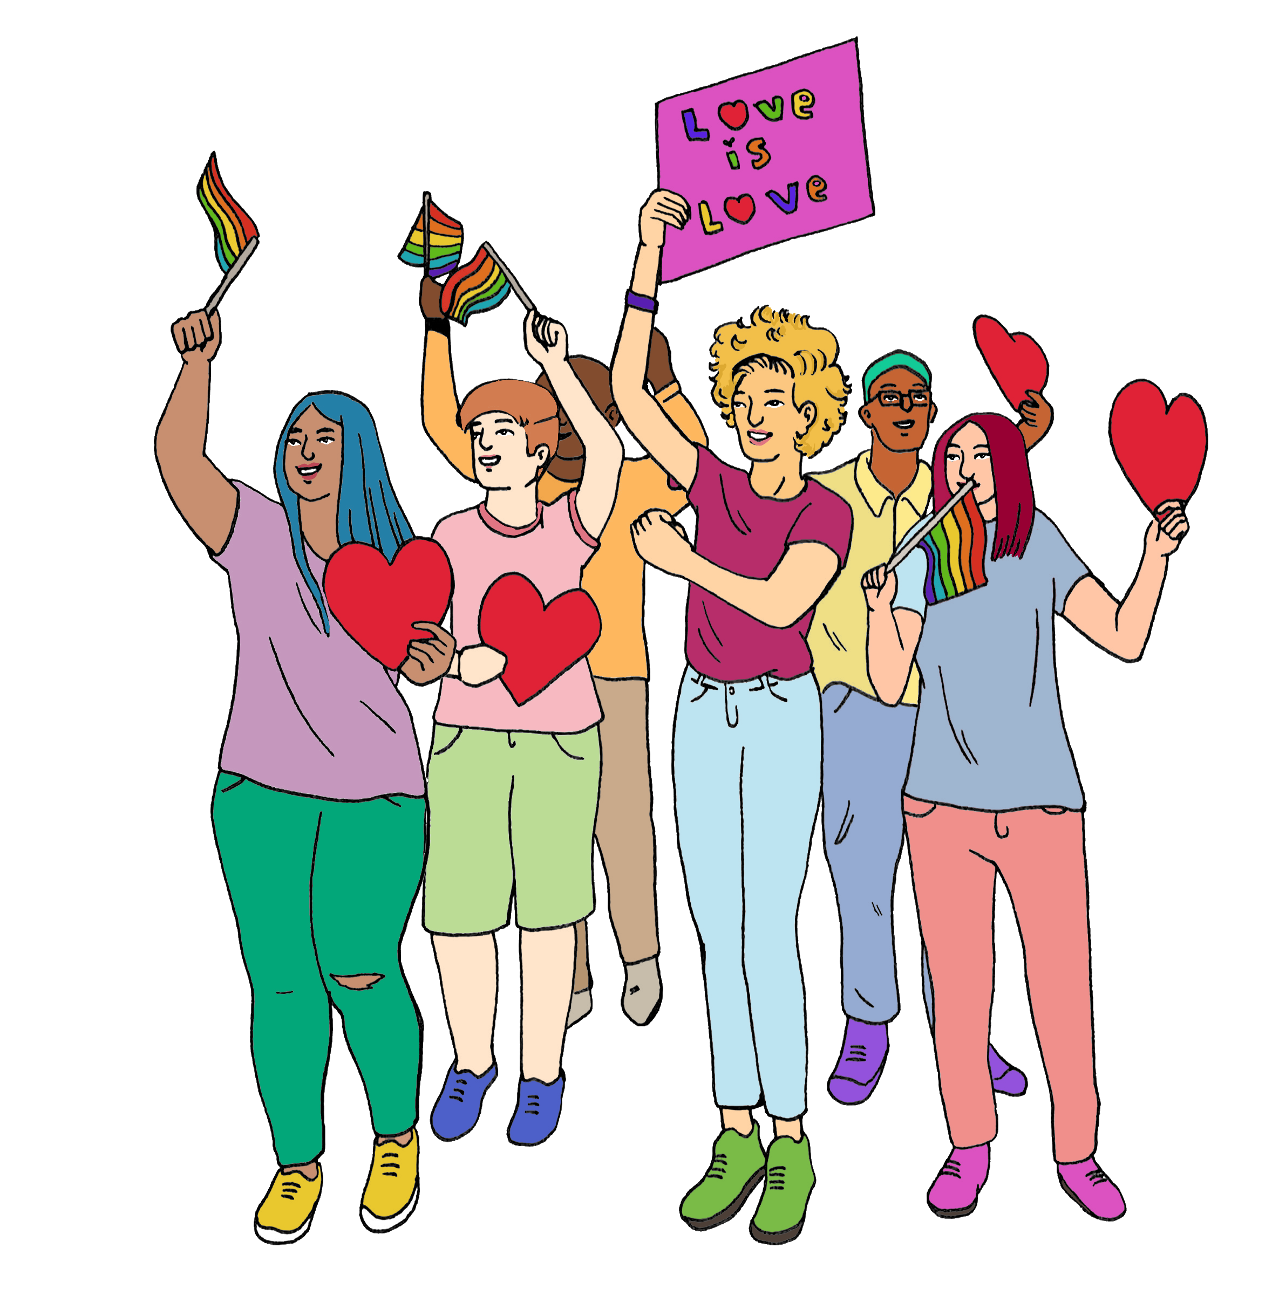

Hate crime harms communities.


Here communities are groups of people who have something the same about them like belonging to the same:
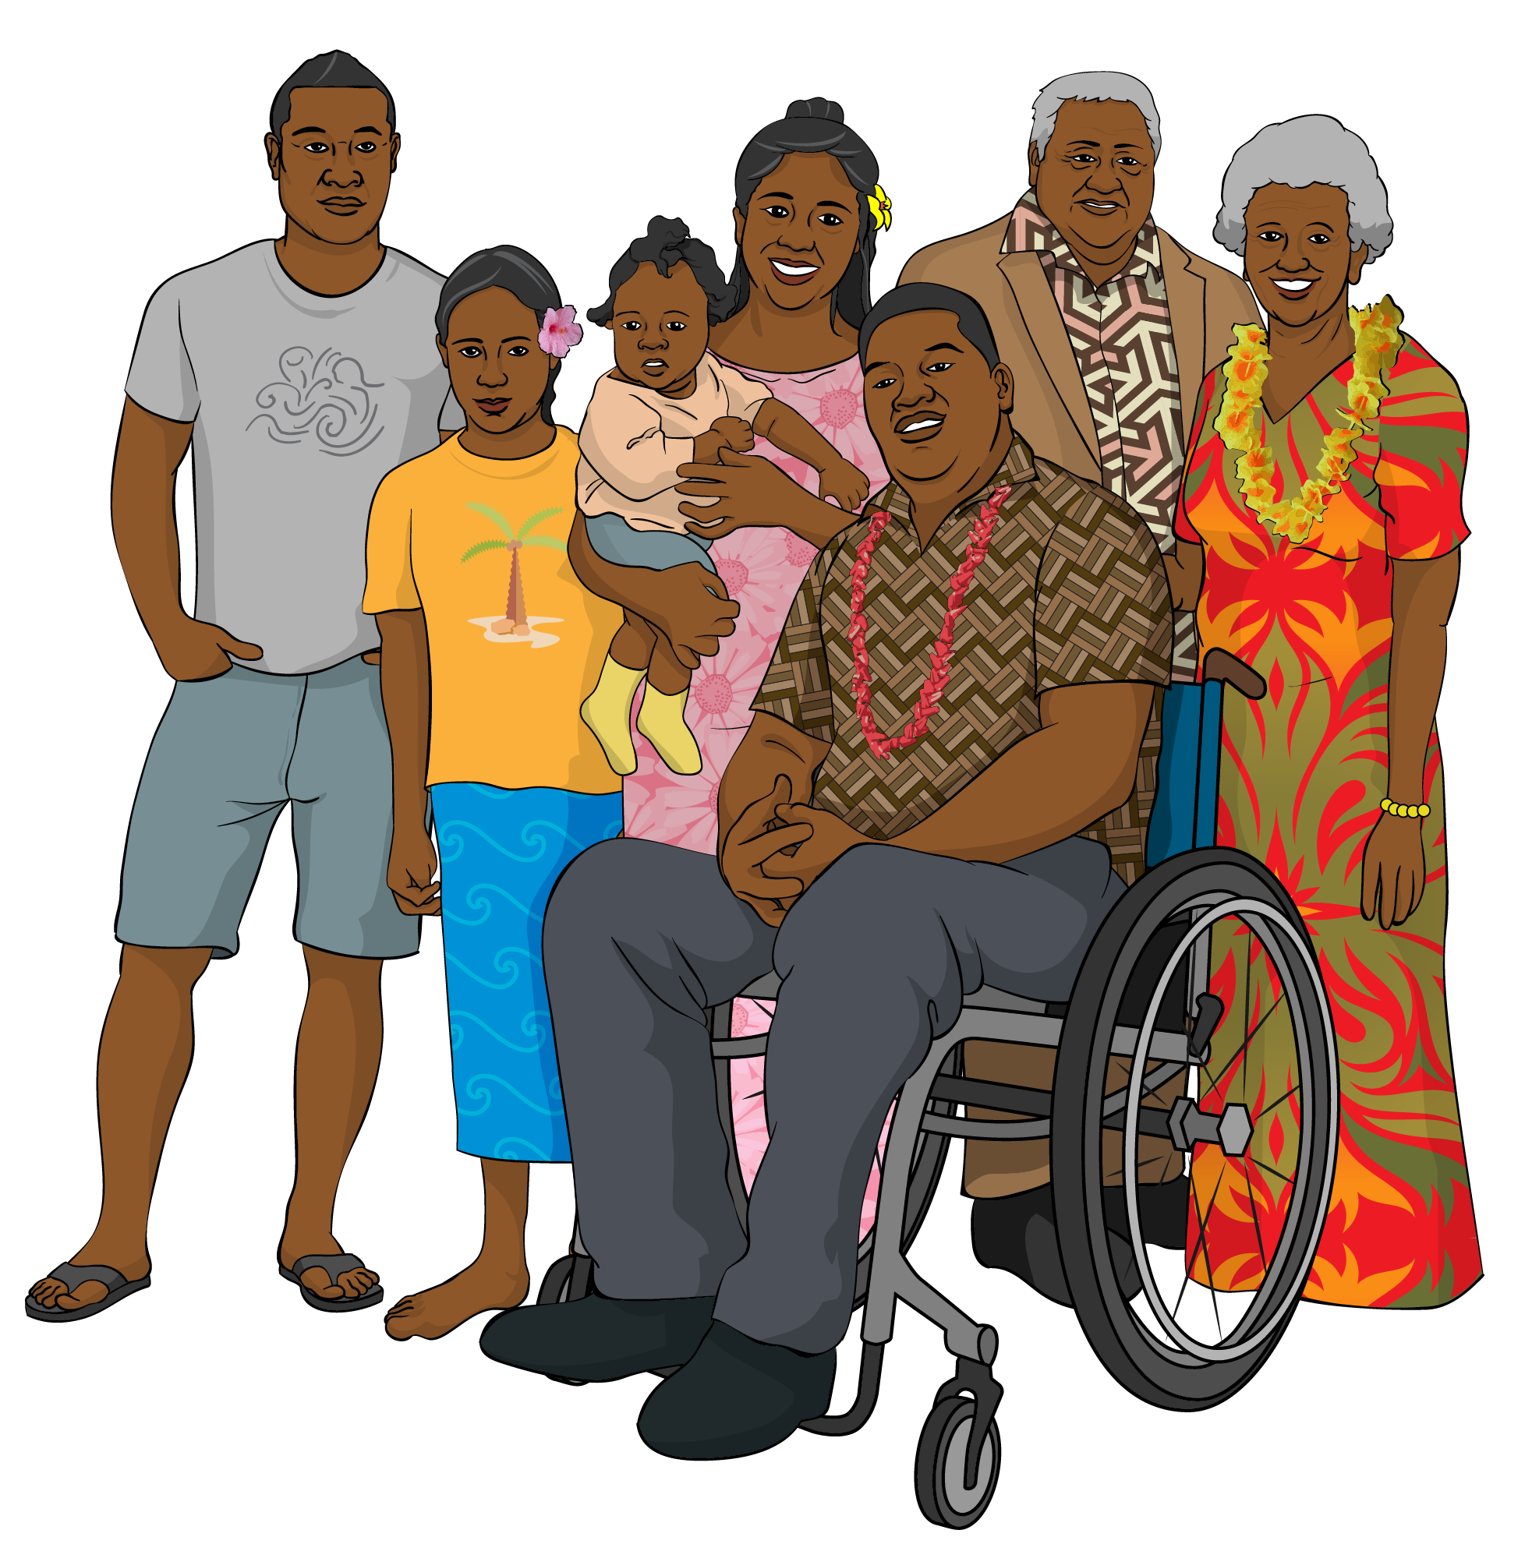
religion
race.



Hate crimes tell communities that they are not safe in Aotearoa New Zealand.


This can make members of these communities feel:
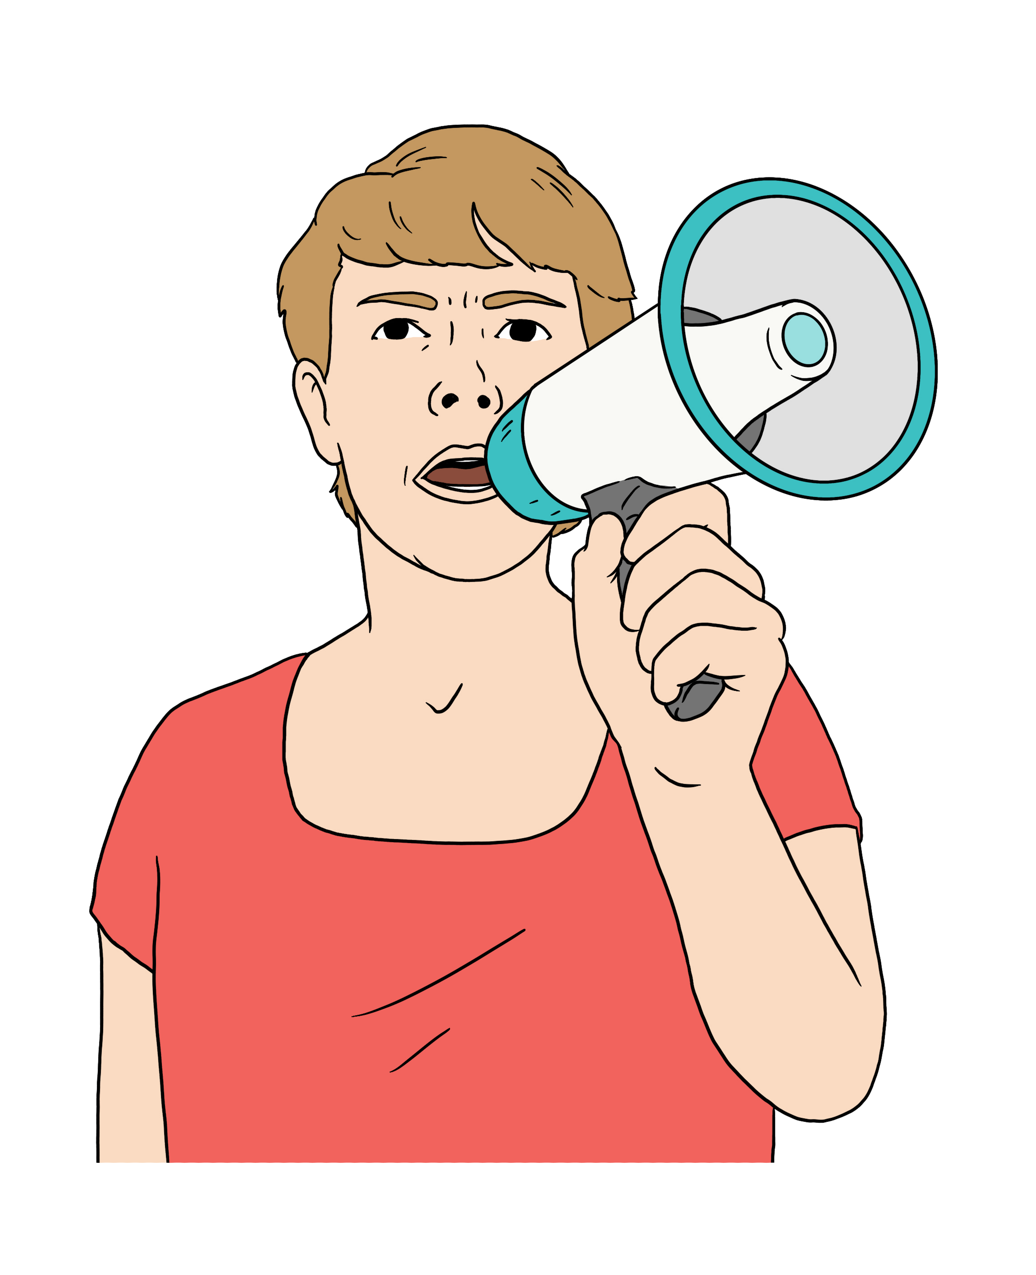
scared
angry
like they cannot:

- speak up for themselves
- do things that are important to them like wearing a headscarf.

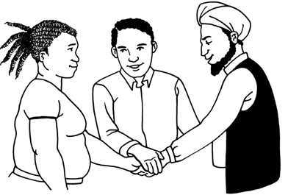
Hate crime harms everyone by making:
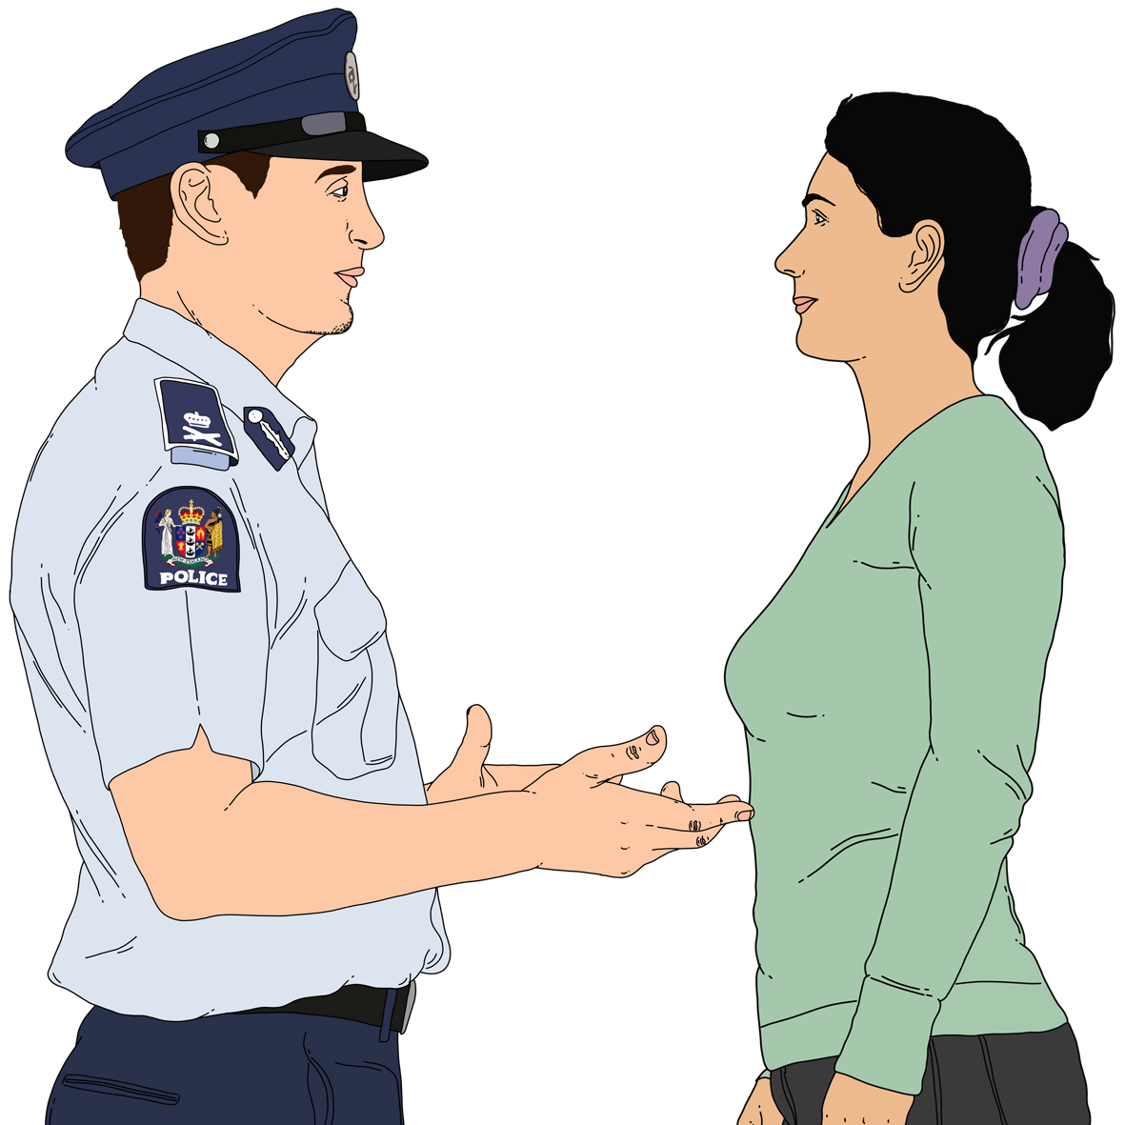
it harder for different communities to work together
people trust groups to do with the law less like the:
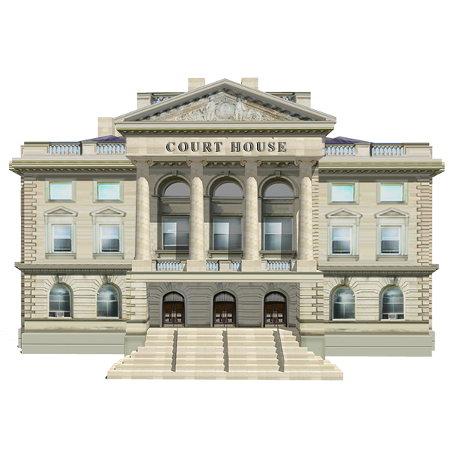
- police
- courts.

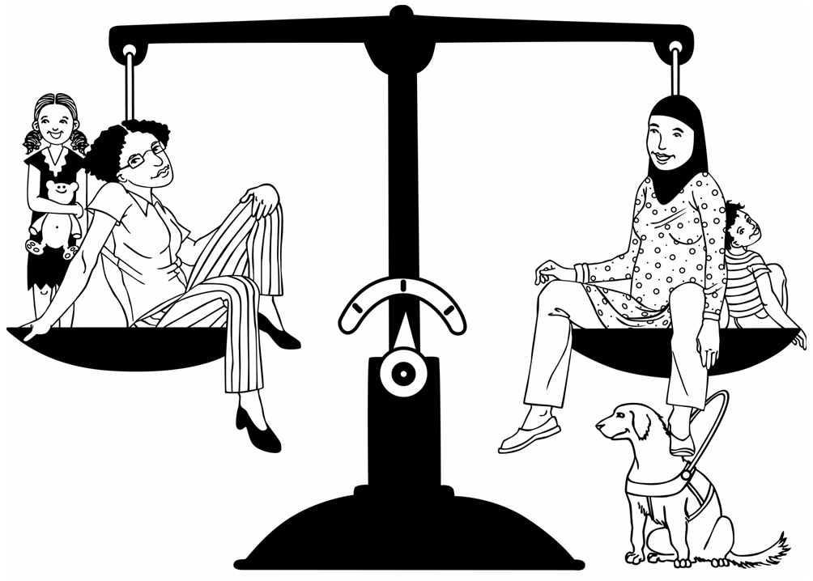
Many New Zealanders think it is important to:

treat everyone the same
be kind to everyone
respect what other people think.


People who do hate crimes do not believe in these things.

What the law says about hate crime in Aotearoa New Zealand

At the moment Aotearoa New Zealand does not have hate crime offences.

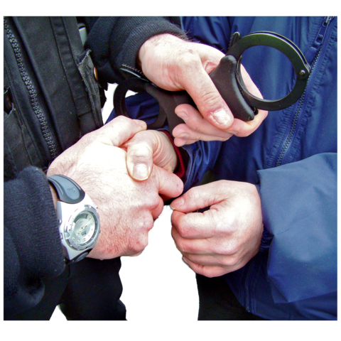
Offence is the word the law uses to name crimes.

If you break the law you can be charged with an offence.
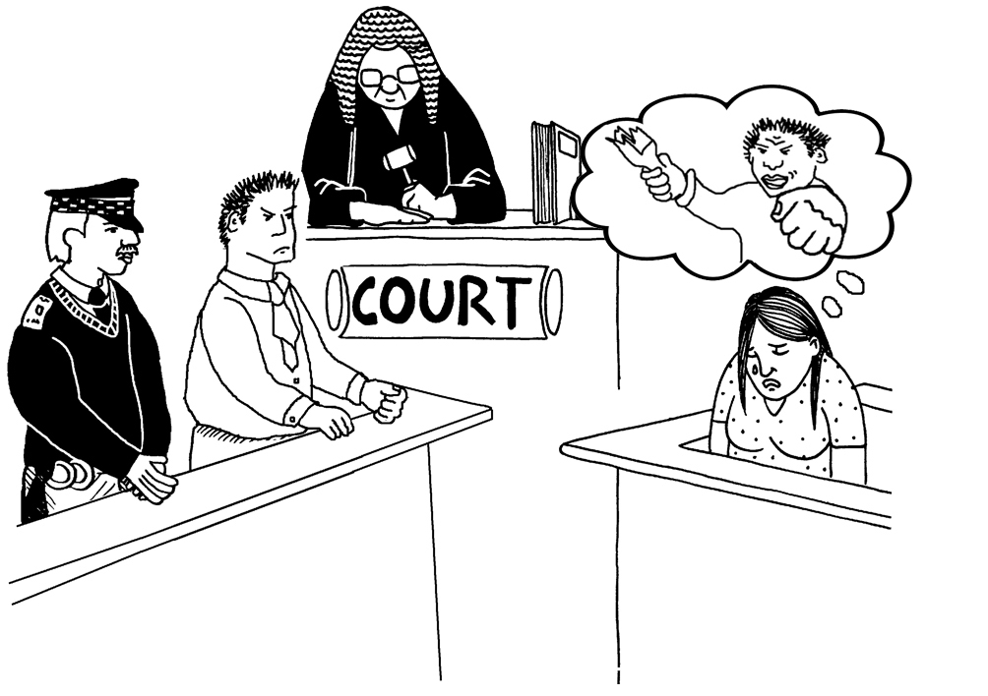

For example if you kill someone you could be charged with the offence of murder.

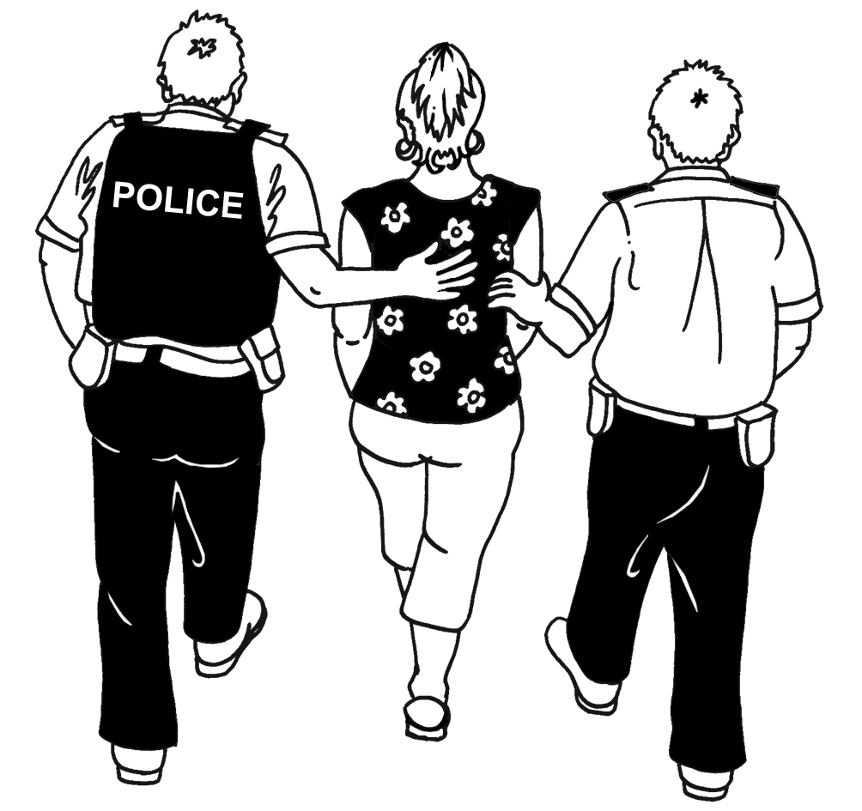
At the moment the law uses other offences when people commit hate crimes.

For example hitting someone is an offence called assault.

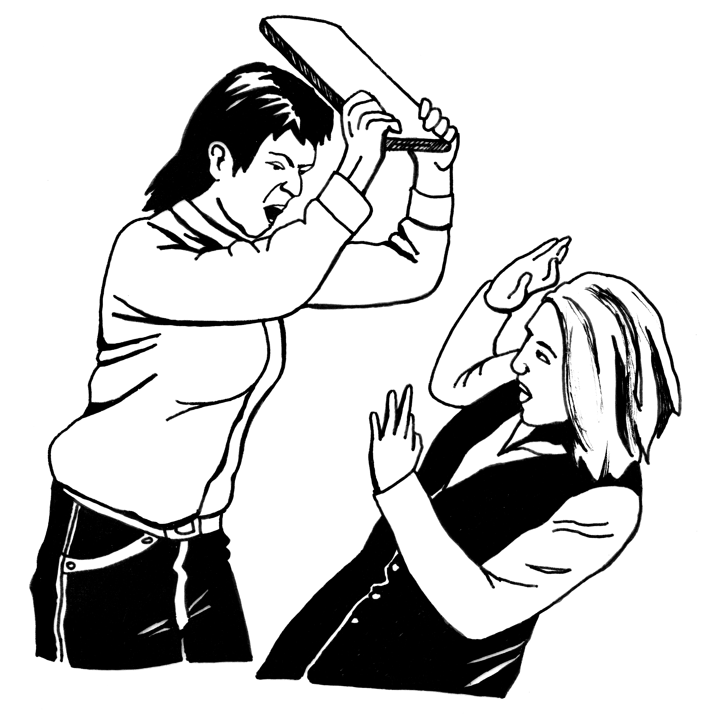
If the reason why you hit someone is that you have hostility towards that group of people you will still be charged with assault.

The court looks at the reasons why someone committed the offence when it is sentencing them.

Sentencing is when a judge tells a person how they will be punished for committing a crime.

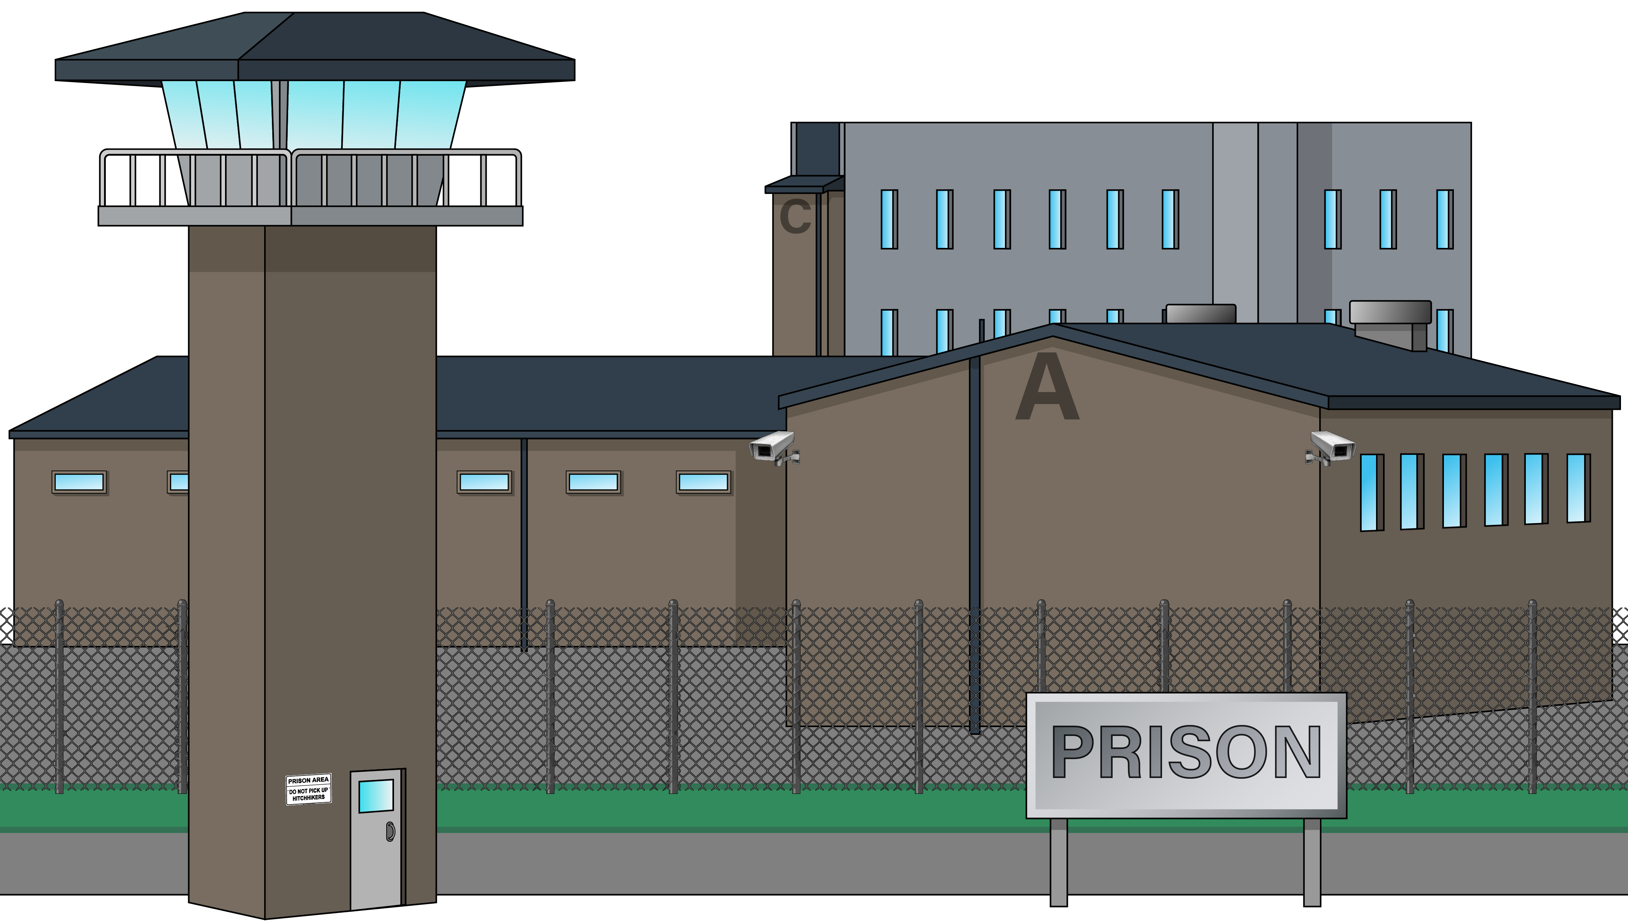
For example if you murder someone you will be sentenced to spend time in jail.


The court can punish someone more if it decides that hostility towards a group of people was the reason why the person committed the offence.


For example the court might say you have to spend longer in jail if the reason why you hit someone is that you have hostility towards that group of people.


We think the law needs to:
punish people properly when they commit a hate crime

tell everyone that hate crime is not okay
stop hate crime from happening
show communities that the law will protect them from hate crime.

What we know about hate crime in Aotearoa New Zealand


We do not have good data about hate crime in Aotearoa New Zealand.

Data means information like:
facts
numbers.

We know that hate crime does happen in Aotearoa New Zealand.


The police started clearly recording if they believe a crime is a hate crime in 2019.

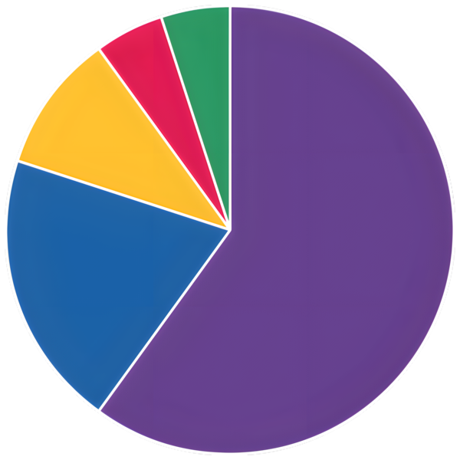
The information from the police shows that less than 1 out of every
1 hundred crimes that people tell police about could be a hate crime.


The police recorded more hate crimes in 2025 than in 2021.


We do not know if there actually were more hate crimes in 2025 than in 2021.

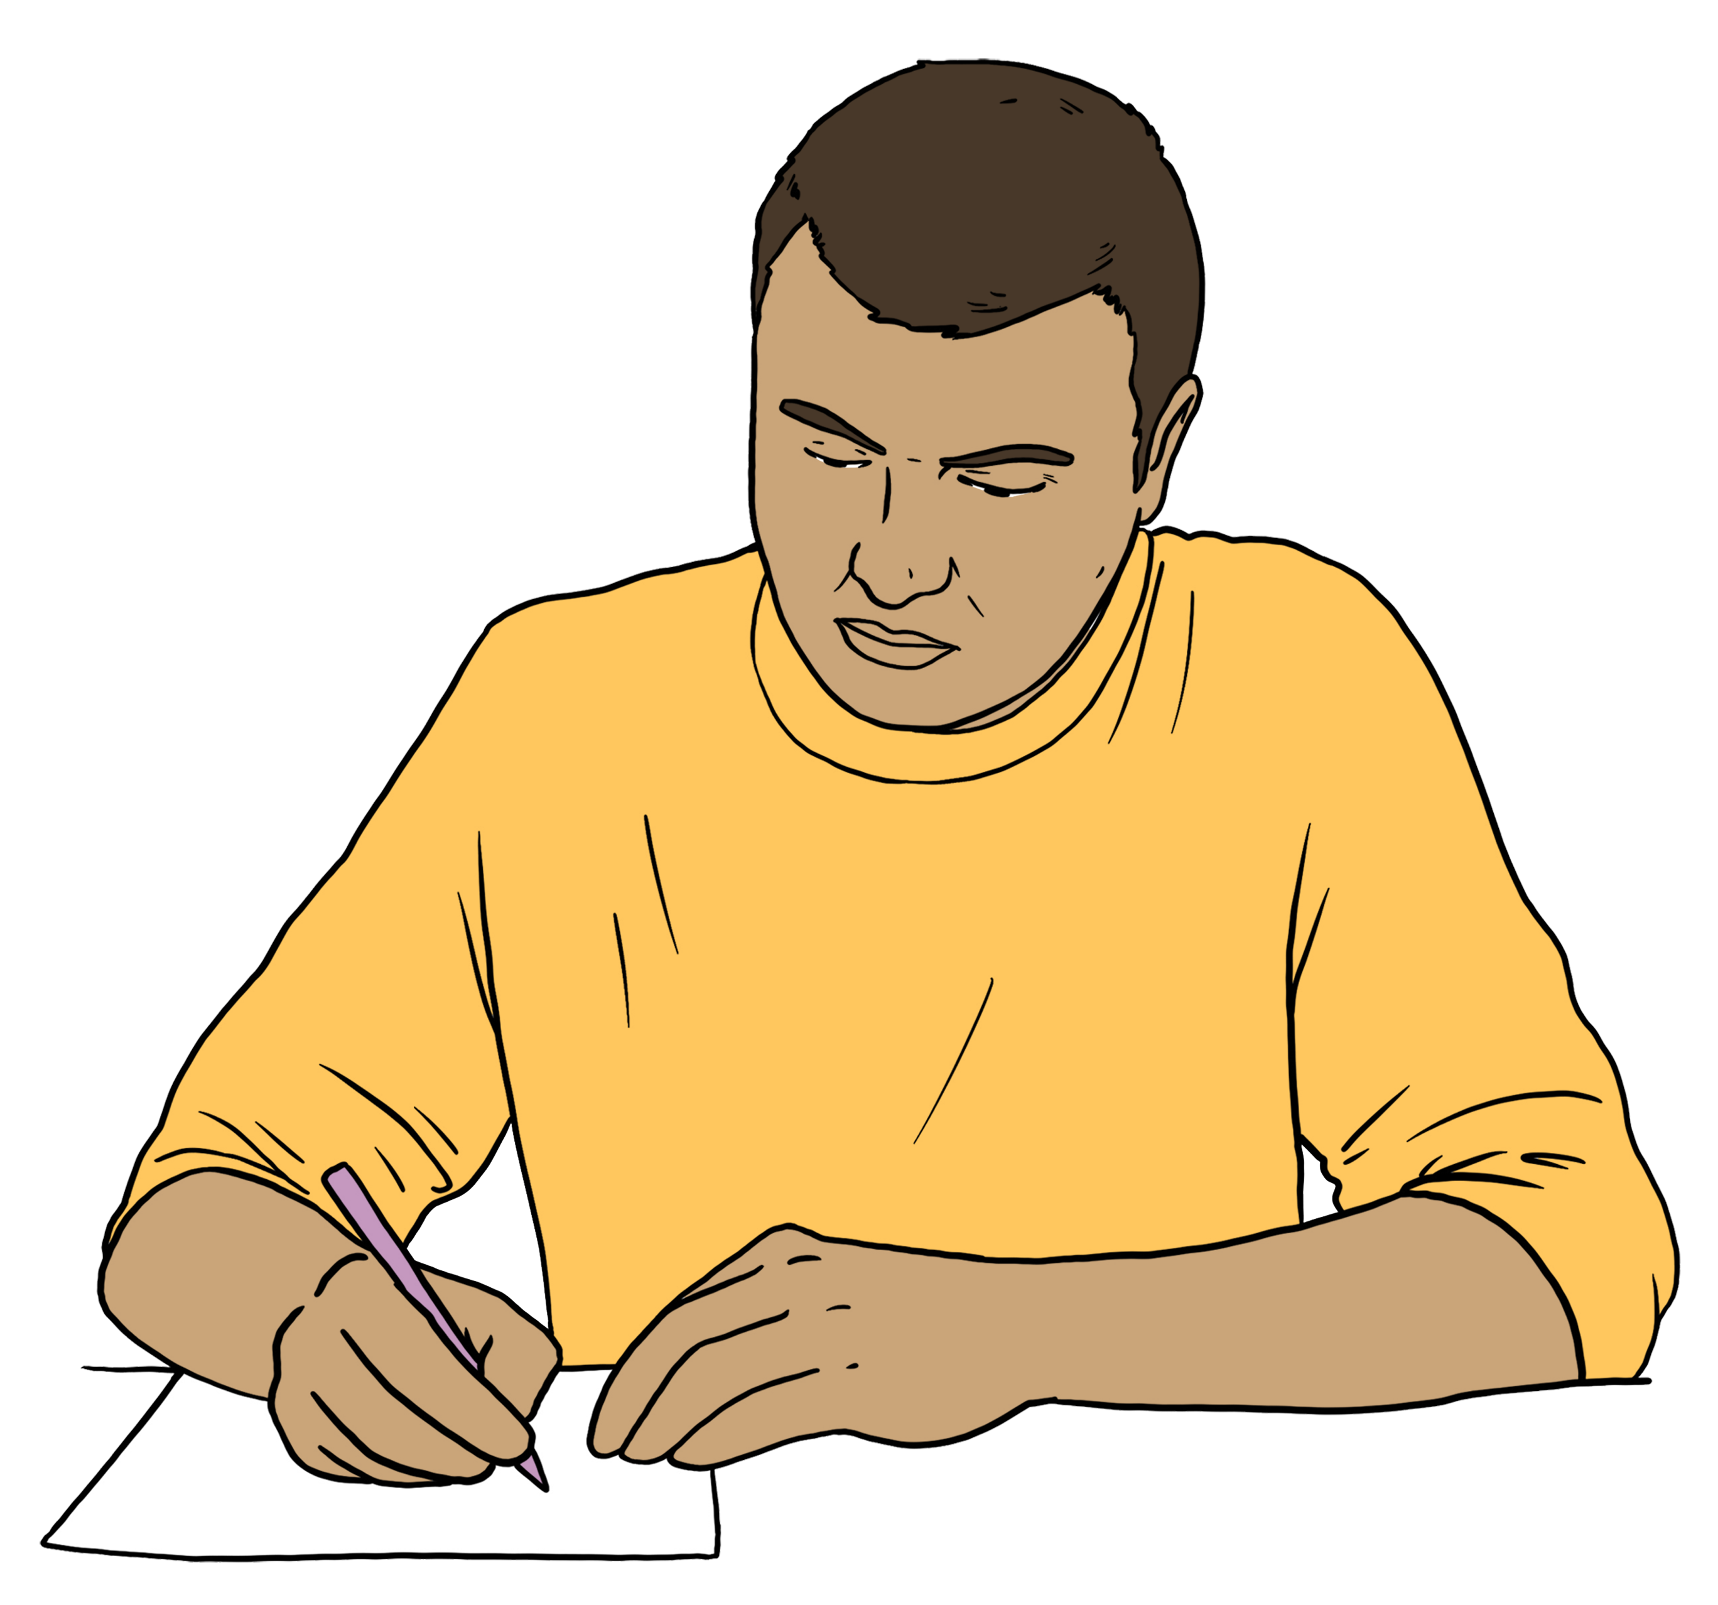
The police doing a better job of recording hate crimes could explain why the numbers were higher in 2025.

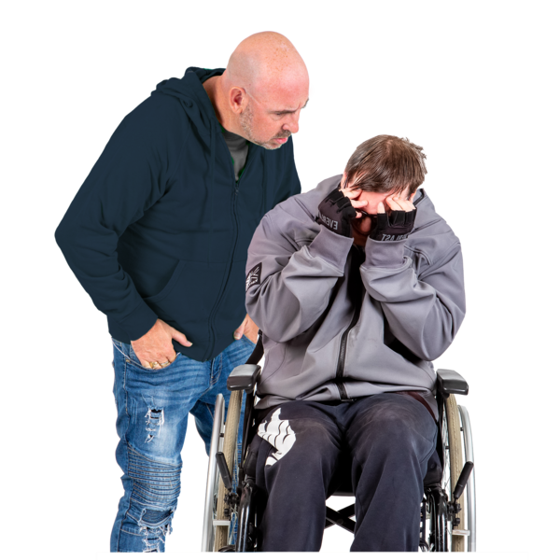
The most common types of hate crimes were:
harassment and threatening behaviour
public disorder
assaults
property damage.


Harassment and threatening behaviour is when someone
does / says something that makes the victim feel scared.

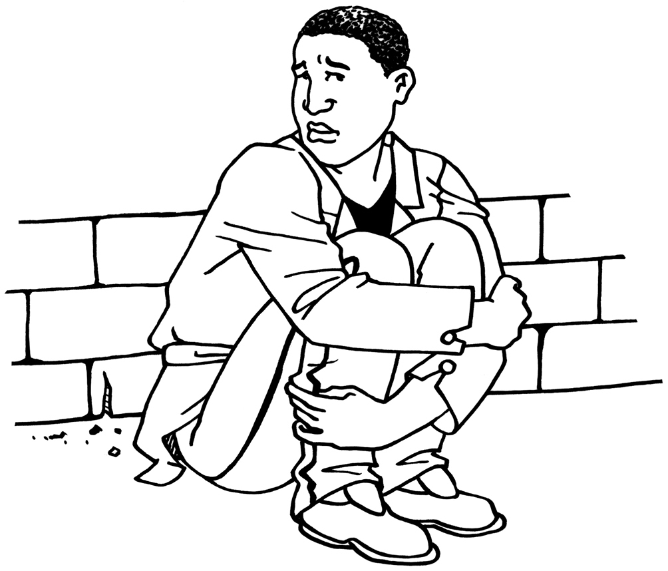
Public disorder is when someone does something in a public place that:
upsets other people
makes other people feel scared.
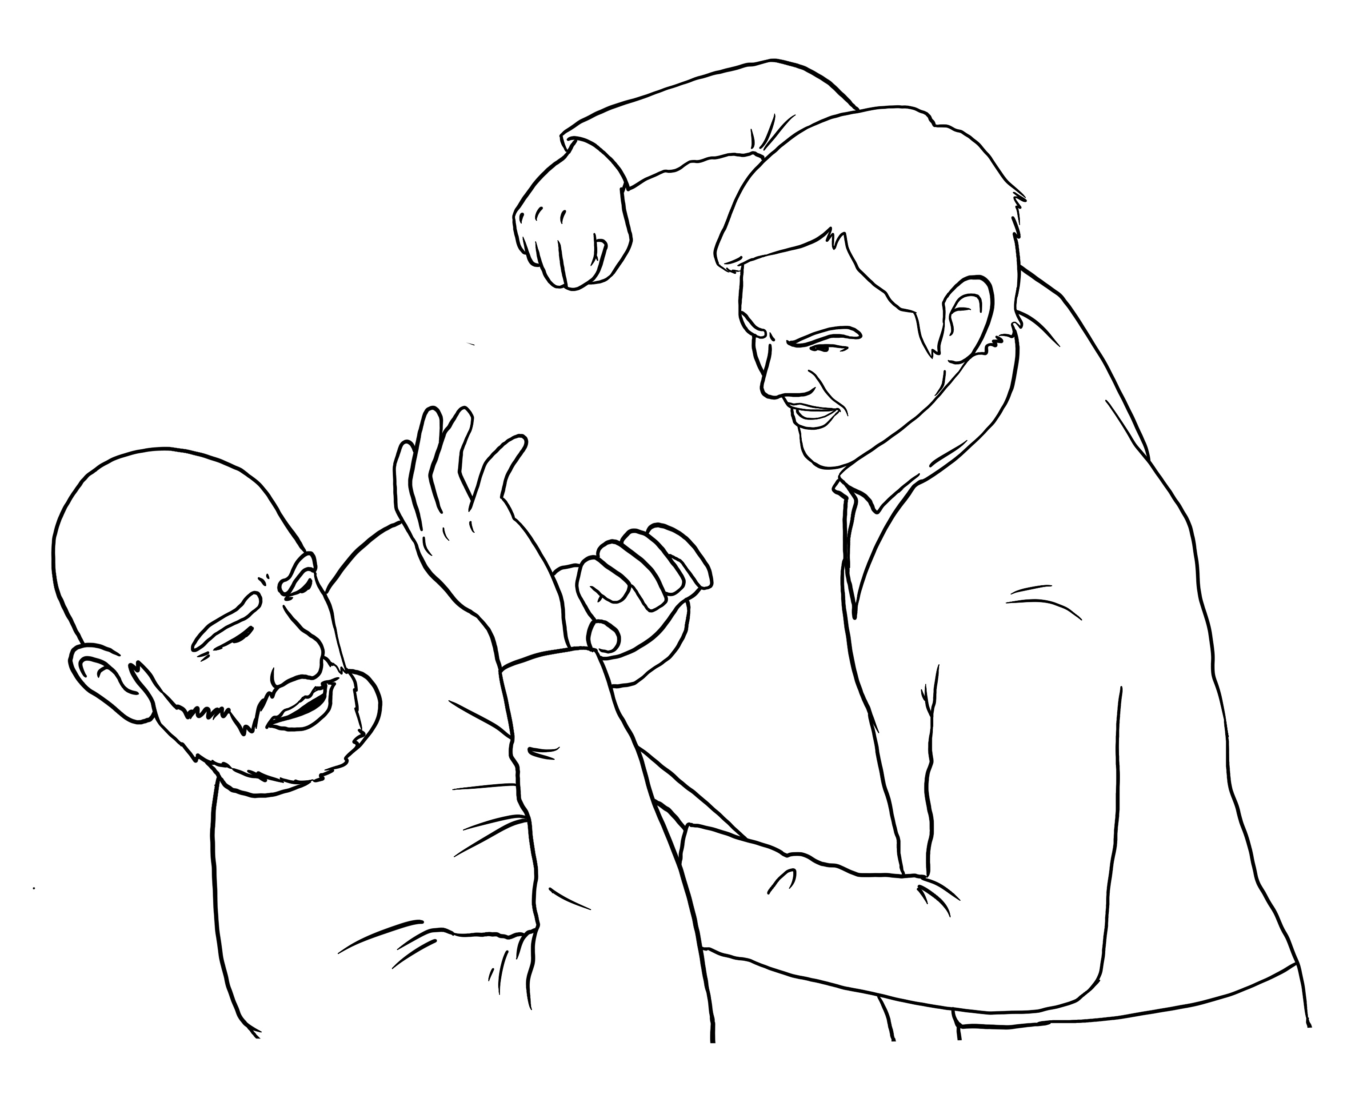
Assault is when someone physically hurts another person like by hitting them.

Property damage is when someone attacks something that another person owns like by smashing the windows of their house.

Hostility towards a person based on their race is the most common reason why hate crime occurs.

Another common reason why hate crime occurs is hostility towards a person based on their:
religion
sexual orientation.

We know many hate crimes do not get reported to the police.

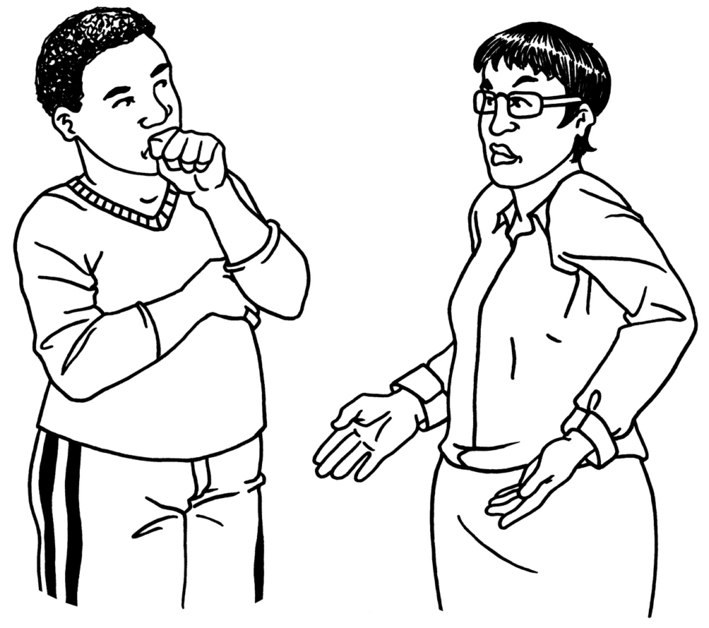
This means police records cannot tell us everything we need to know about hate crime in Aotearoa New Zealand.

Why we did this review



The Government asked us to do this review in March 2024.

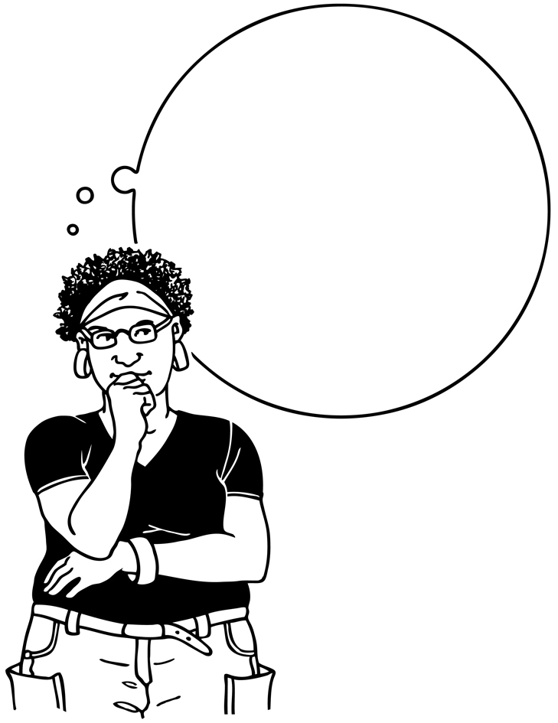
The Government wanted to know:
how the law in Aotearoa New Zealand deals with hate crime
if there should be new laws to say what counts as a hate crime.


In 2019 a terrorist attacked masjidain in Christchurch.


A terrorist is someone who:

commits a crime because of their:
- religious beliefs
- political beliefs
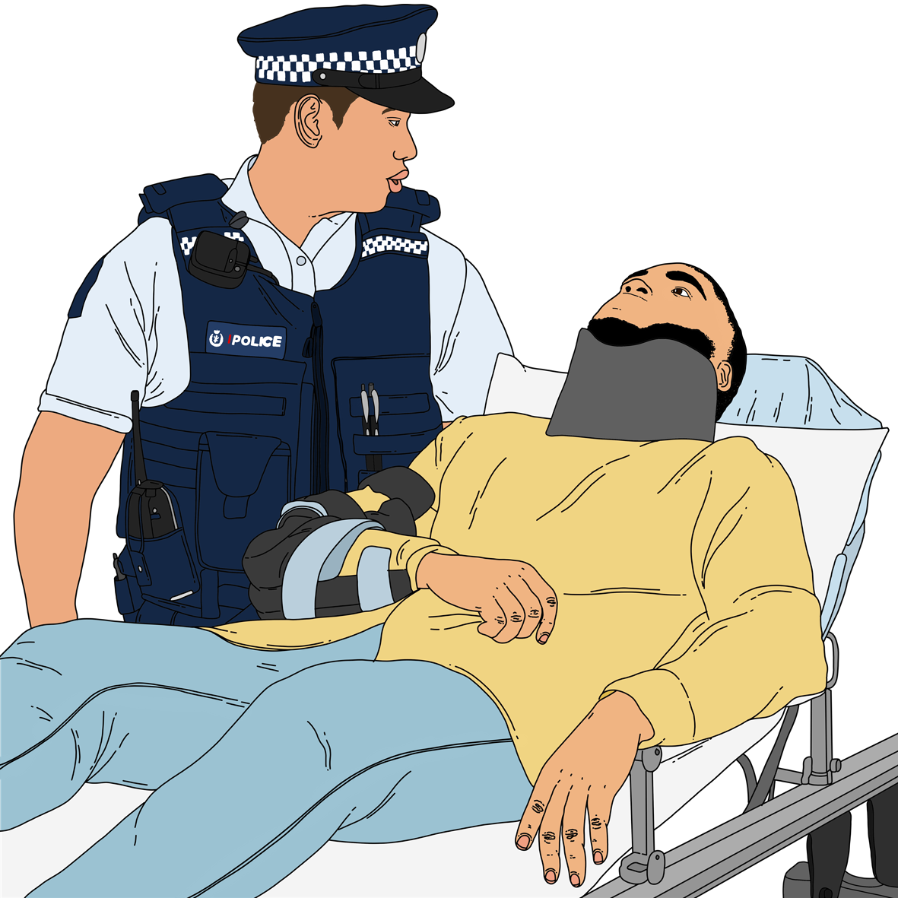
- other beliefs
hopes their crime will:
- hurt people
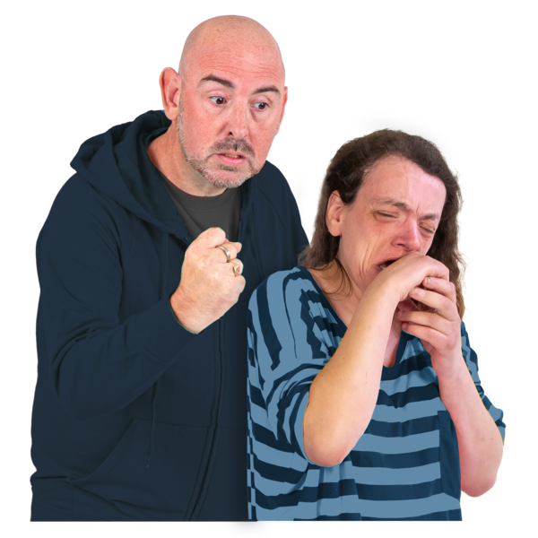
- make people scared
- make the Government do things differently.


Masjidain are places where
Muslims go to worship / be part of their community.

Masjidain are also called mosques.
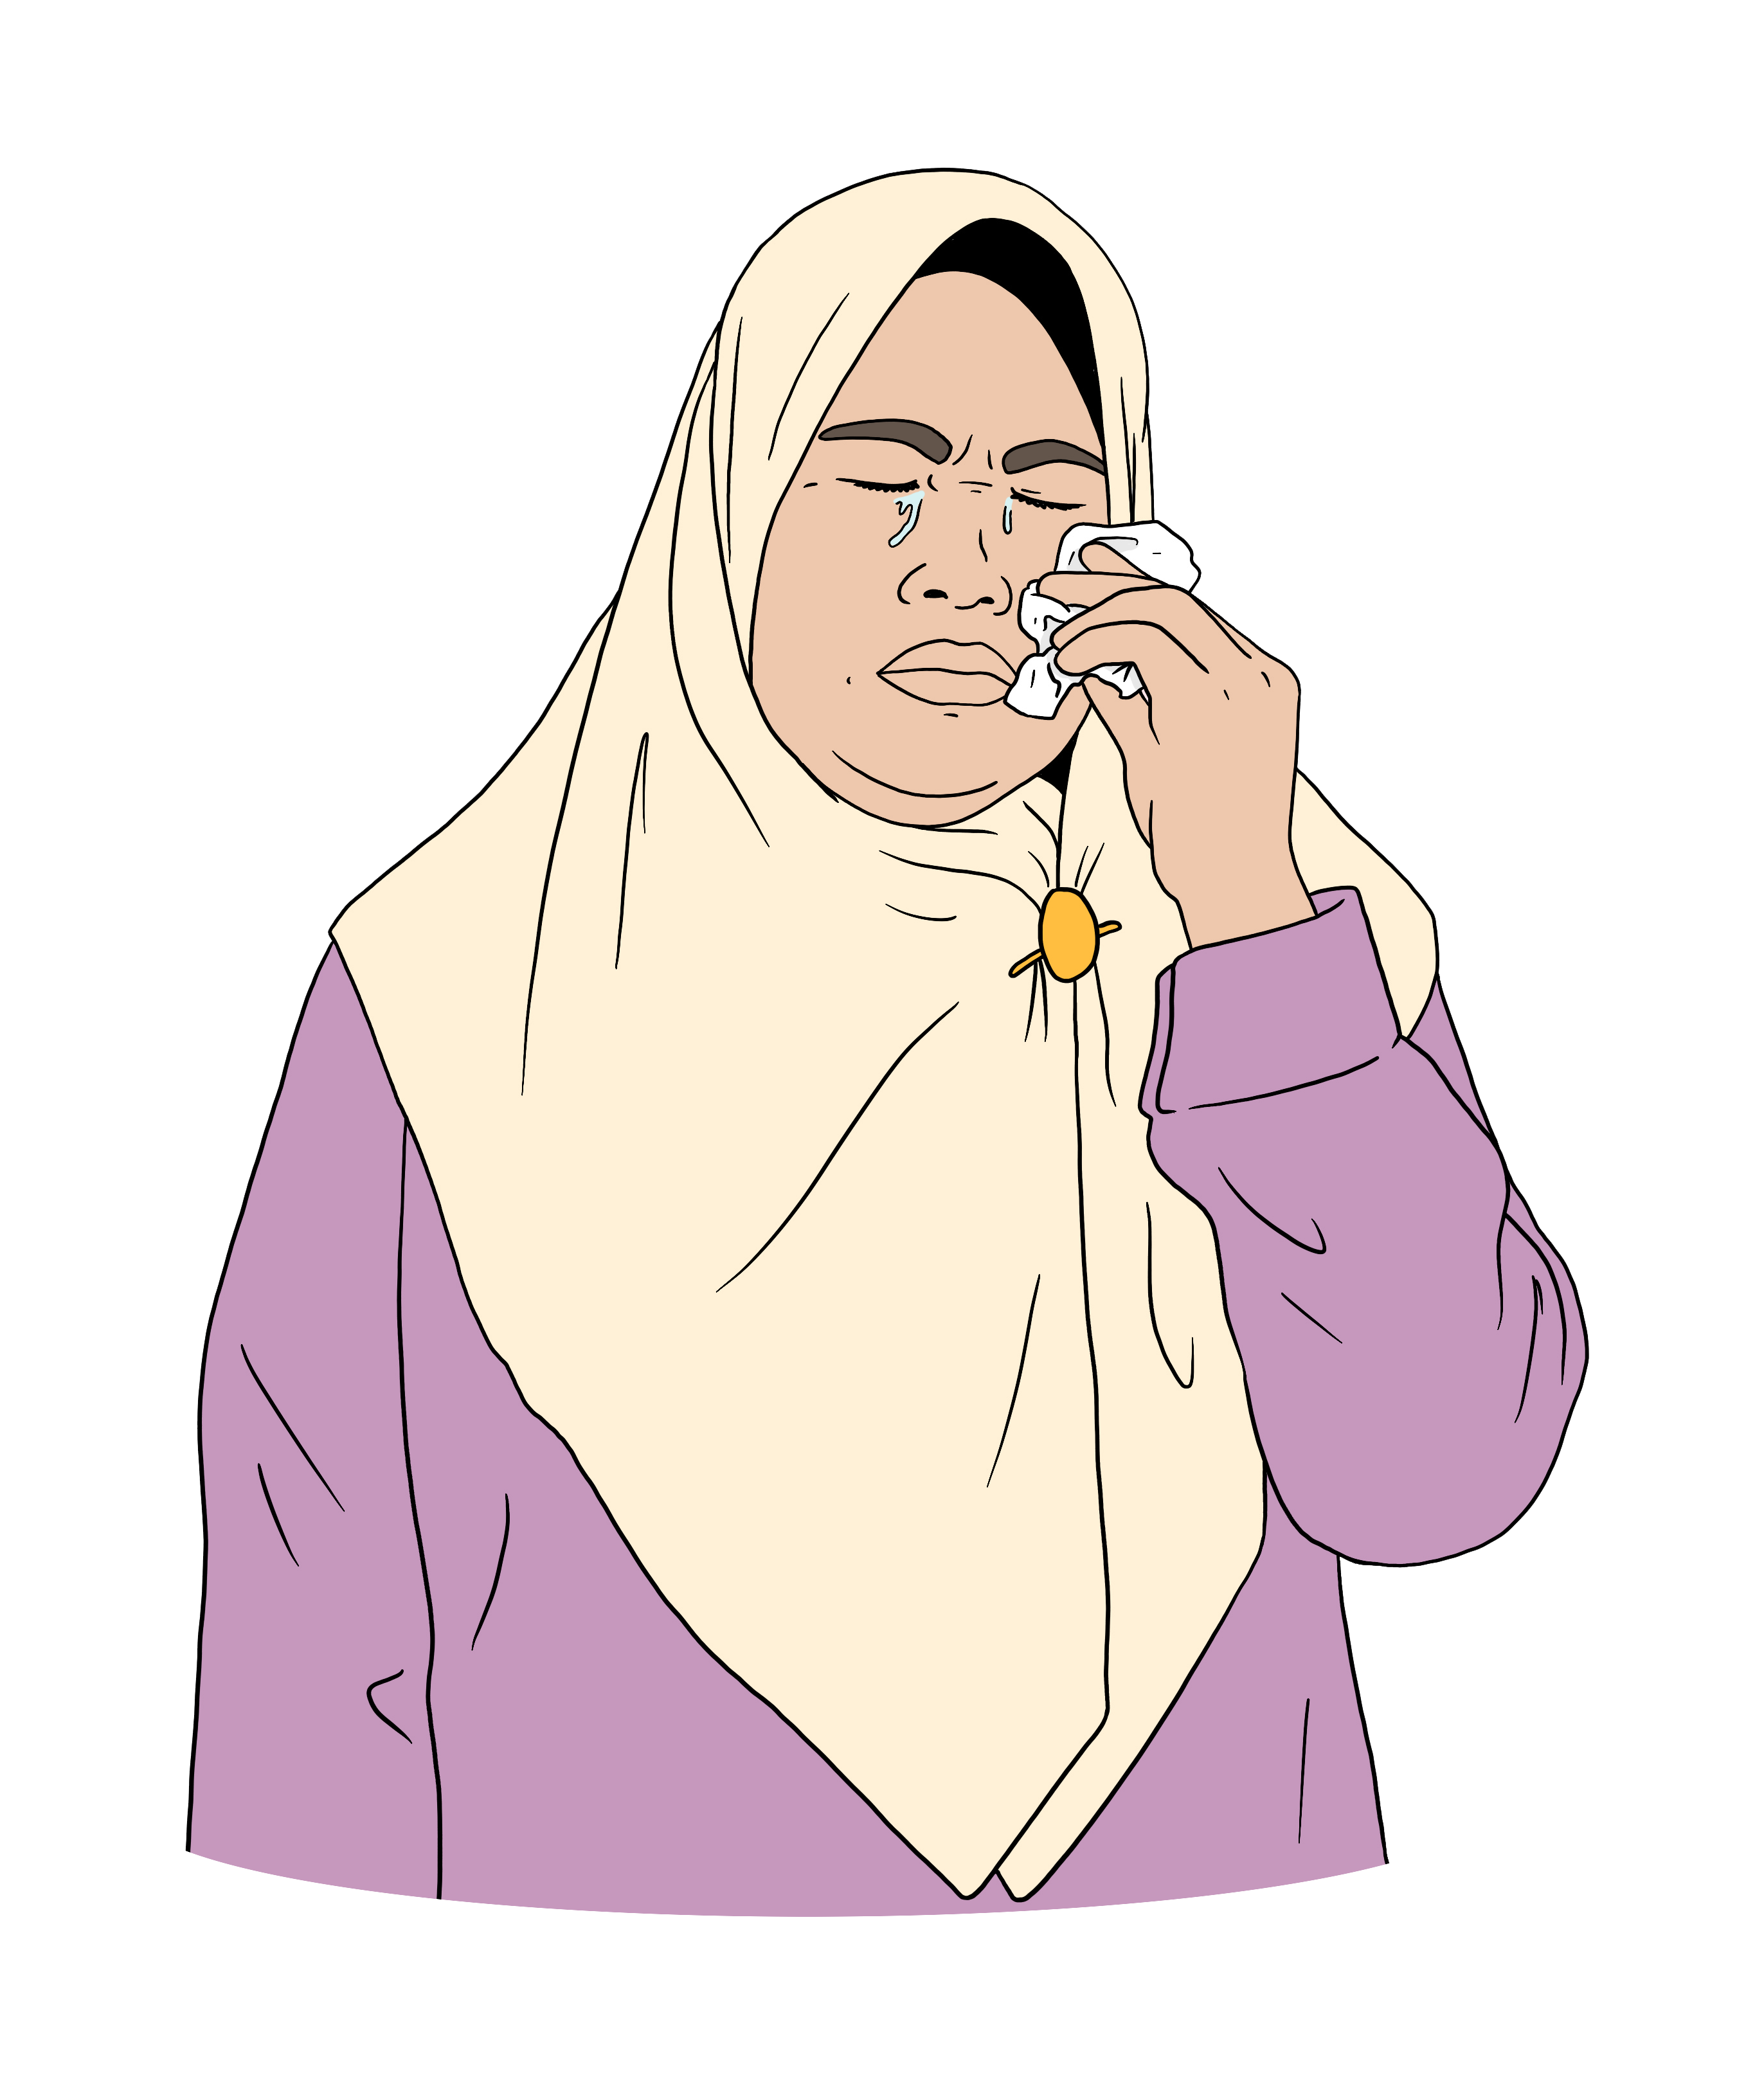
This terrorist attack was harmful to:
the Muslim community
everyone in Aotearoa New Zealand.


There was a Royal Commission of Inquiry into the terrorist attack.

A Royal Commission of Inquiry:
looks carefully at something bad that happened to find out:
- what happened
- what could have stopped it from happening
makes recommendations about what the Government could do
to stop the bad thing from happening again.

Here recommendations are ideas about what the Government should do.

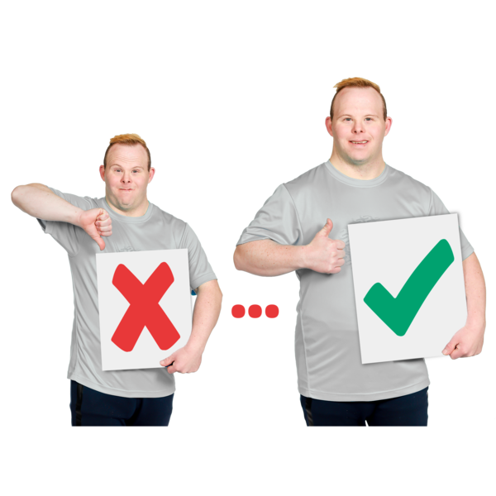
The Royal Commission of Inquiry into the terrorist attack said the law in Aotearoa New Zealand needed to do more to:
show that hate crime is very bad
stop people from committing hate crimes.

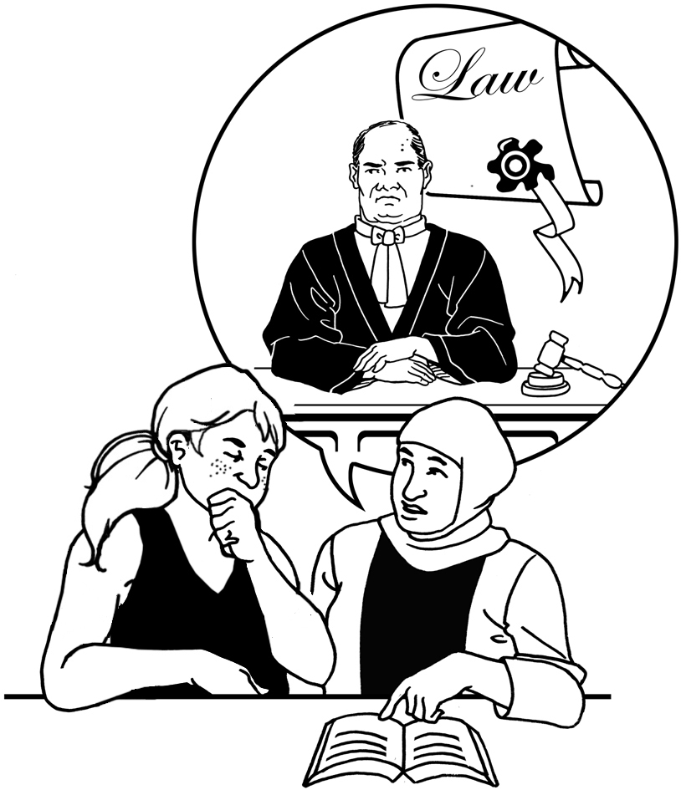
The Royal Commission of Inquiry recommended that the Government should create new hate crime offences.

The Government has to respond to the recommendations of the Royal Commission of Inquiry.

Here respond means the Government:
looks at the recommendations
decides what to do next.

The Government asked us to do this review as part of its response to the Royal Commission of Inquiry.

What the review looked at


The main question our review looked at was if Aotearoa New Zealand should have hate crime offences.

We only looked at things that are already illegal like:
assault
intimidation
graffiti.

Something is illegal if it breaks the law.


Intimidation is when someone behaves in a way that makes
another person feel scared on purpose.

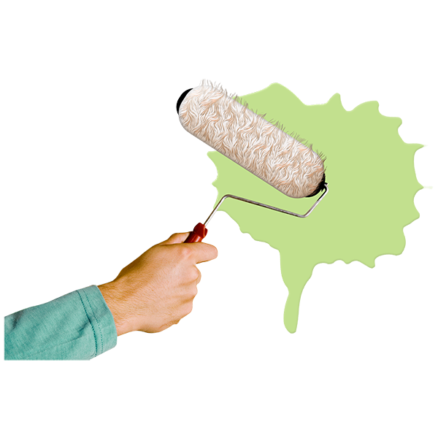
Graffiti is when someone paints something in a public place where painting is not allowed like on a fence.

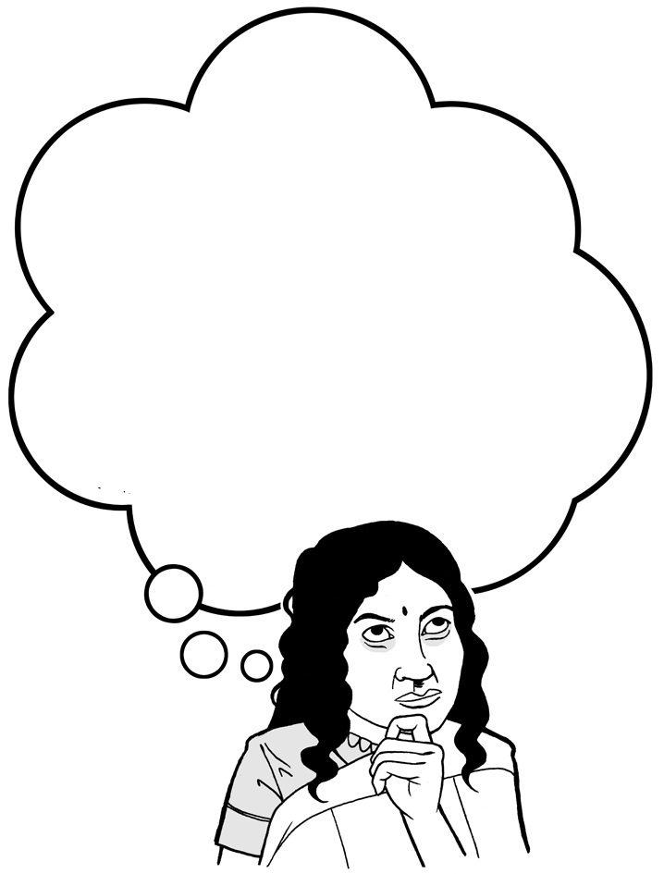
We wanted to know if there should be new offences that people could be charged with if:
they did 1 of these illegal things
hostility towards a group of people was the reason why they did the illegal thing.


We did not look at laws about hate speech.

Hate speech means saying / writing things that show hostility towards a group of people.


Some people we spoke to when we were doing our review told us what they thought about hate speech laws.


Many people said they were more worried about hate speech than hate crime.


Hate speech:
is more common than hate crime

makes people feel:
- hurt
- scared.

Some people told us they did not think there should be laws about hate speech.

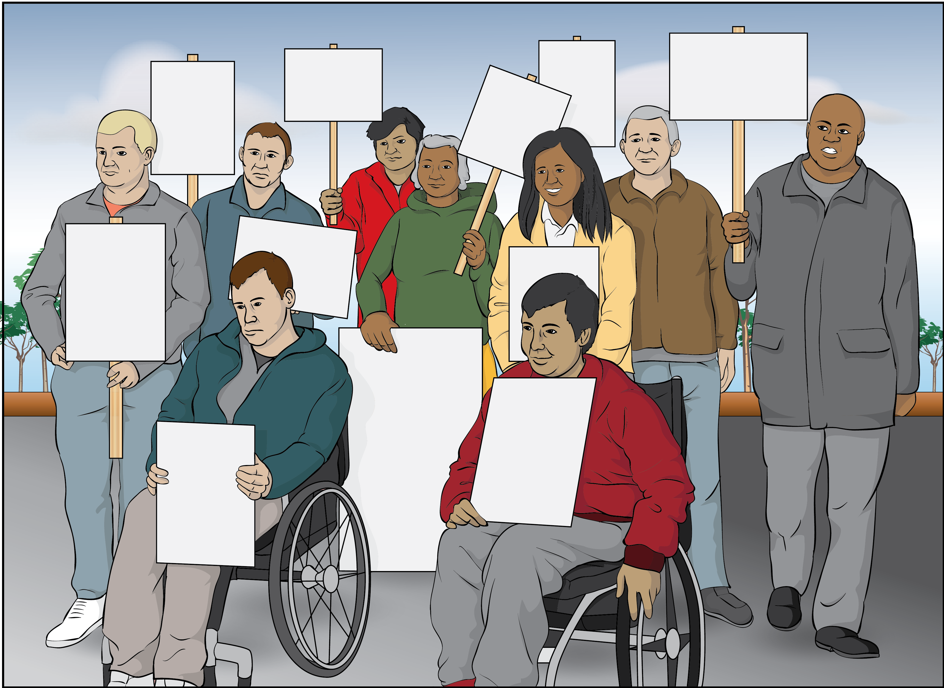
These people thought laws about hate speech would stop people having freedom of expression.

Freedom of expression is a right.

Having freedom of expression
means the Government cannot stop you from saying things.

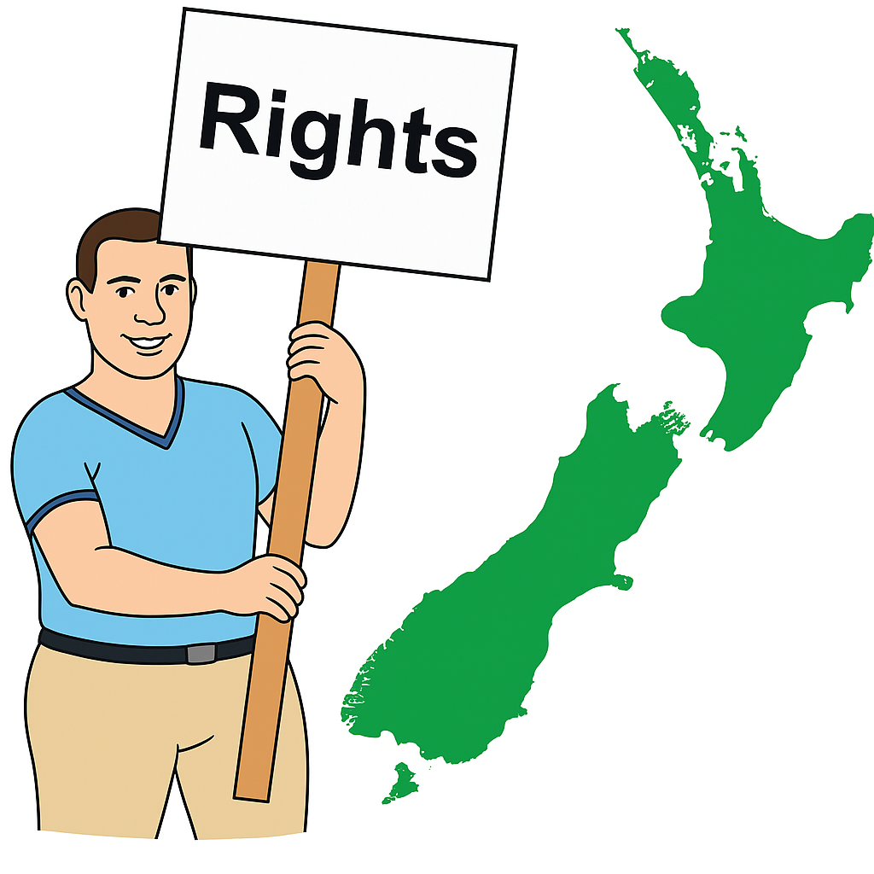
A right is something everyone should:
have
be able to do.

Looking at hate speech laws was not part of this review so we have not made recommendations about hate speech laws.

Our review only looked at what the law can do to stop hate crime.


We know other things also have to happen to stop hate crime like:
working with communities who get hurt by hate crime
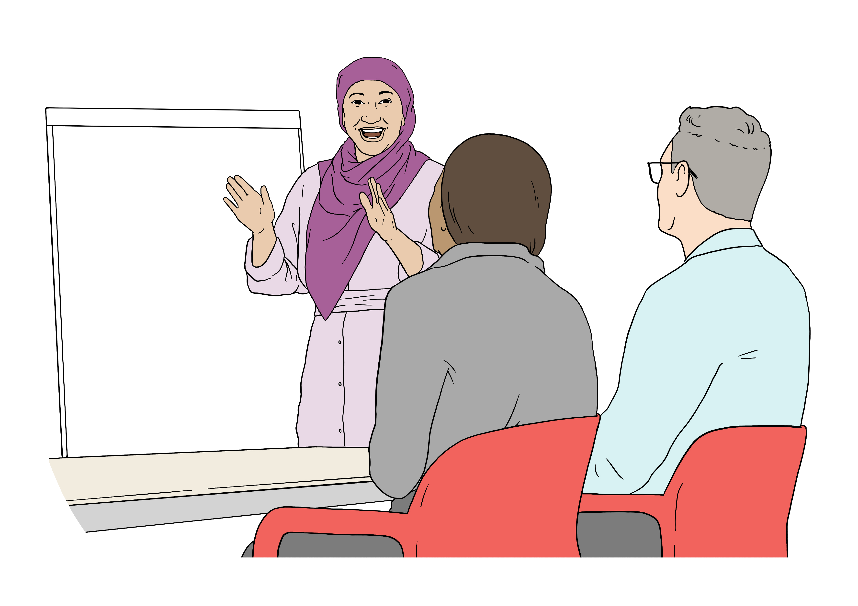
teaching people about:
- hate crime
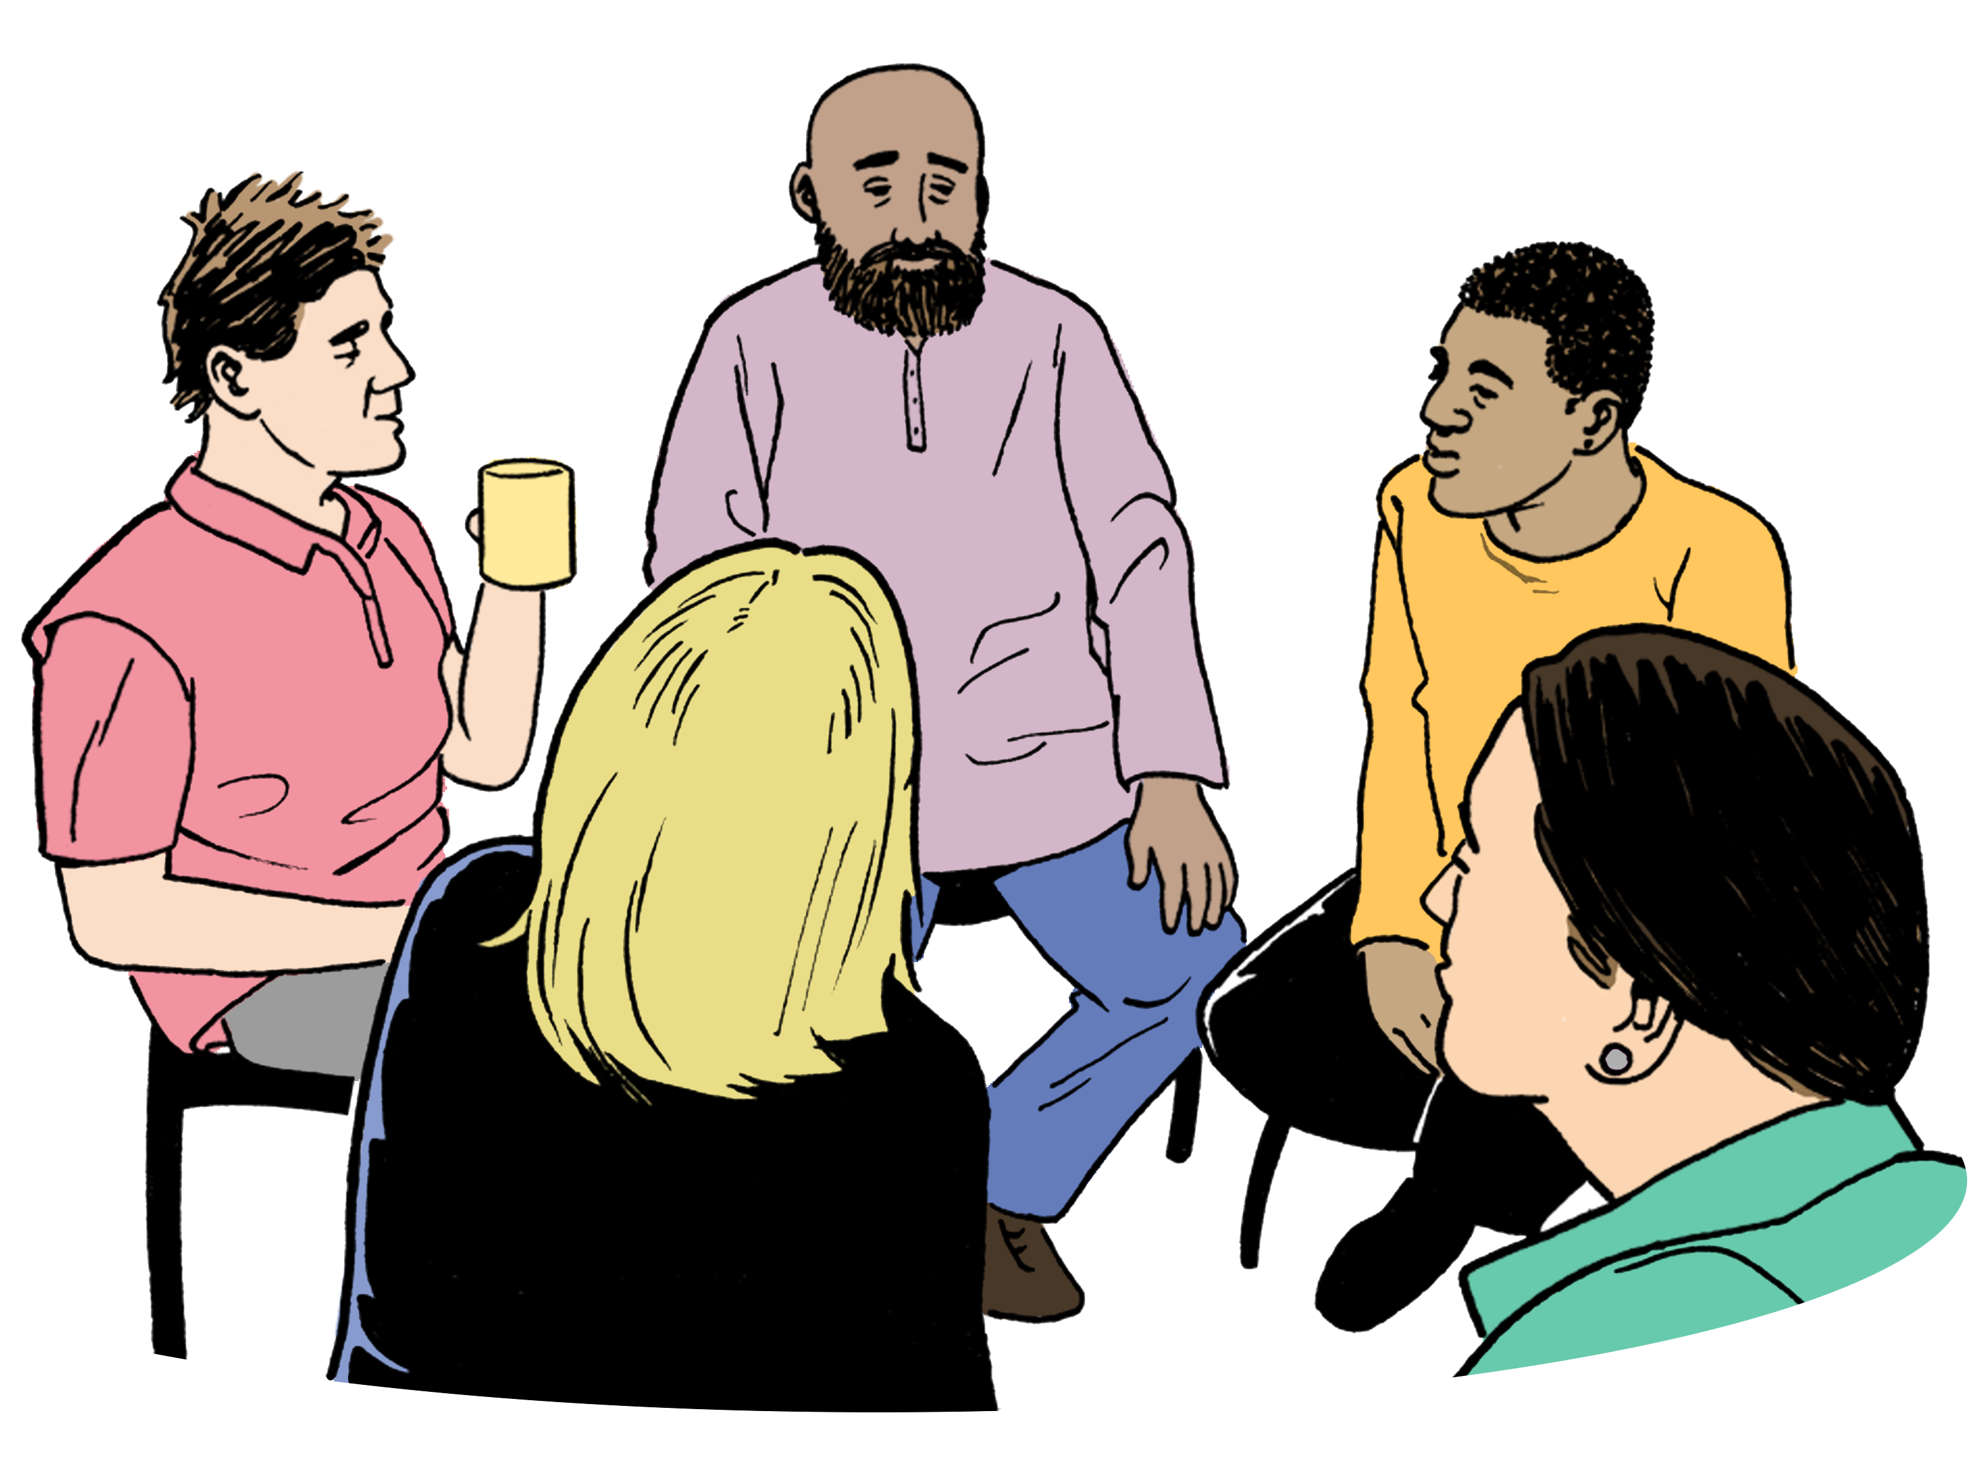
- treating everyone fairly
- making sure there are services to support people who are victims of hate crime.

What problems did we find?

Our review found there were some problems with how the law in Aotearoa New Zealand deals with hate crime.

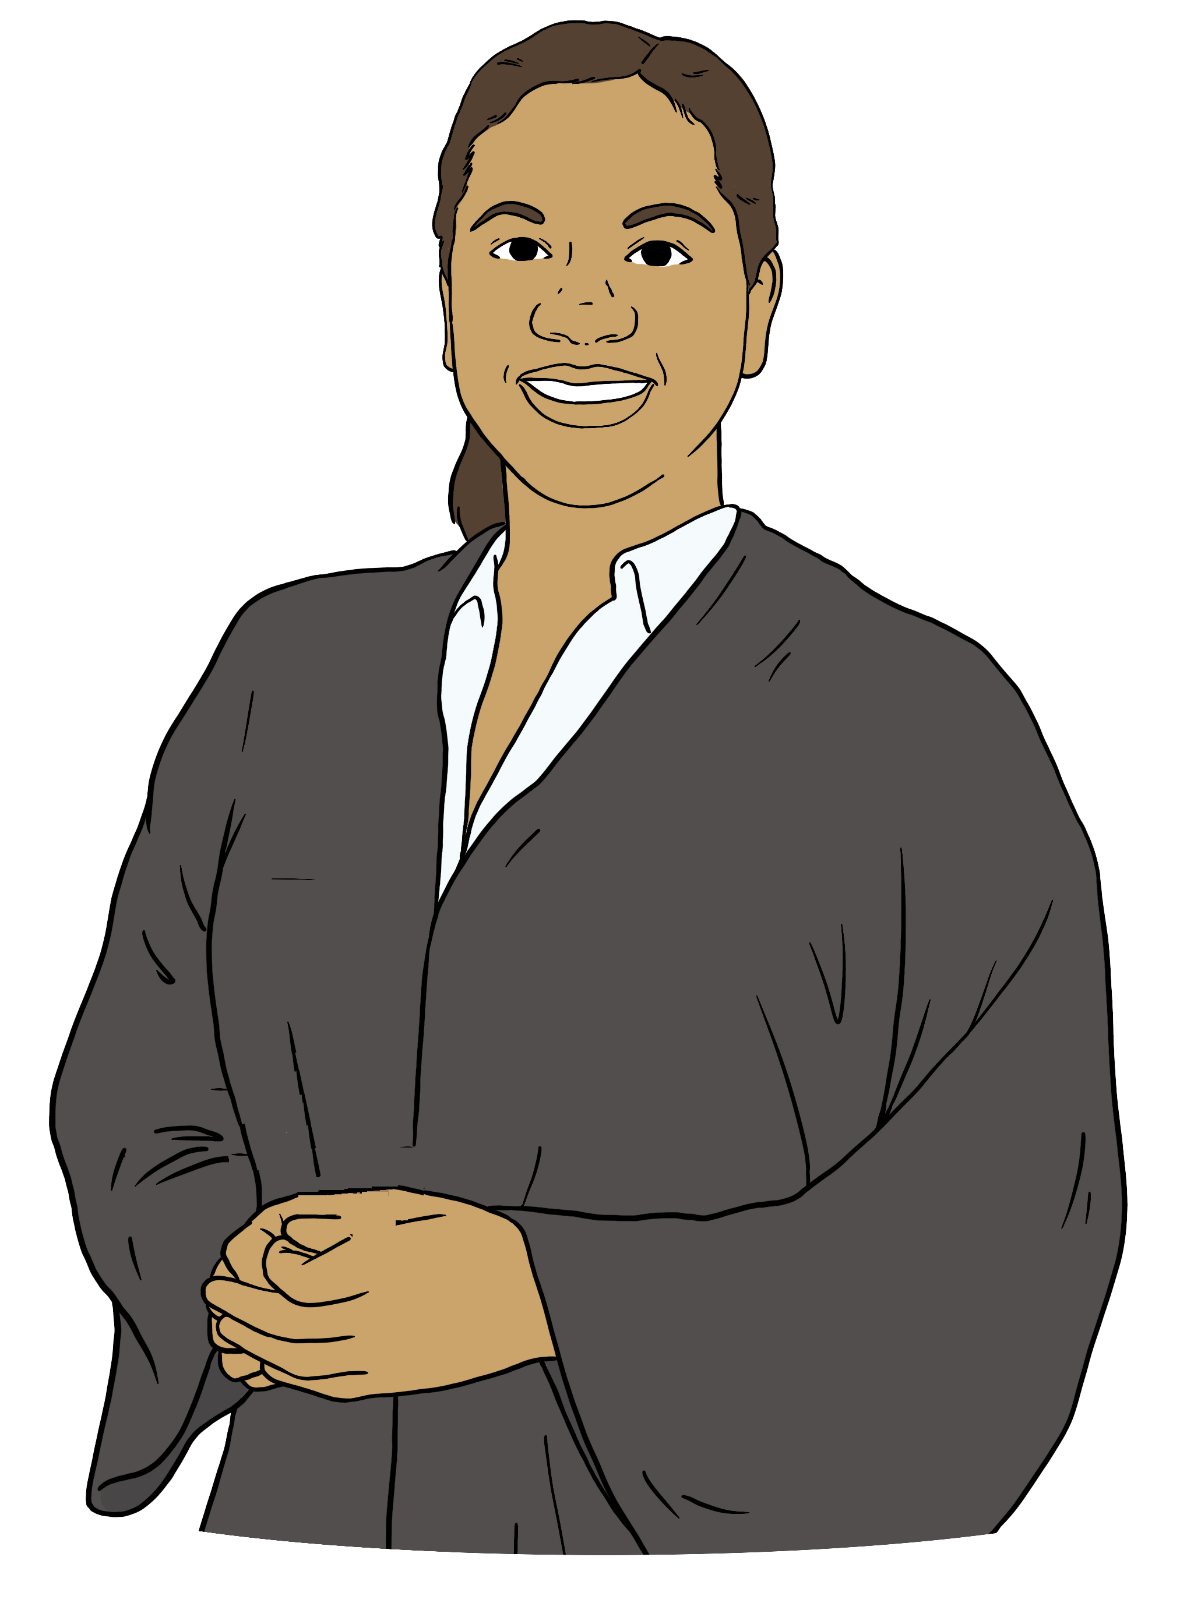
Judges do not have to clearly say that:
an offence was a hate crime
the offence being a hate crime makes it more serious.

When a judge does say an offence was a hate crime this does not always get written down somewhere.

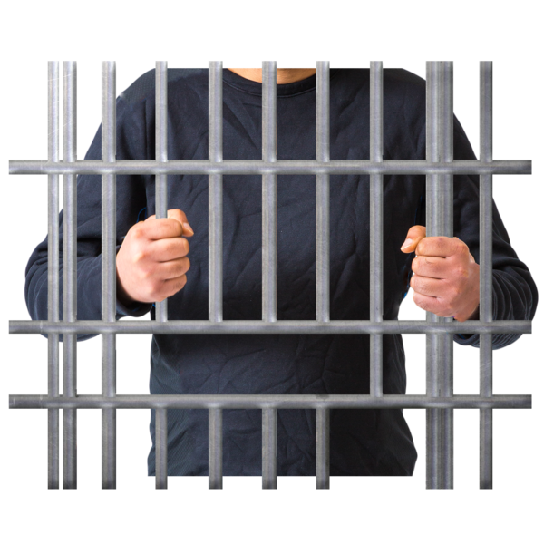
The problems we found make it harder for the justice system to:
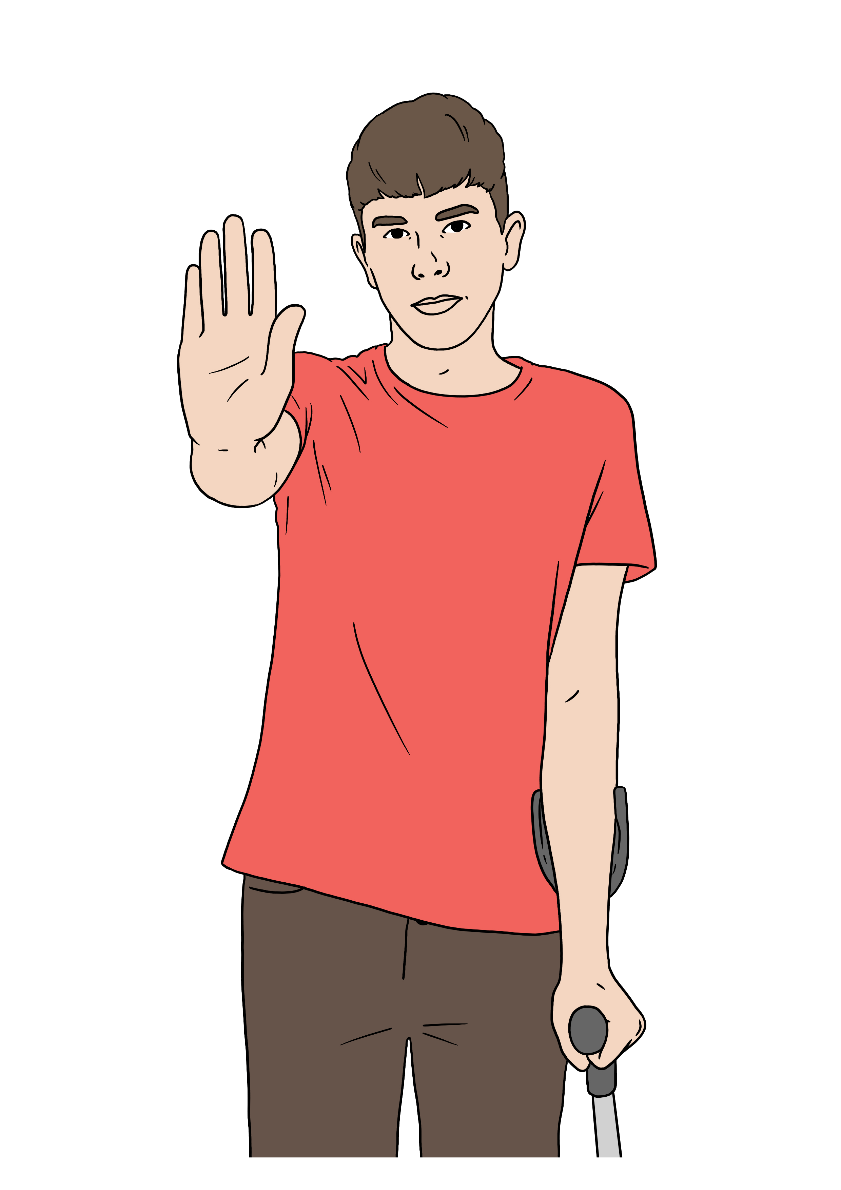
punish people who have committed hate crimes
stop people from committing hate crimes again in the future
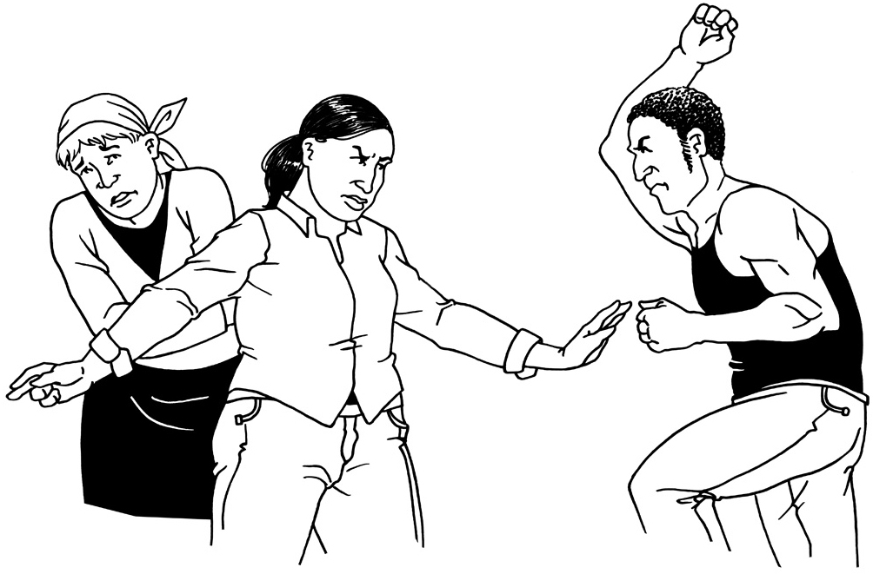
know if it is doing what it needs to do to protect people from hate crime.

Here the justice system means:
the police
the courts
the Department of Corrections.


The Department of Corrections is the part of the Government in
charge of prisons.
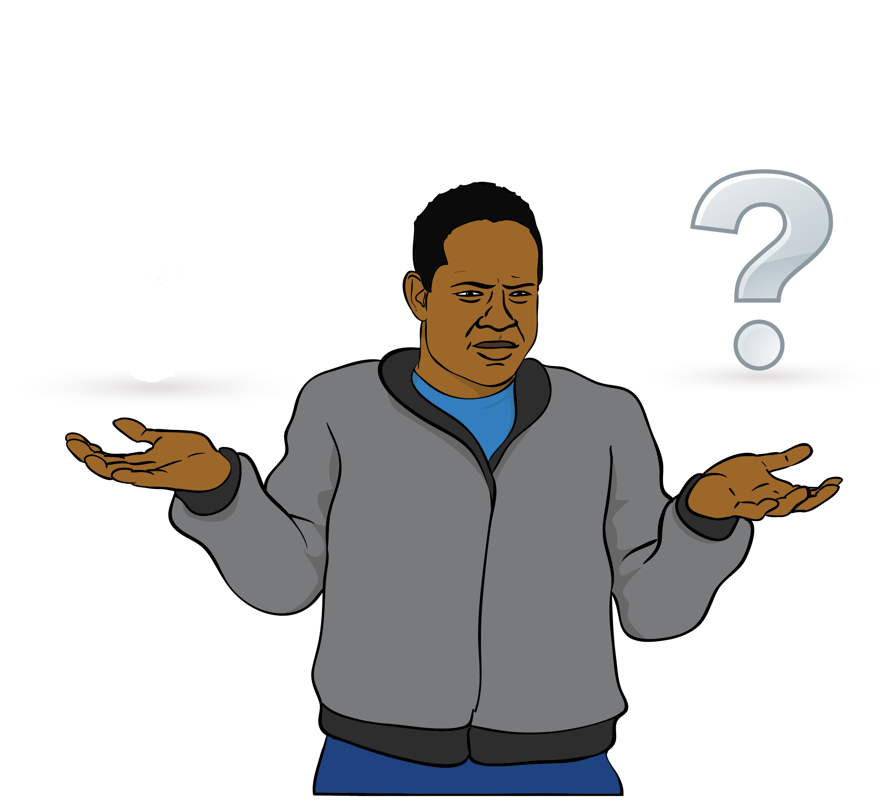
There is no clear way to make sure the court knows a crime might have been a hate crime.

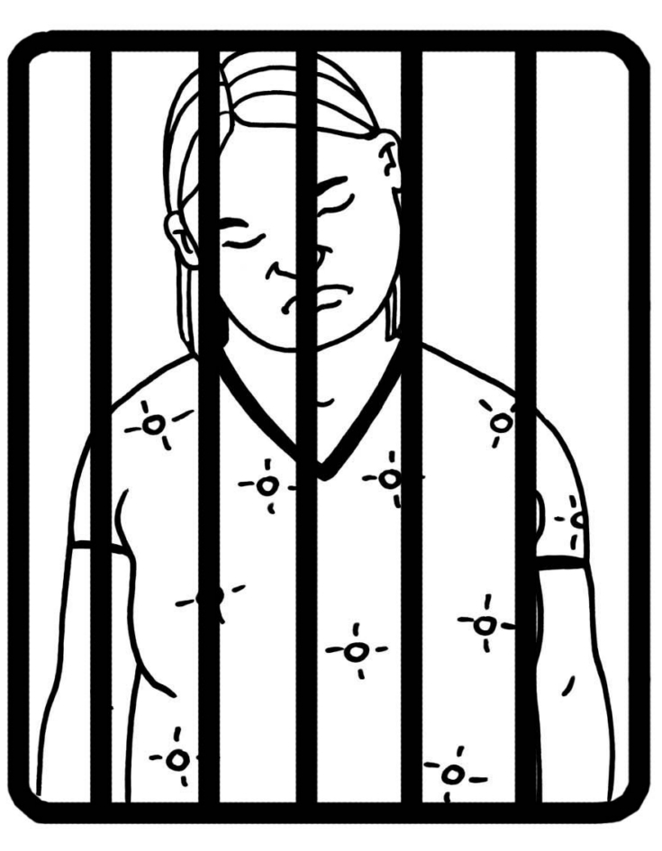
This means:
some people do not get punished as much as they should for committing hate crimes
it is harder to stop people from committing hate crimes again in the future.
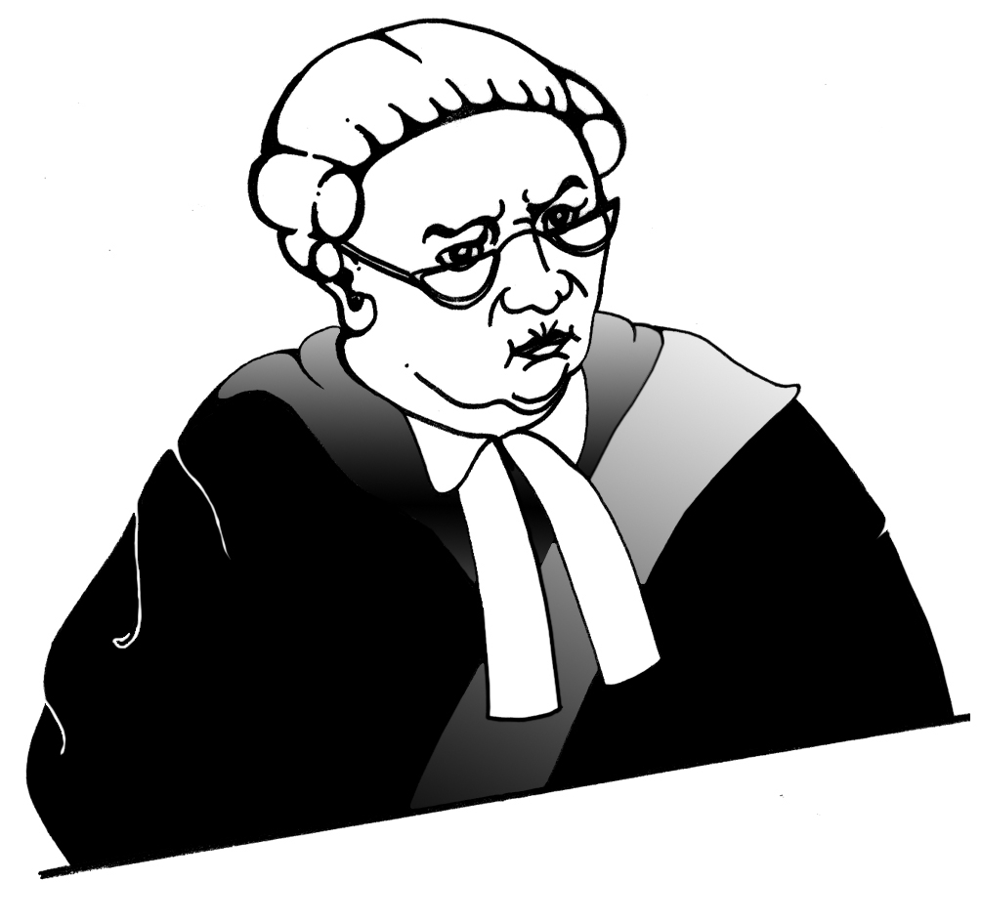

These problems are serious.

We do not think Aotearoa New Zealand needs new hate crime offences to solve these problems.

We think we can solve these problems by making some changes to the way the law already deals with hate crime.

Why we do not think Aotearoa New Zealand needs new hate crime offences

Our review asked whether Aotearoa New Zealand needed new hate crime offences to deal with hate crimes.

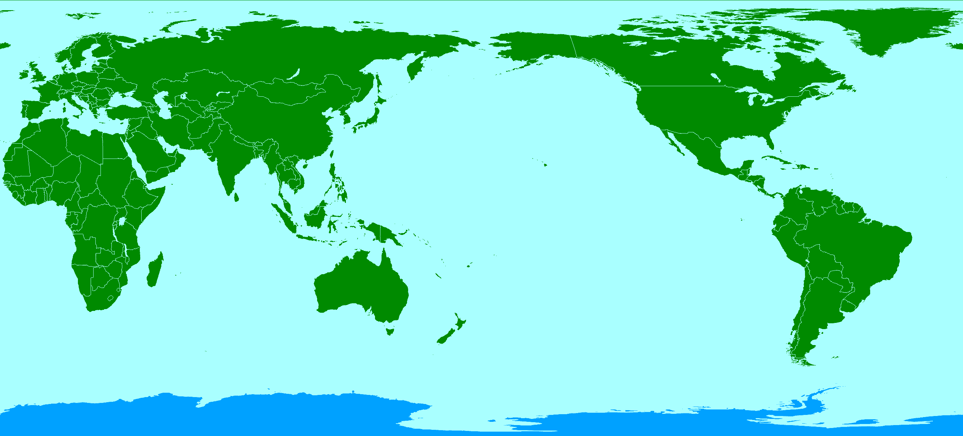
Some other countries already have hate crime offences.

The Royal Commission of Inquiry into the Christchurch terrorist attack said Aotearoa New Zealand should have hate crime offences.


There are some good things about having hate crime offences like making it:

clear that the law sees hate crimes as more serious than other crimes
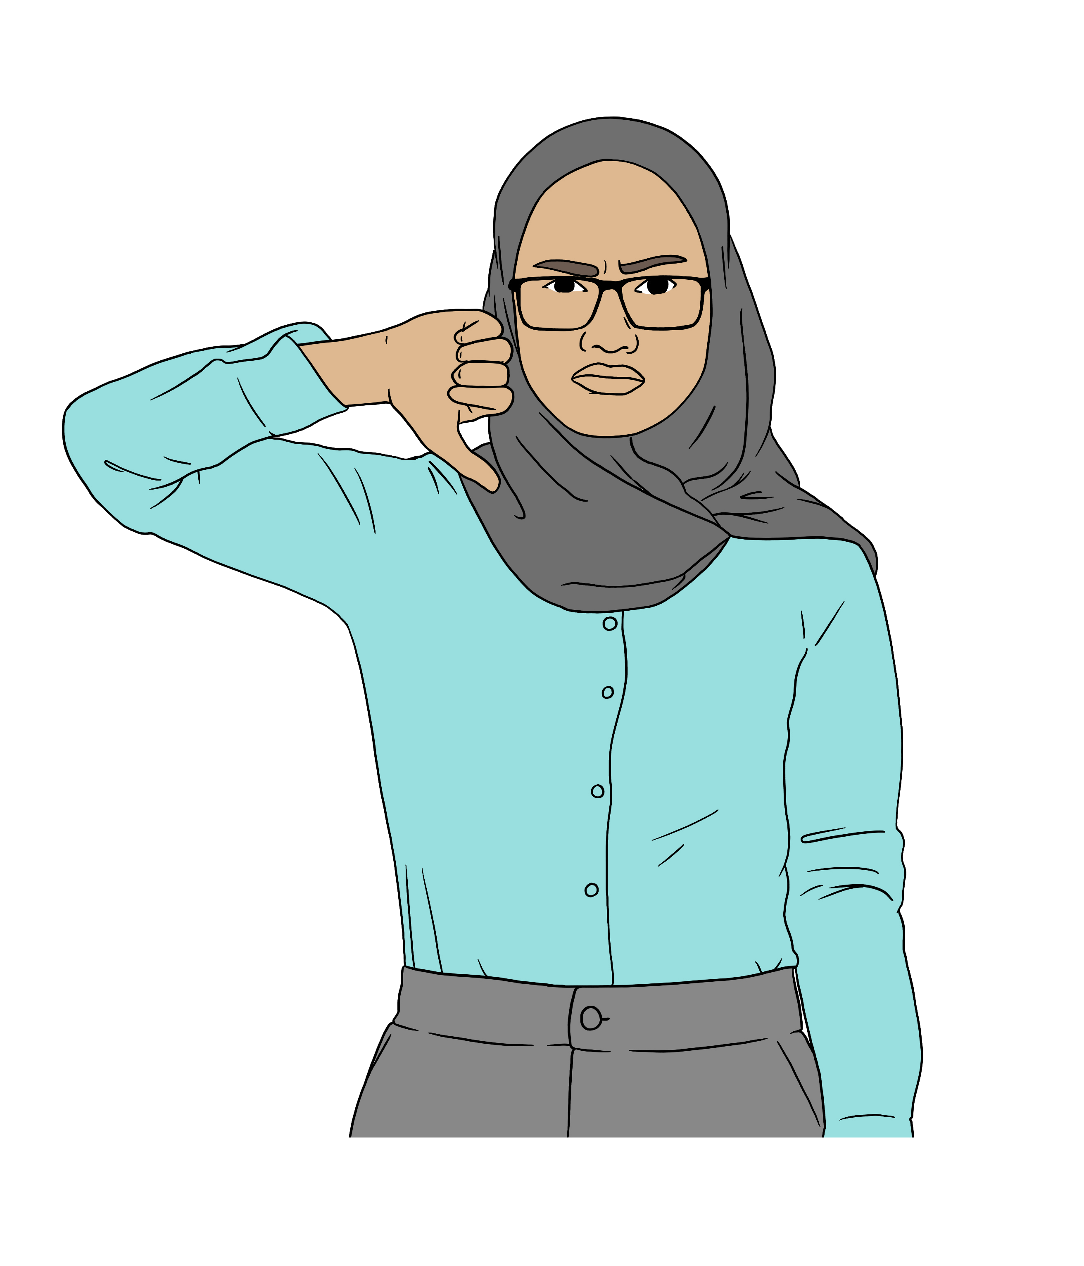
easier to record data about hate crimes.

There are also bad things about having hate crime offences.


Prosecutors might not always use hate crime offences.

Prosecutors are lawyers who
charge people with crimes.

In a trial the prosecutor has to prove beyond a reasonable doubt that
the person committed the crime.

A trial is how a court decides if someone committed a crime.


Proving something beyond a reasonable doubt means showing that it is almost certain the person
committed the crime.


An example of this problem is that assault is already a crime.

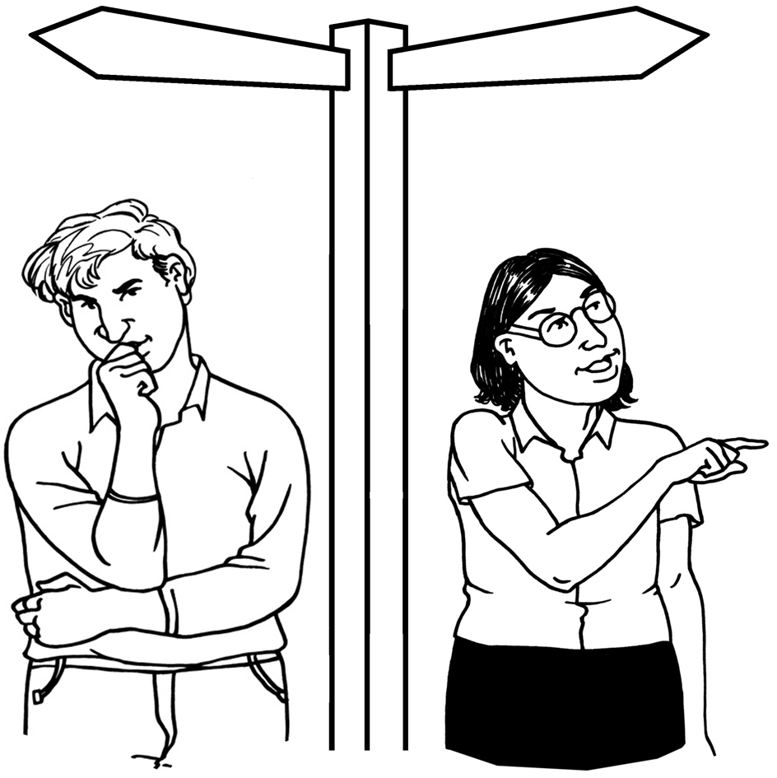
Prosecutors might still decide to charge a person with assault instead of using a new hate crime charge.


Some of the reasons why prosecutors might do this are:
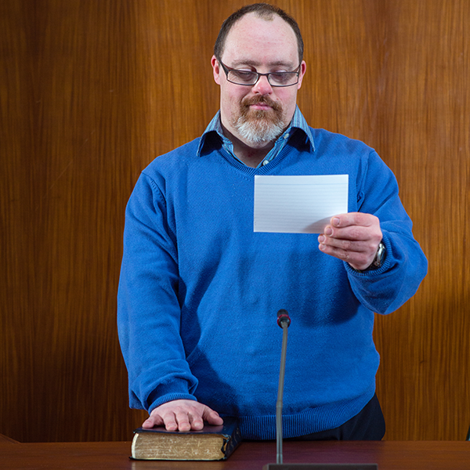
it might be easier to prove the charge if the prosecutor does not also have to prove it was a hate crime
people might be more likely to plead guilty to crimes that are not hate crimes.

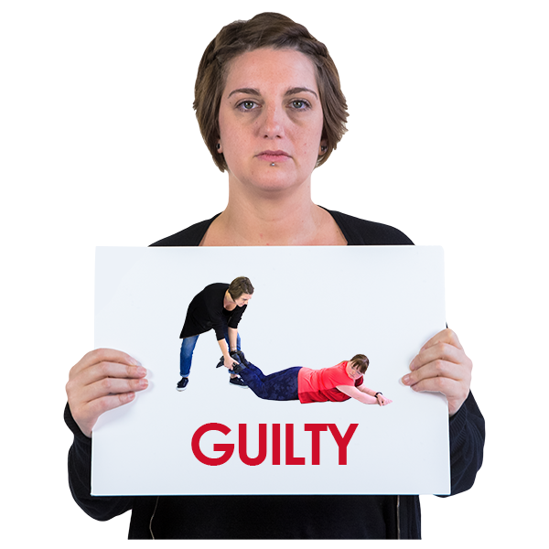
When someone pleads guilty to a crime this means they say they committed the crime.

When someone pleads guilty to a crime they do not need a trial.
Another problem with having hate crime offences is juries might not want to convict people of hate crimes.


Juries are groups of people who decide if a person is guilty of a crime.

When a jury convicts someone this means they decide the person did
commit the crime.

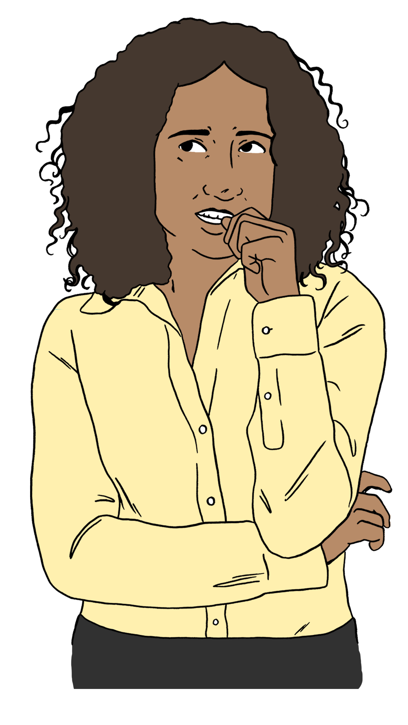
The jury might not want to convict someone if they are worried that this will make life harder for the person in the future.

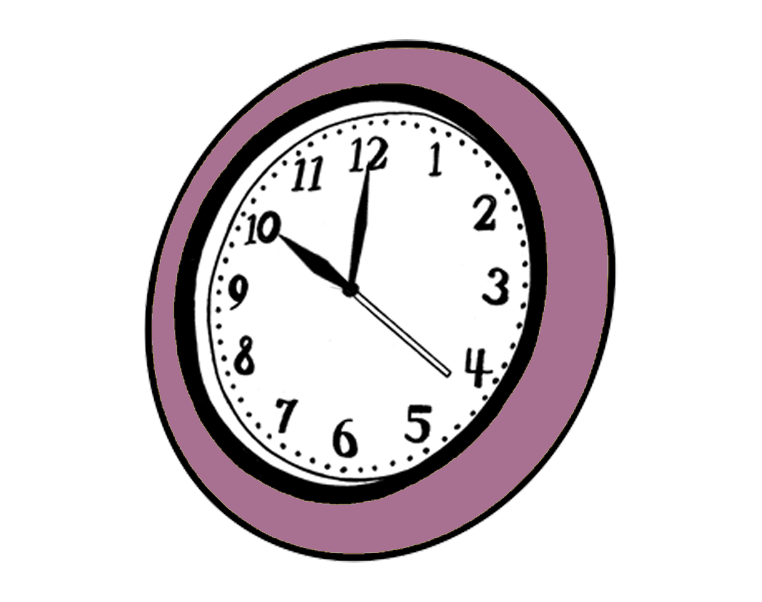
New hate crime offences would make trials take longer.


The prosecutor would have to prove beyond a reasonable doubt that the reason why the person committed the crime was hostility towards a group of people.

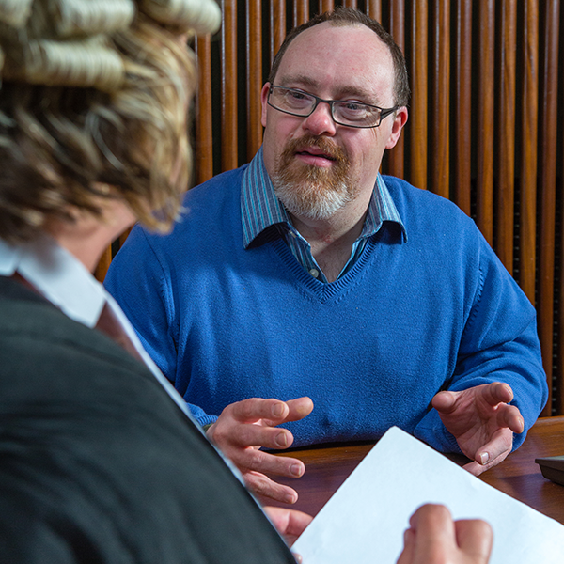
The prosecutor would probably need to show the court more evidence to prove this.


Evidence is information that
supports the:
prosecutor to show that the person committed the crime
person to show that they did not commit the crime.


The victim of the crime might need to give the court this evidence.

This could be stressful for the victim.

There would be more trials if less people plead guilty because they were charged with a hate crime offence.


Having new hate crime offences might mean that the court does not get to say an offence was a hate crime.

This could happen if:
the prosecutor chose not to charge the crime as a hate crime
the jury chose not to convict the person of a hate crime.


If either of these things happened the court would have no way of saying that the crime was a hate crime.

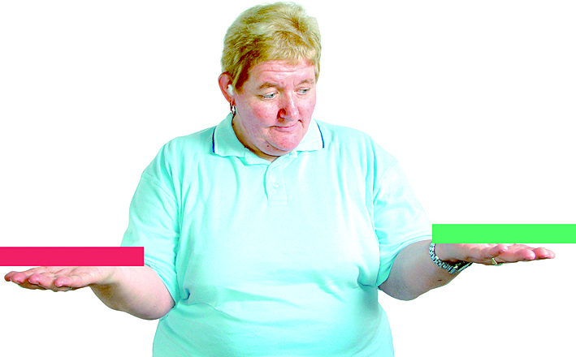
In countries with hate crime offences these offences only include some:
kinds of offence
protected characteristics.

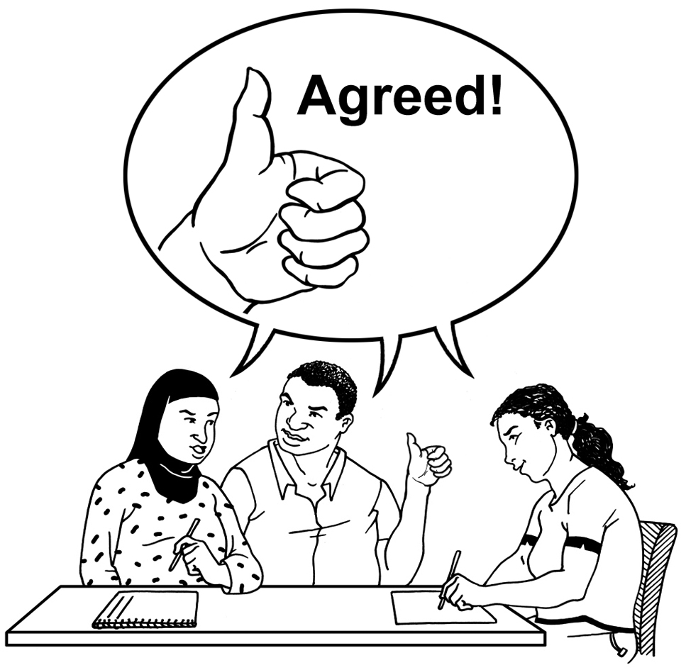
This means someone could commit a crime that:
many people think should be called a hate crime
the law does not count as a hate crime.

The law would have to change if new types of hate crime happened in the future.

At the moment the law in Aotearoa New Zealand deals with hate crime by giving people longer sentences if the crime was a hate crime.

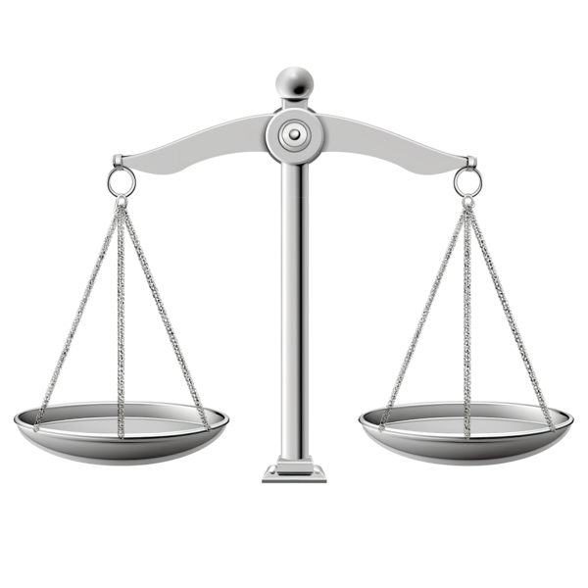
The law also deals with other things that make a crime worse in the same way.

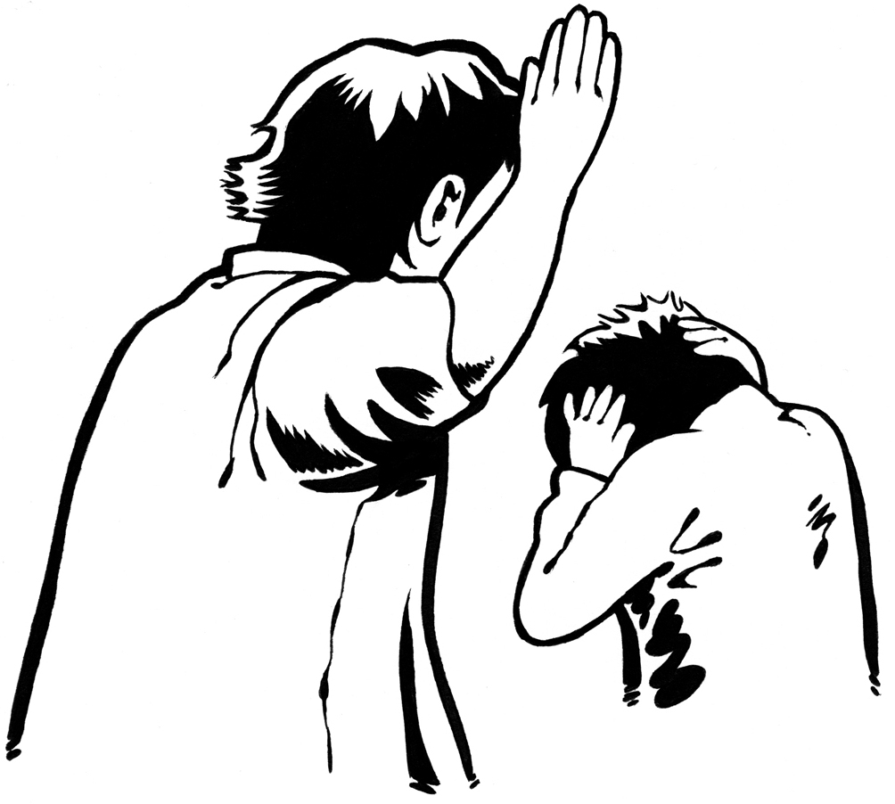
For example if a person assaults someone who is vulnerable they might get a longer sentence.

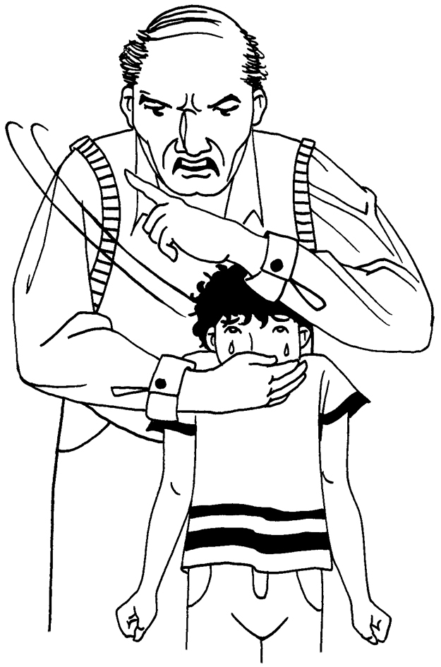
Someone is vulnerable if they are less able than other people to
protect themselves.

For example children are vulnerable.

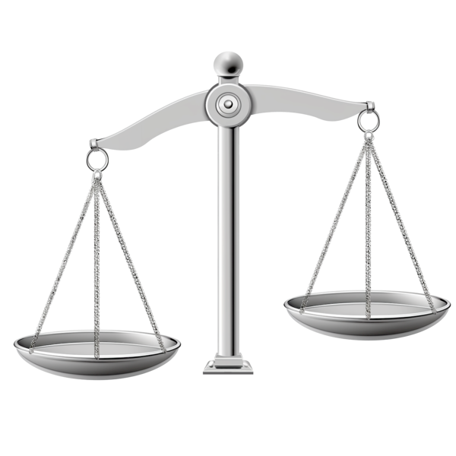
If Aotearoa New Zealand had hate crime offences this would mean the law would treat hate crime differently from other things that make a crime worse.

Our recommendations


We think what Aotearoa New Zealand does at the moment is the right way to deal with hate crime.

This means we do not think Aotearoa New Zealand needs new hate crime offences.

We think the court should keep punishing someone more if it decides that hostility towards a group of people was the reason why the person committed the offence.


We recommend some changes that could make Aotearoa New Zealand better at dealing with hate crime.

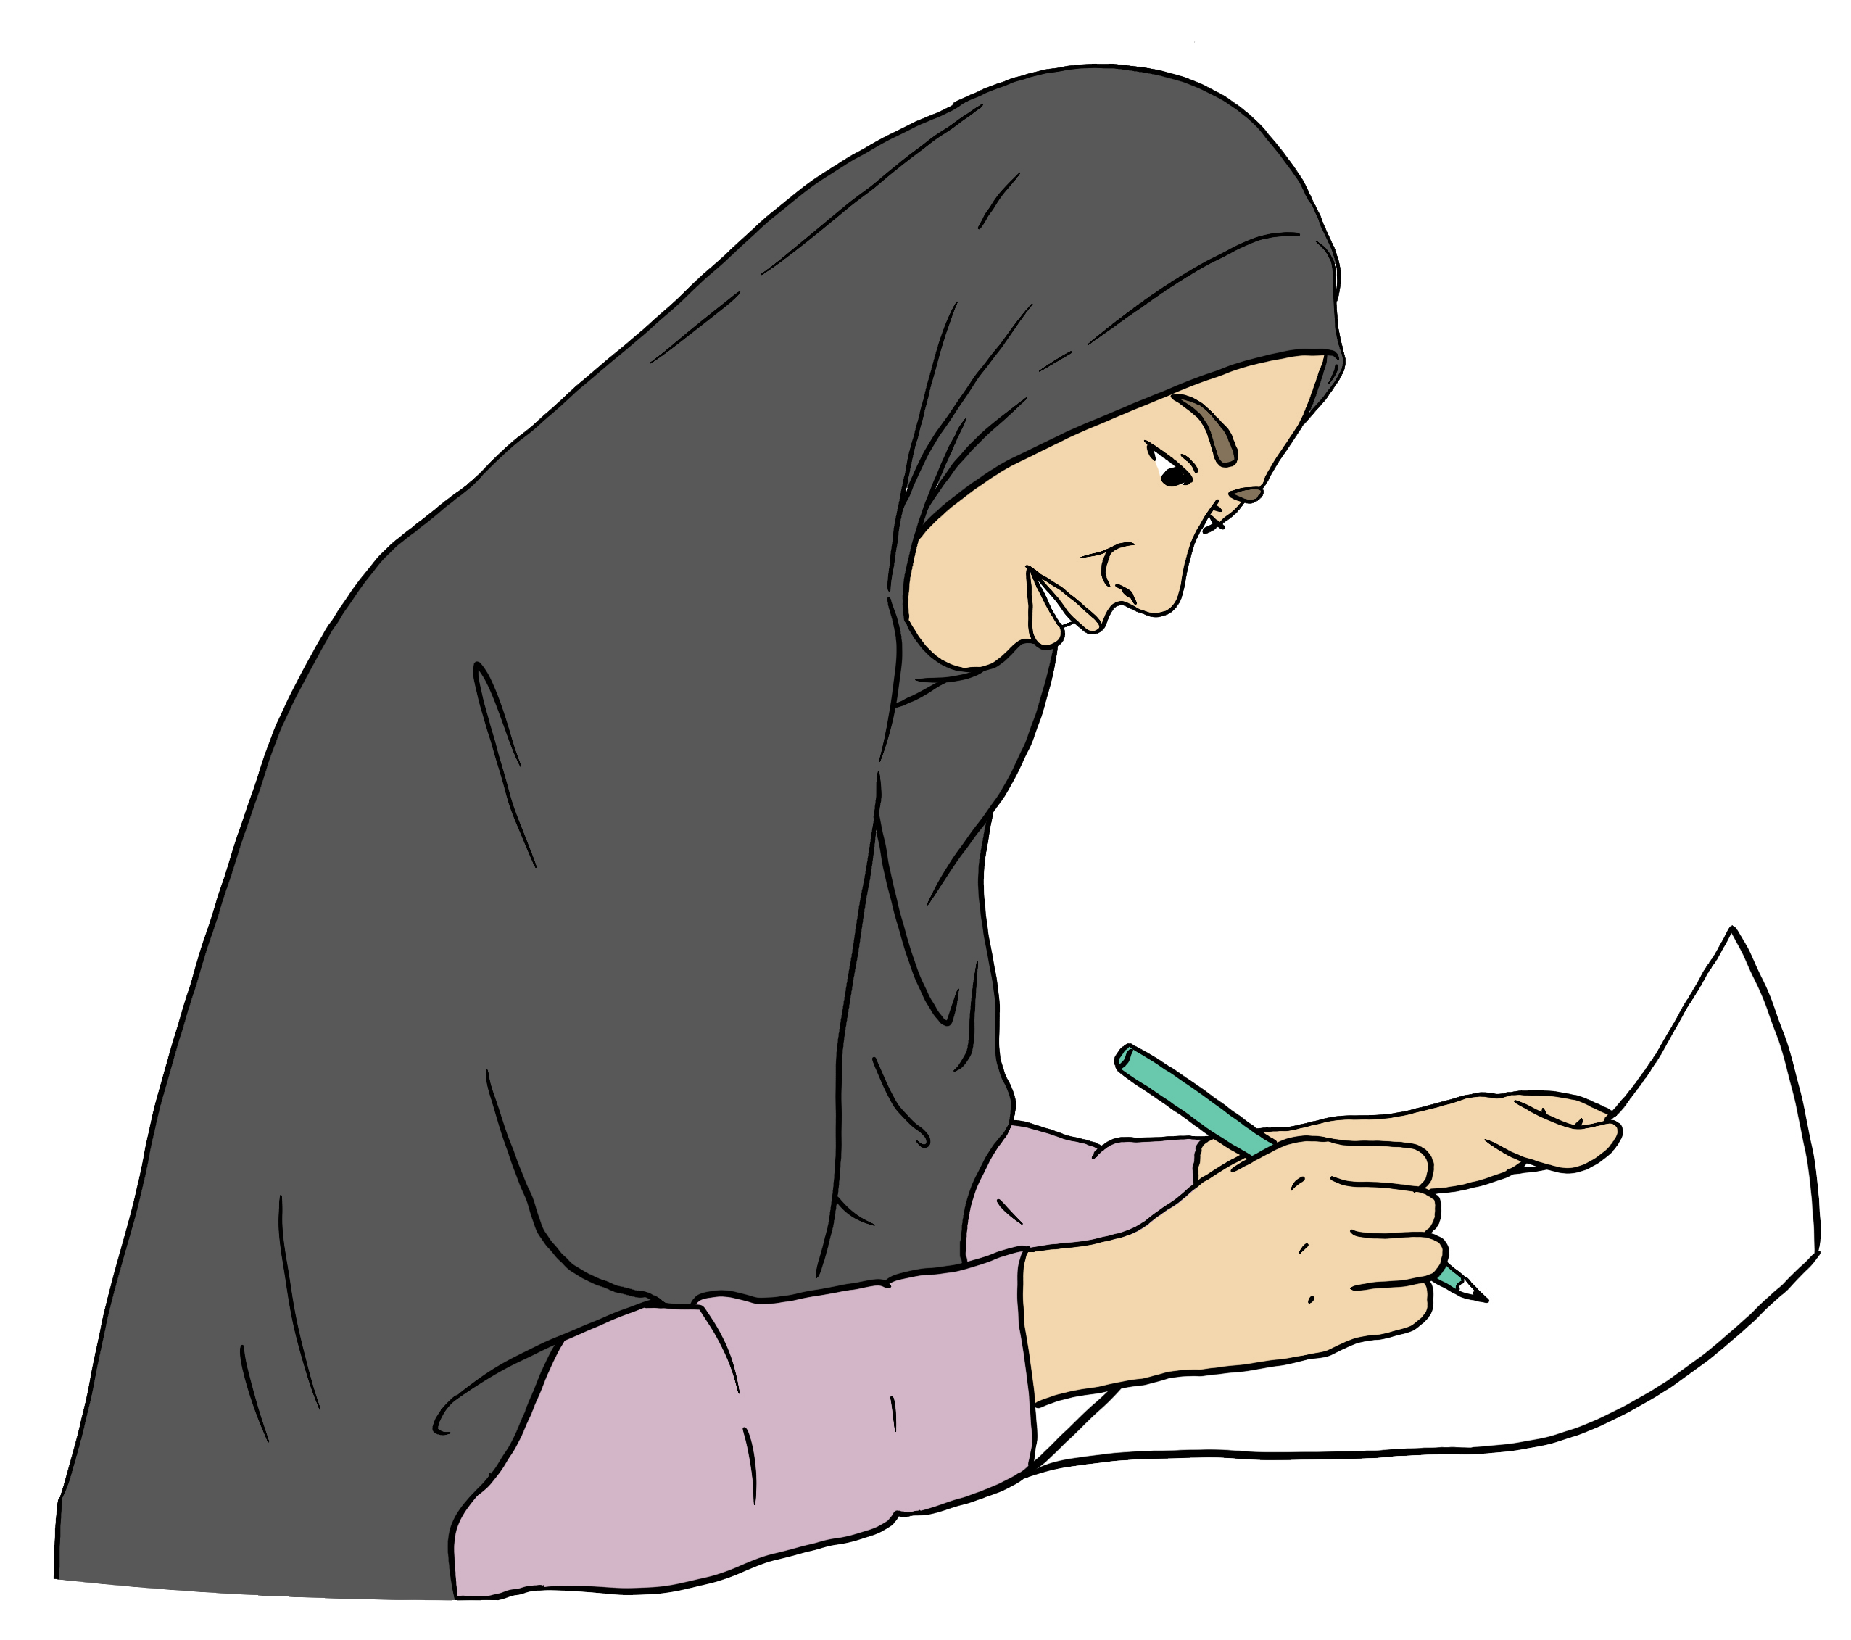
These changes will make it easier to record that something was a hate crime.

This will make it easier for the:
justice system to manage people who have committed hate crimes
Government to decide what to do about hate crime.

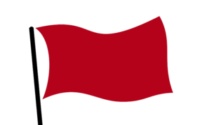
We recommend that there should be a hate crime flag in court records.



A hate crime flag is a note in court records that quickly tells everyone that the reason why a person committed a crime might be hostility towards a group of people.

When the judge sentences the person they would look at the evidence to decide if the crime was a hate crime.


If the crime was a hate crime the judge would have to record this.

The record would mean that if the person committed another crime in the future the court would know they had committed a hate crime in the past.

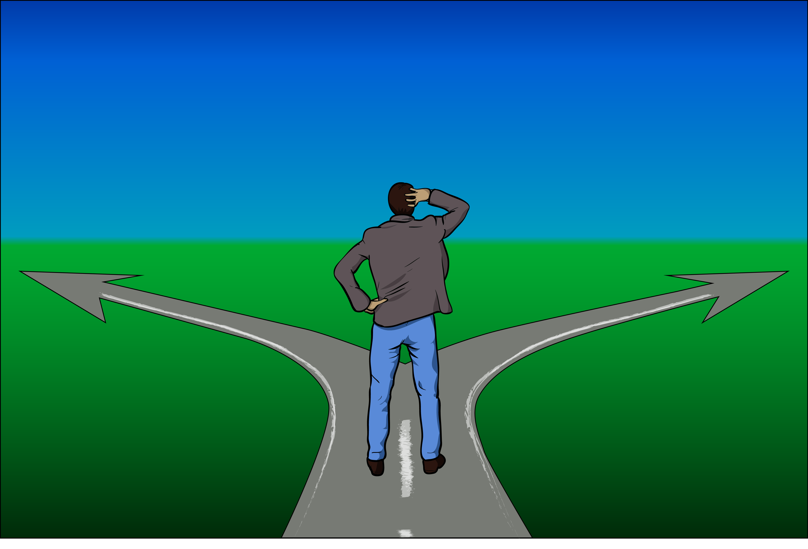
This might change how the court decided to punish the person for future crimes.

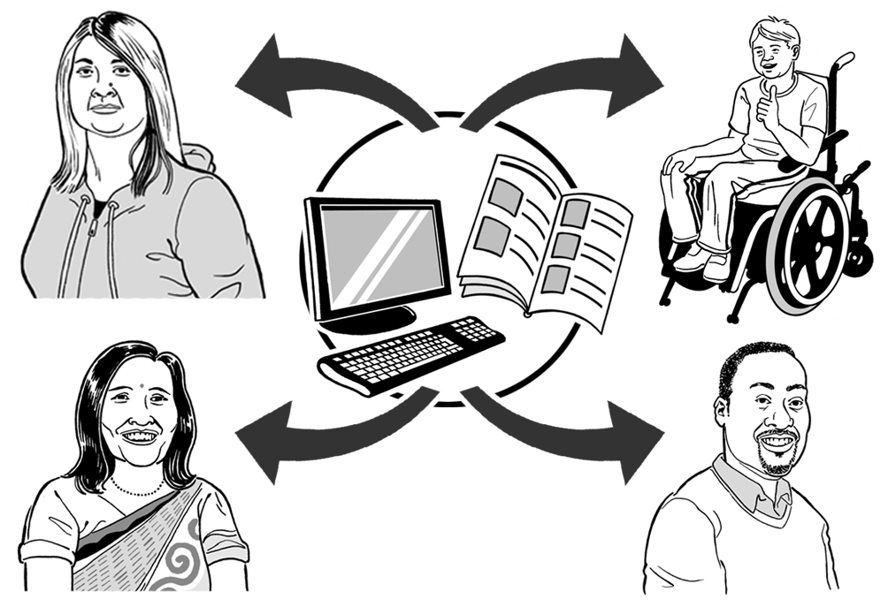
We think the court record should be shared with the:
police
Department of Corrections.

This would make it easier to stop hate crimes from happening in the future.

For example the police might be more likely to charge someone instead of giving them a warning if they know the person has committed a hate crime in the past.


Here a warning is when police:
record that they think you committed a crime
do not charge you with the crime.

If the Department of Corrections knows someone has committed a hate crime they can:
give them support to try to stop them from committing another hate crime
protect other people from the person like:
- other prisoners
- staff who work in the prison.

The hate crime flag would make it easier to collect data about hate crime.

This would make it easier for:
the Government to decide what to do about hate crime
people to see how the justice system was dealing with hate crime.


We think the Ministry of Justice should publish this data.


The Ministry of Justice is the part
of the Government in charge of the justice system.

We also think the police should publish the data they collect about hate crimes that get reported to the police.

We think judges should have to say that they think hostility towards a group of people was the reason someone committed a crime when they are sentencing them.

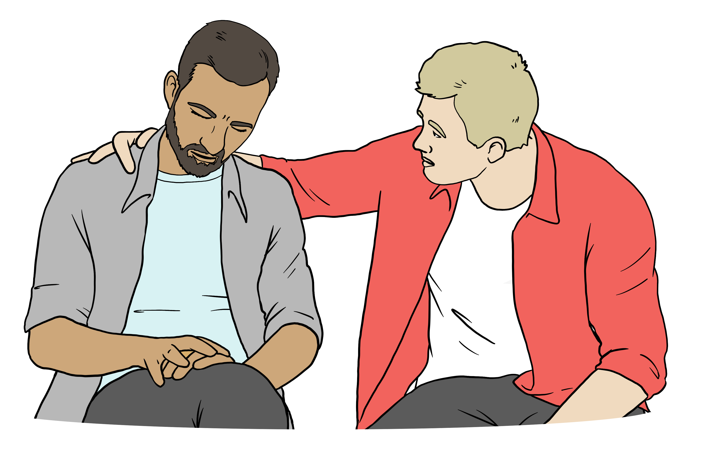
This will tell:
victims that the court knows how they were harmed by the hate crime
everyone that hate crime is not okay in Aotearoa New Zealand
everyone that they can trust the justice system to deal with hate crime.
The law tells judges what they need to think about if they are deciding that hostility towards a group of people was the reason someone committed a crime.

We think there should be some changes to this law.

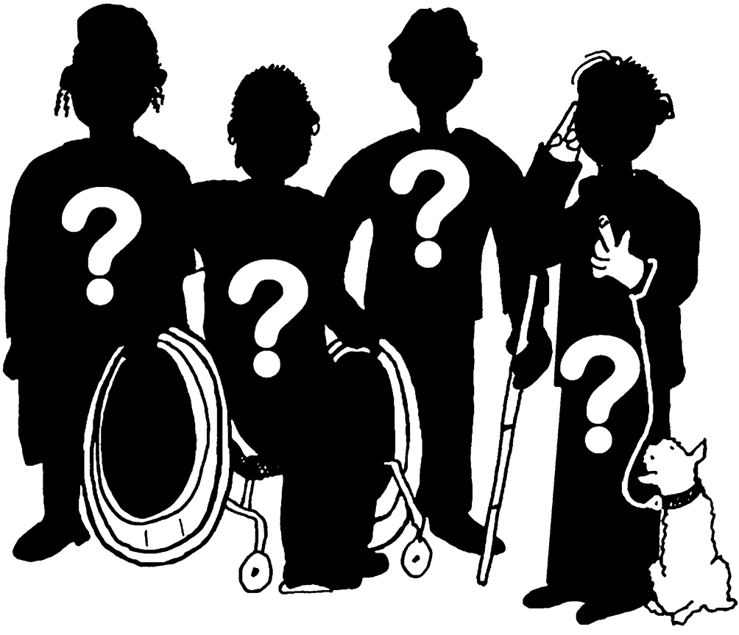
At the moment a judge can only say hostility towards a group of people was the reason someone committed a crime if the person believed their victim had a protected characteristic.

We think this should be changed so that judges can still decide a crime was a hate crime if:
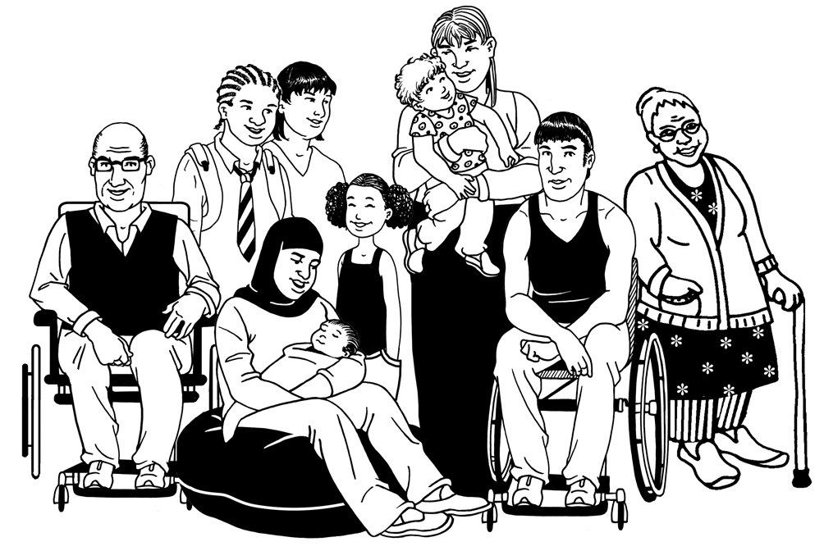
hostility towards a group of people was the reason someone committed the crime
the victim did not belong to that group of people.


This change would protect:
people who support people in the group hurt by the hate crime like a doctor who cares for transgender people
innocent bystanders.

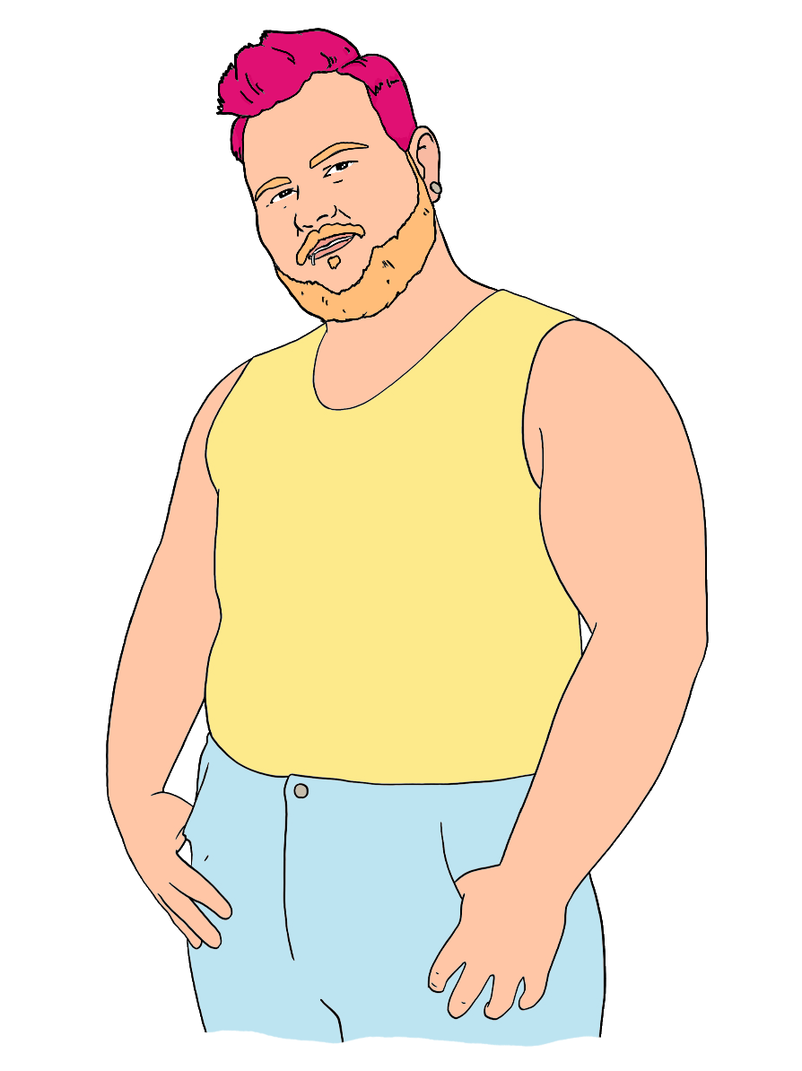
A person is transgender if their gender is different from the gender the doctors thought they were when they were born.

An innocent bystander is someone who is:
hurt by a crime
not the person the criminal
meant to hurt.

We think sex should be added to the list of protected characteristics.

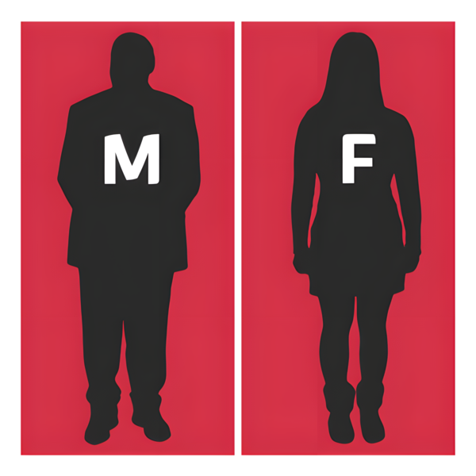
Here your sex means the physical parts of your body that make you:
male
female
intersex.
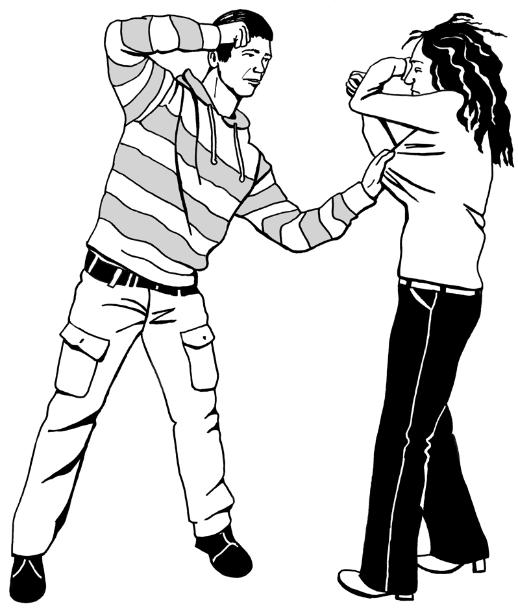
Making sex a protected characteristic would make it clear that it is a hate crime if:
someone hurts a woman
and
hatred of women was the reason why the person hurt their victim.


If the Government decides to change the law there should be training about the changes for:
police
prosecutors.

The Government should also think about if judges need training on changes to the law.

What happens next

Our job is to:
review laws in Aotearoa New Zealand
make recommendations to the Government.

We do not write new laws.

We have written a report about our recommendations for the Government.

The Government will:
look at our recommendations
decide what to do next.
This information has been written by Te Aka Matua o te Ture | Law Commission.


It has been translated into Easy Read by the Make it Easy Kia Māmā Mai service of People First New Zealand Ngā Tāngata Tuatahi.

The ideas in this document are not the ideas of People First New Zealand Ngā Tāngata Tuatahi.

All images used in this Easy Read document are subject to copyright rules and cannot be used without permission.


Make it Easy uses images from:


- Photosymbols

- Change Images


- Huriana Kopeke-Te Aho

- SGC Image Works

- T Wood


- Studio Rebeko

- Inga Kramer.

