

**Mahuru | September 2023**

**Te Whanganui-a-Tara, Aotearoa**

**Wellington, New Zealand**

Pūrongo Rangahau | Study Paper 24

**Appendix 4:**

**Timeline of statutory and common law engagement with tikanga**

The following timeline is provided as a supplement to Part Two of this Study Paper. It illustrates how statutes and common law addressing tikanga have developed since 1840 and, as they do so, the inter-relationship between statutes and the common law. The timeline should be viewed with this illustrative purpose in mind. The descriptions of cases and statutes have been shortened. They do not provide a comprehensive analysis of the statutes and cases, which can be found in Part Two.

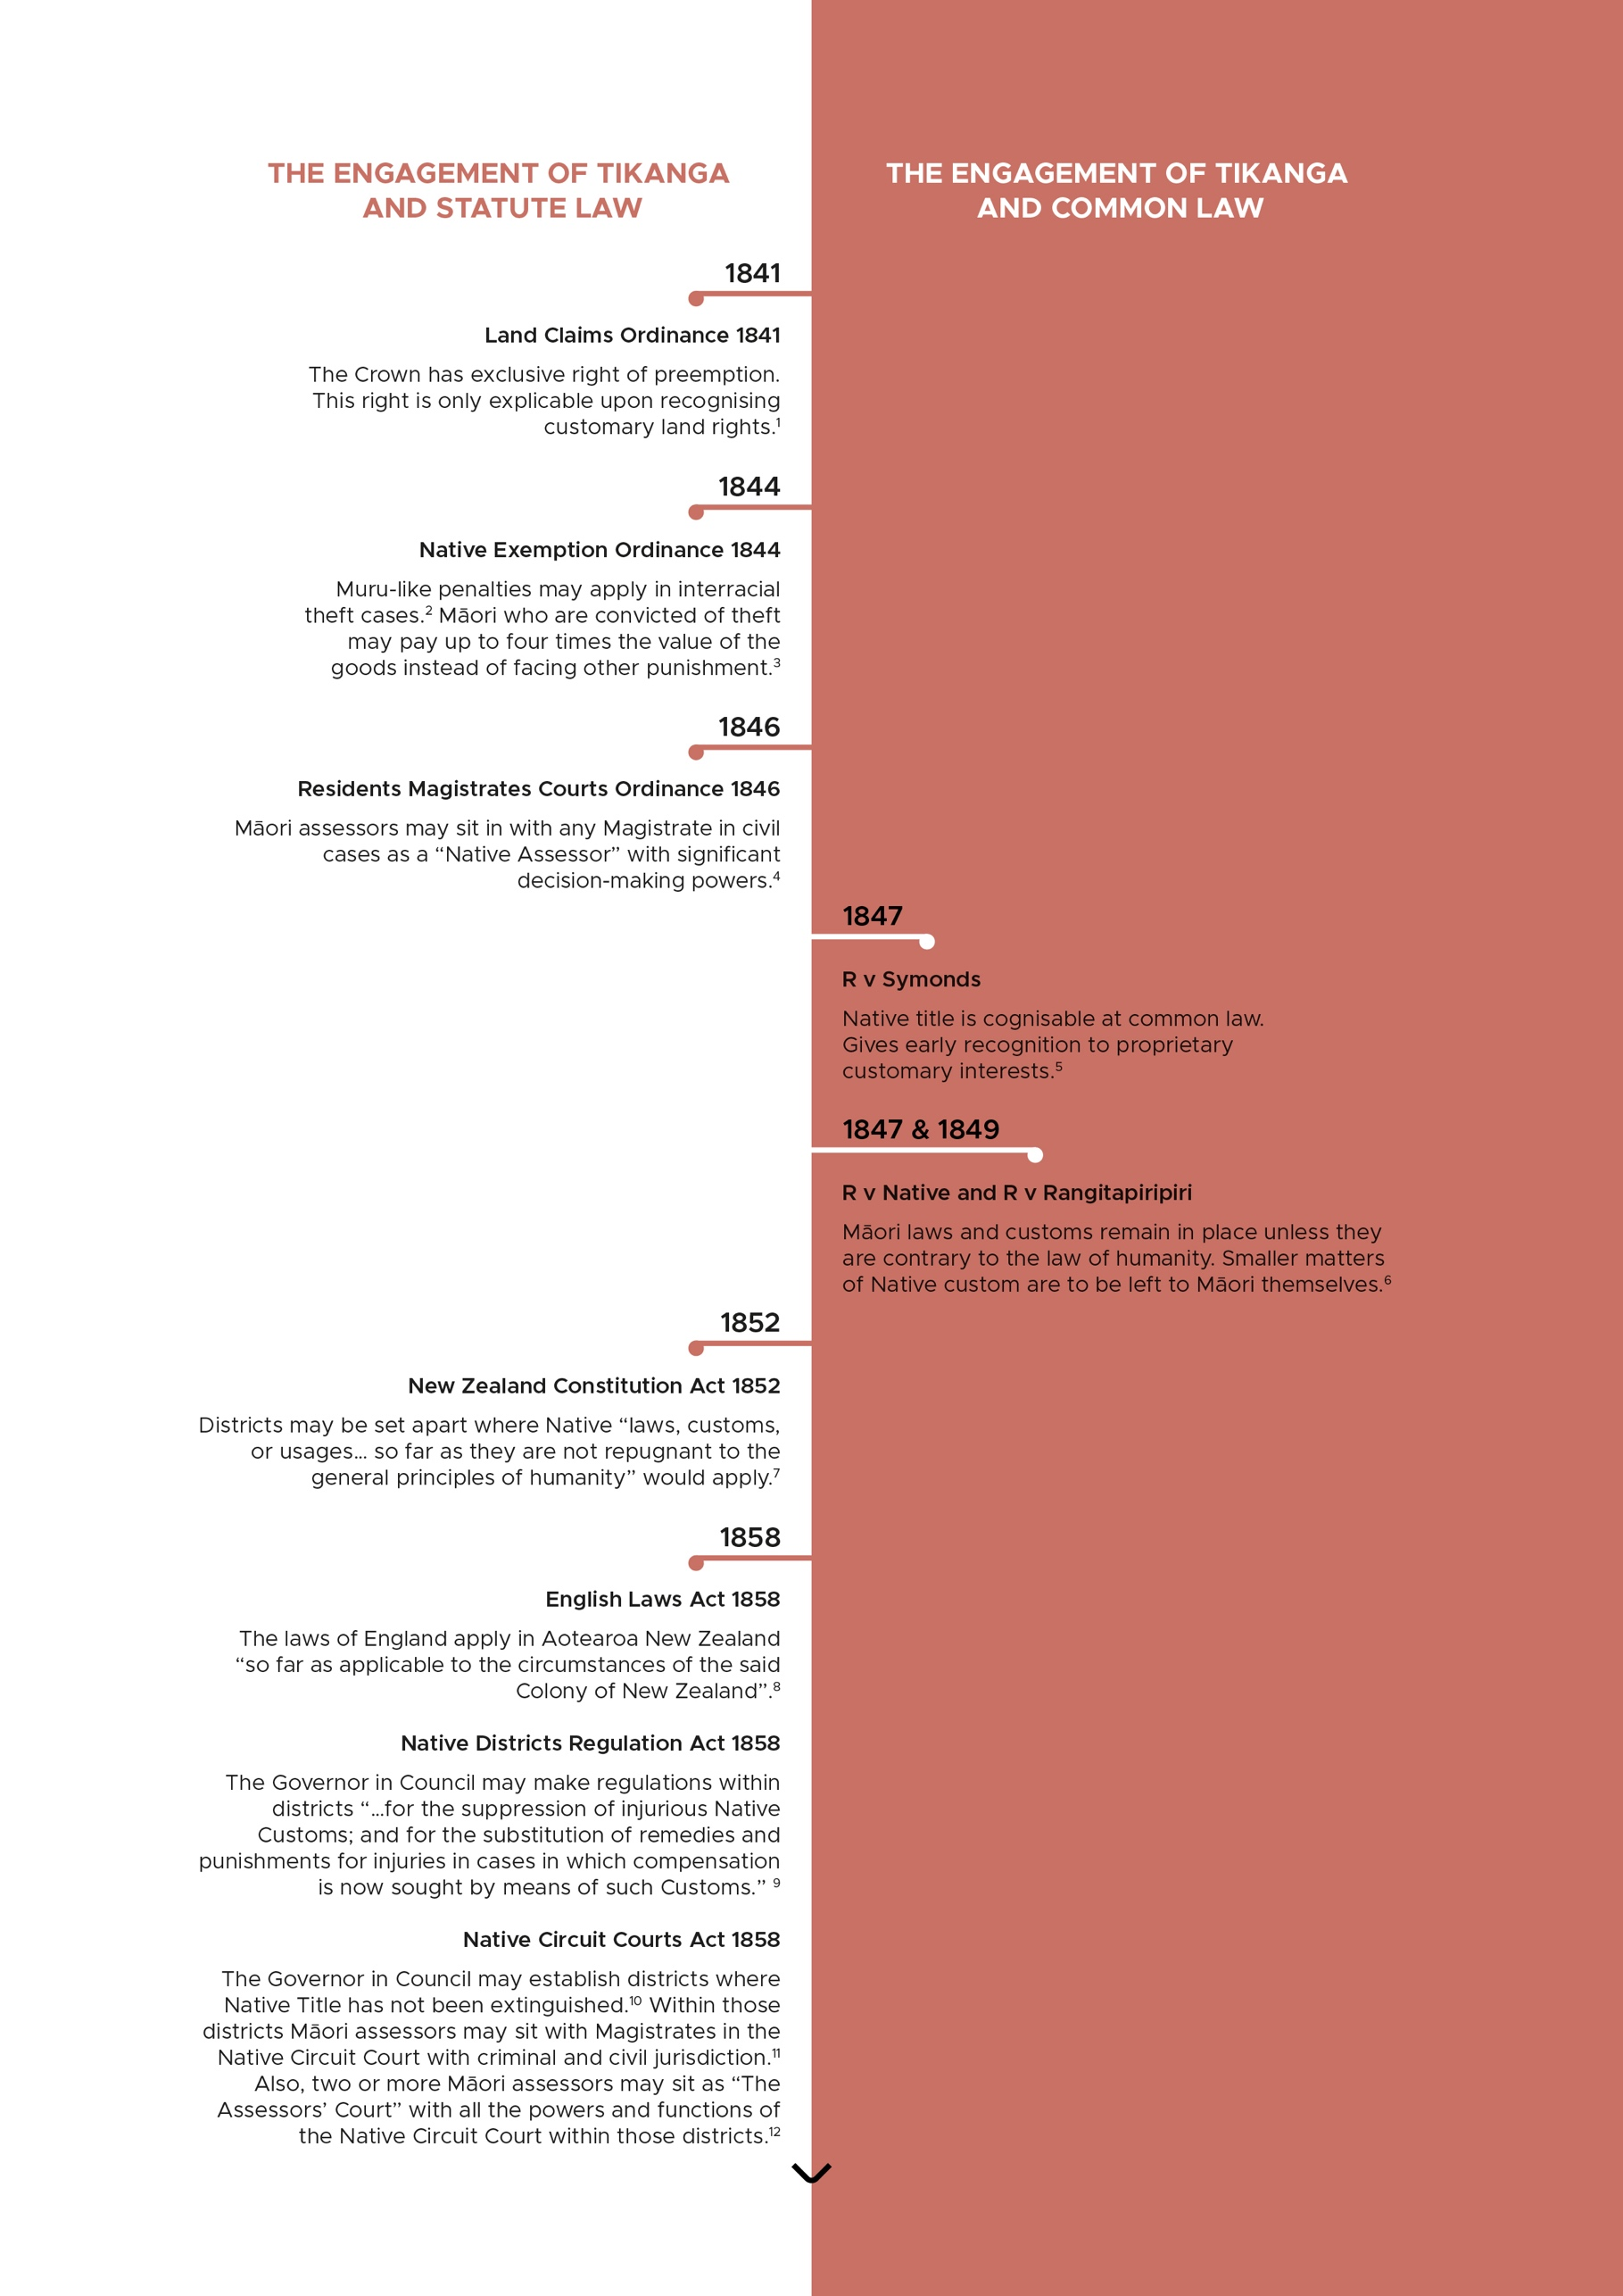

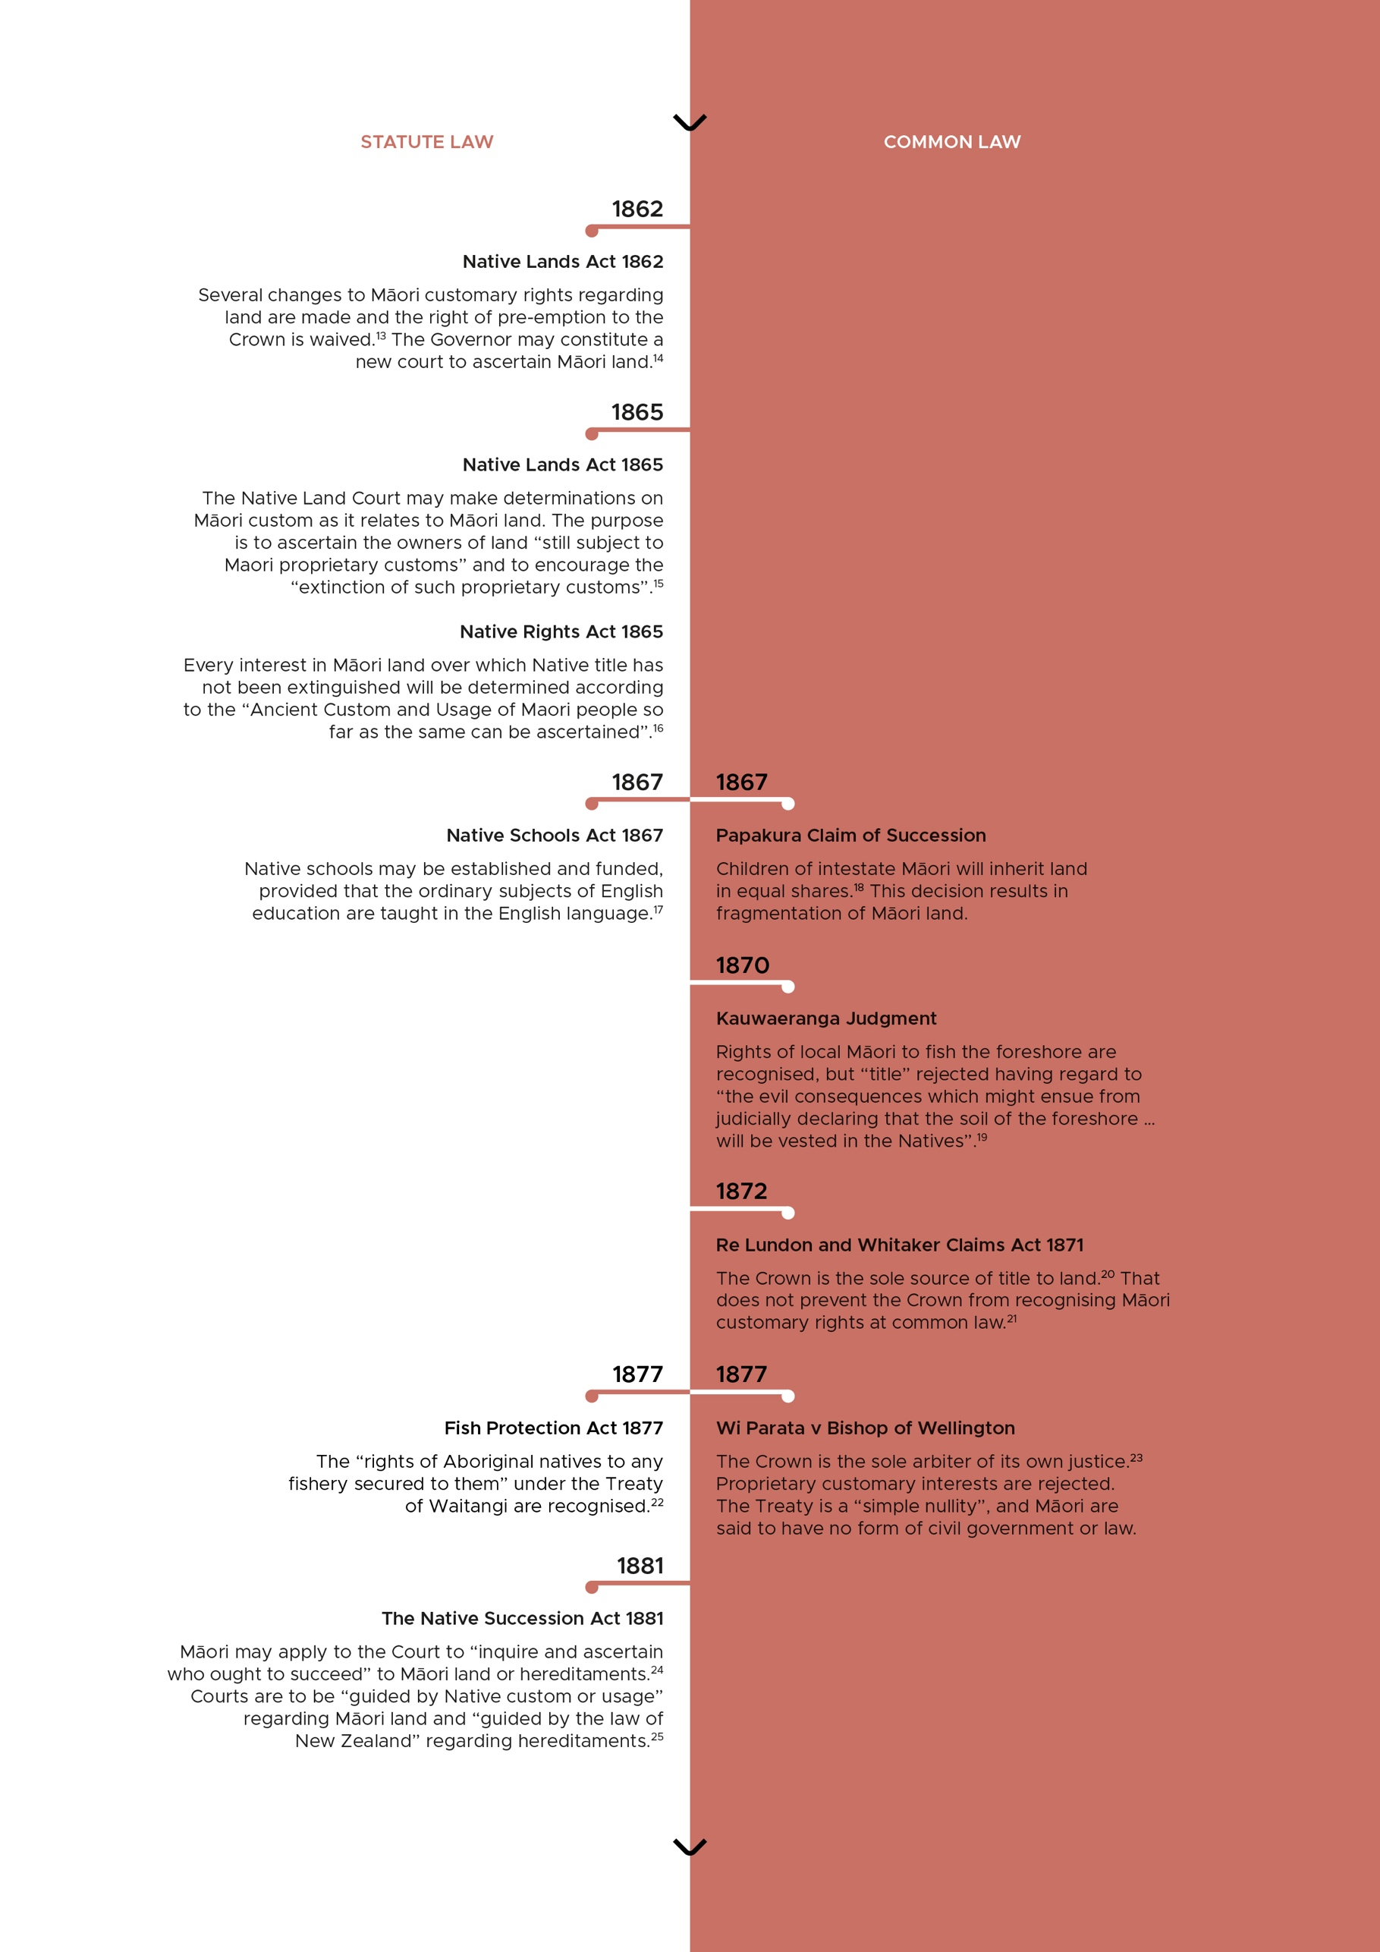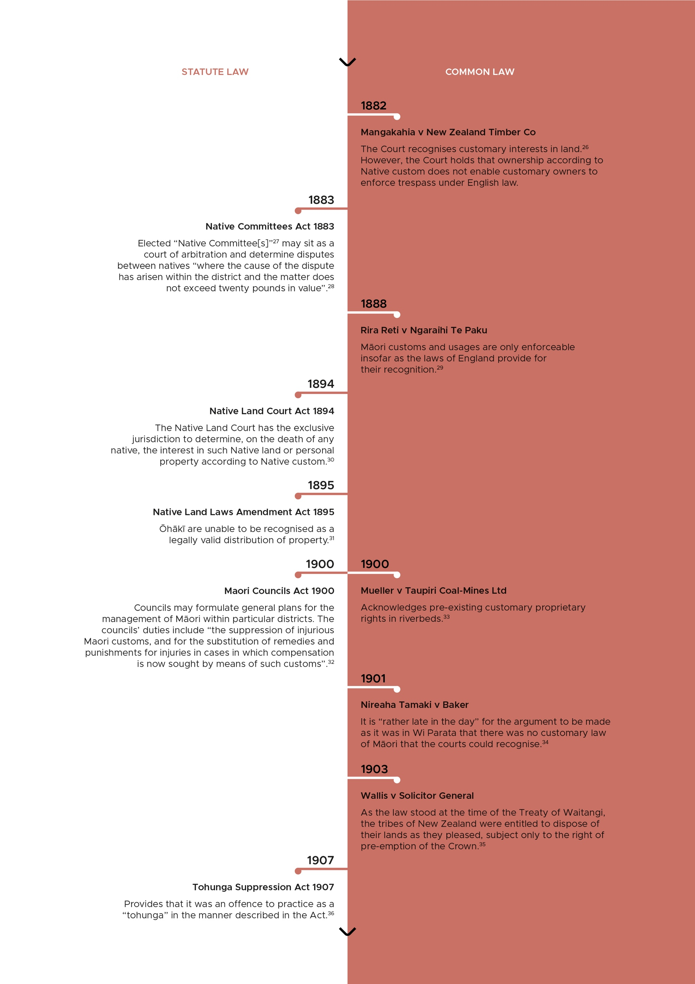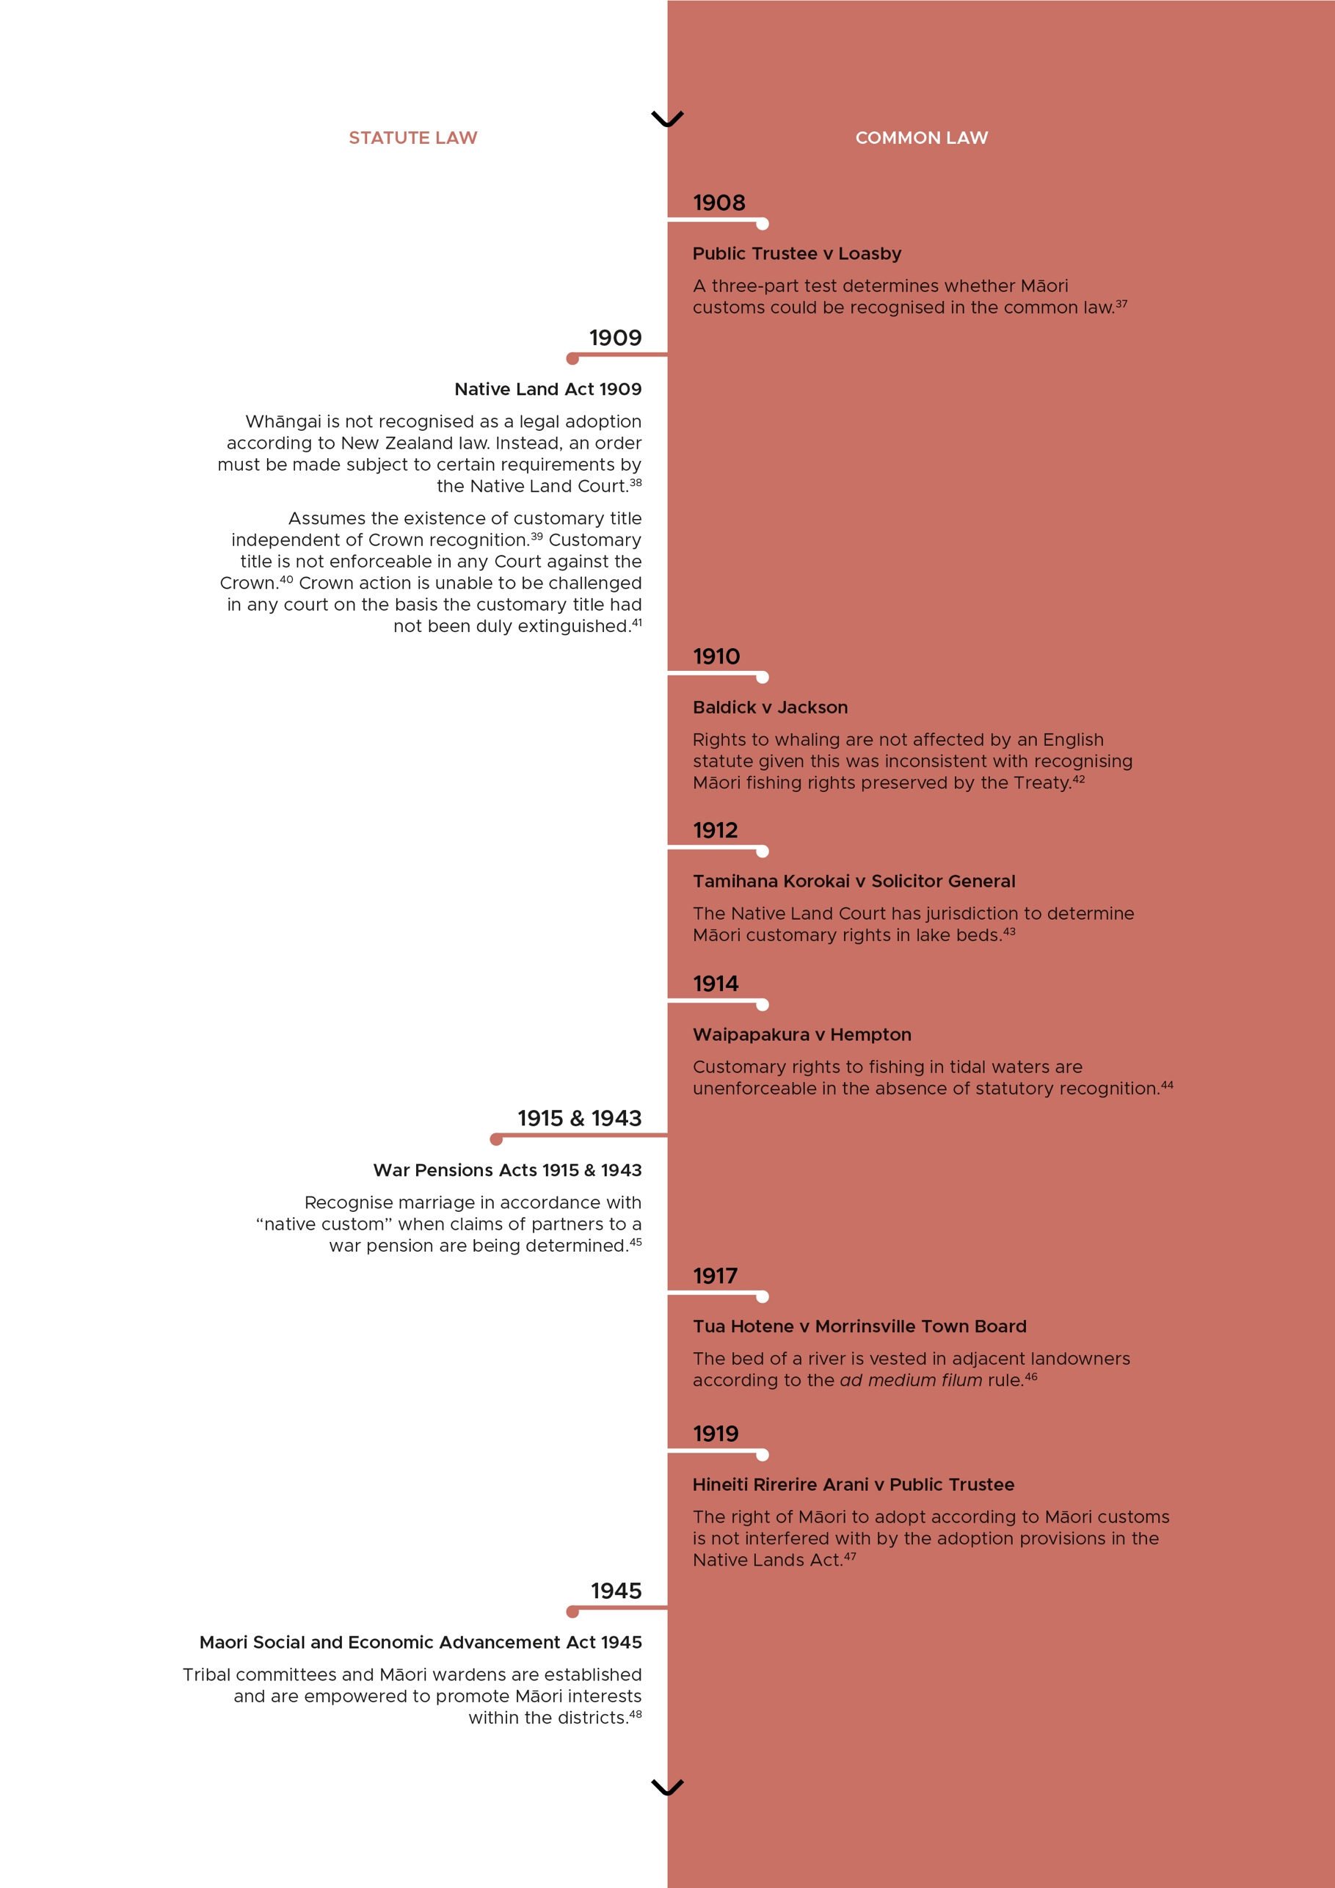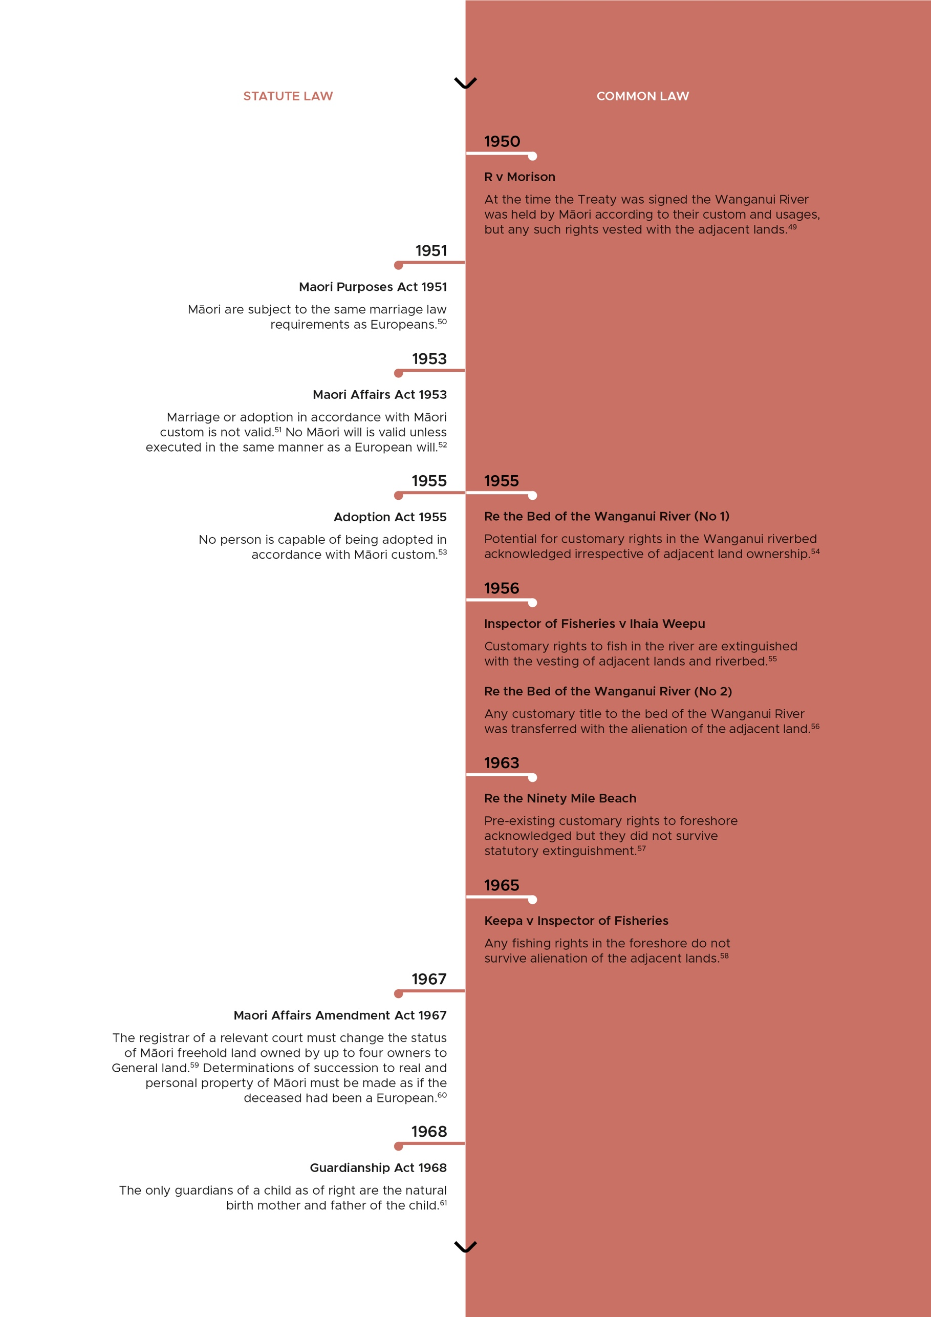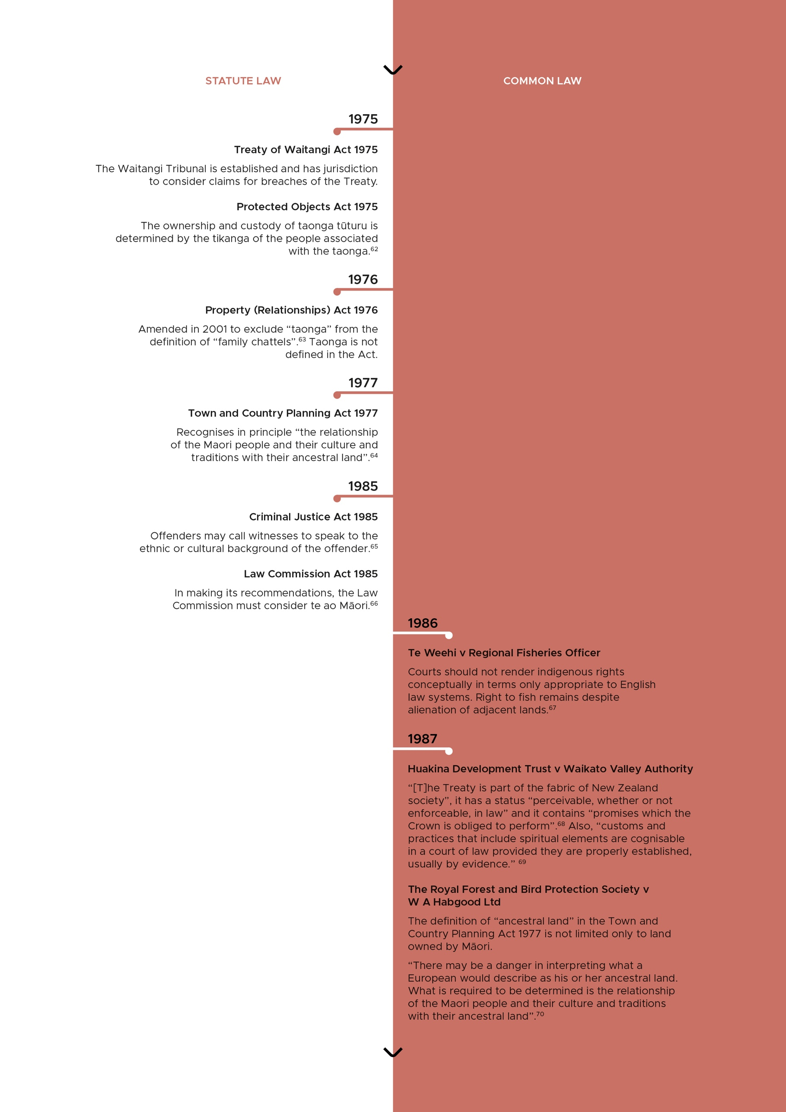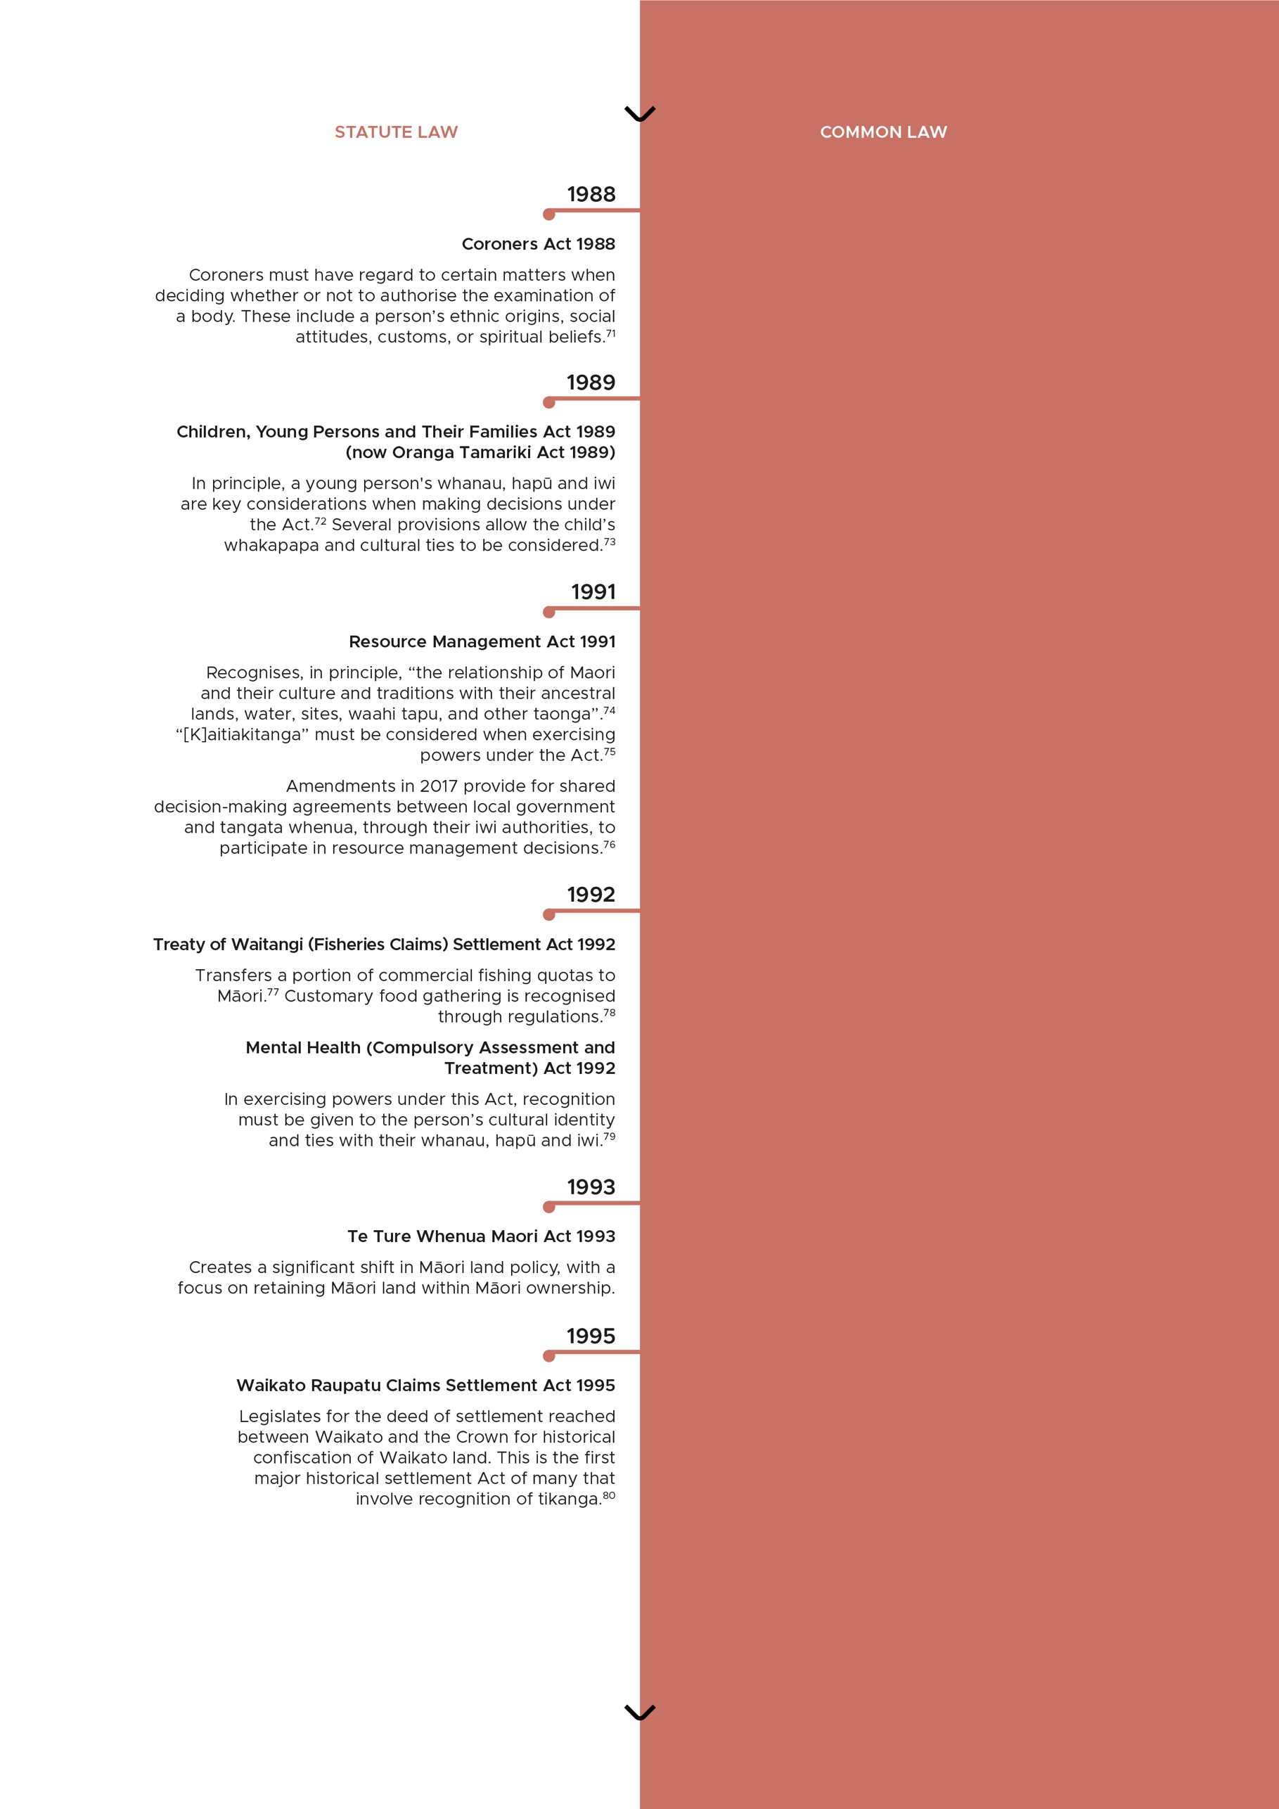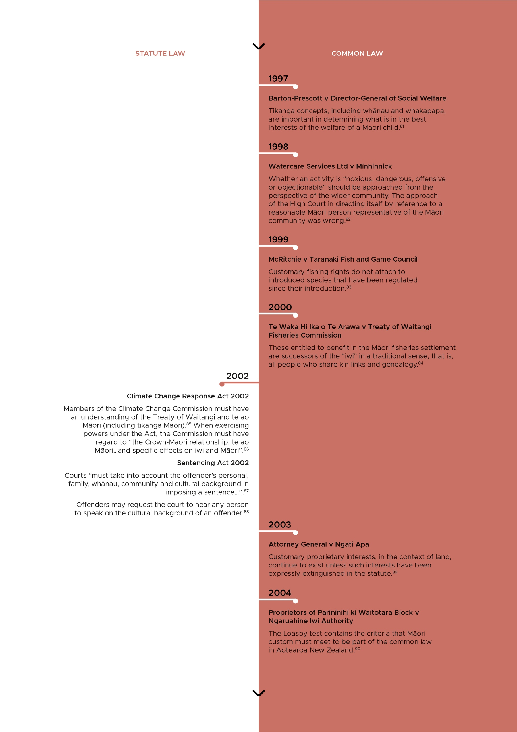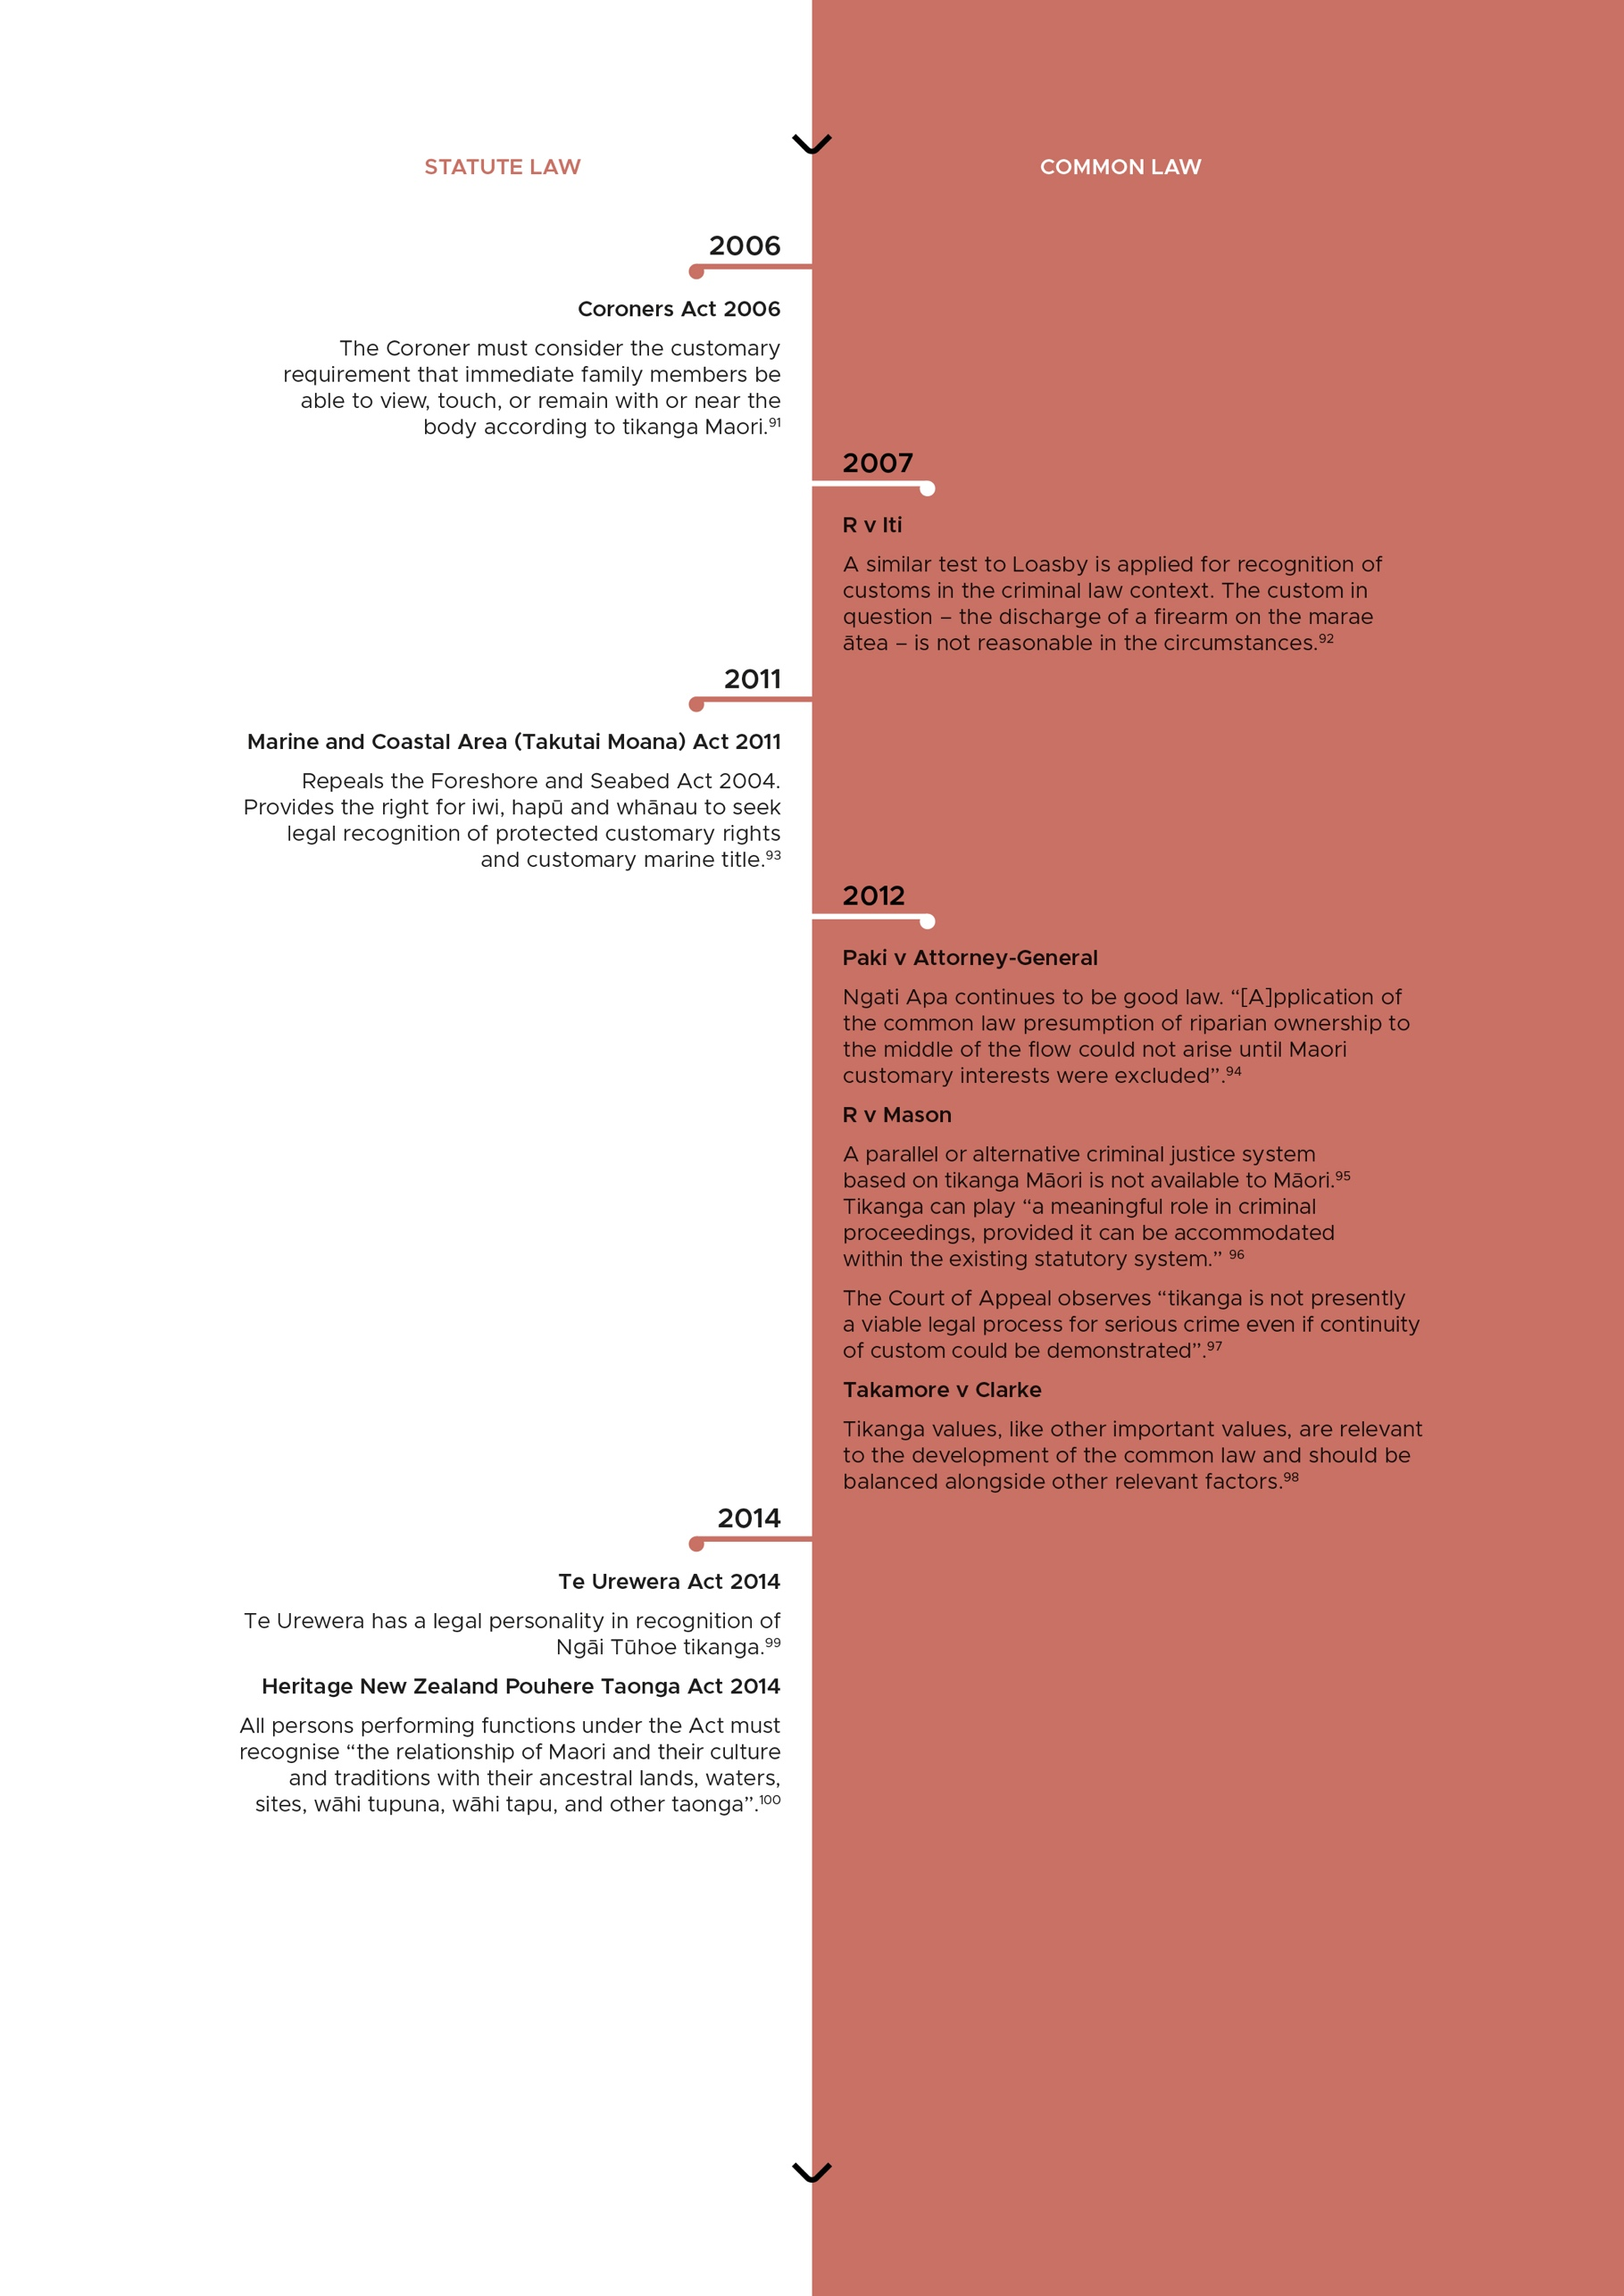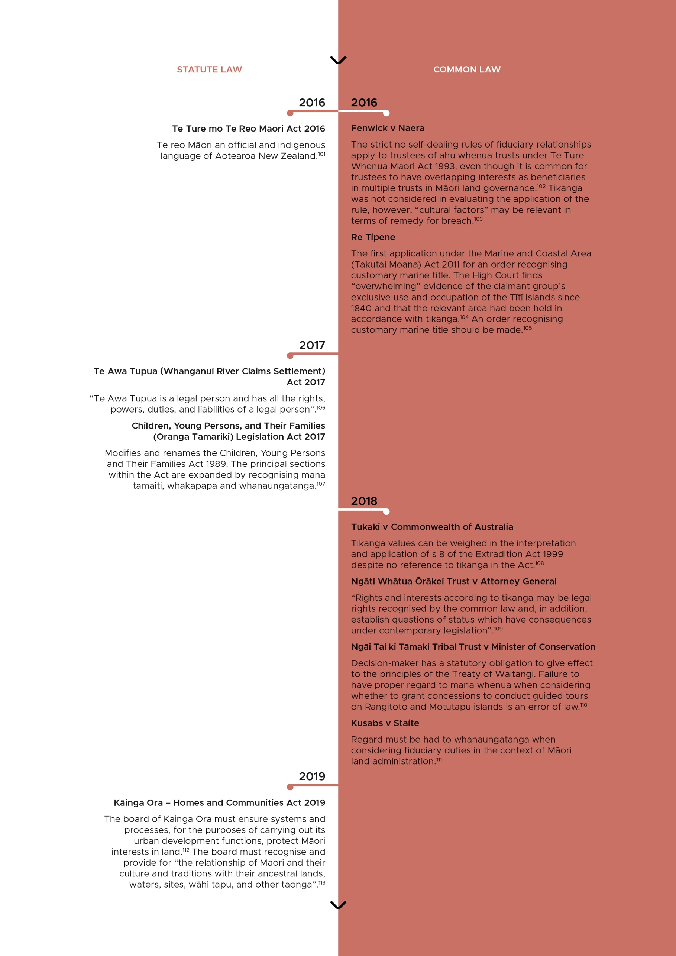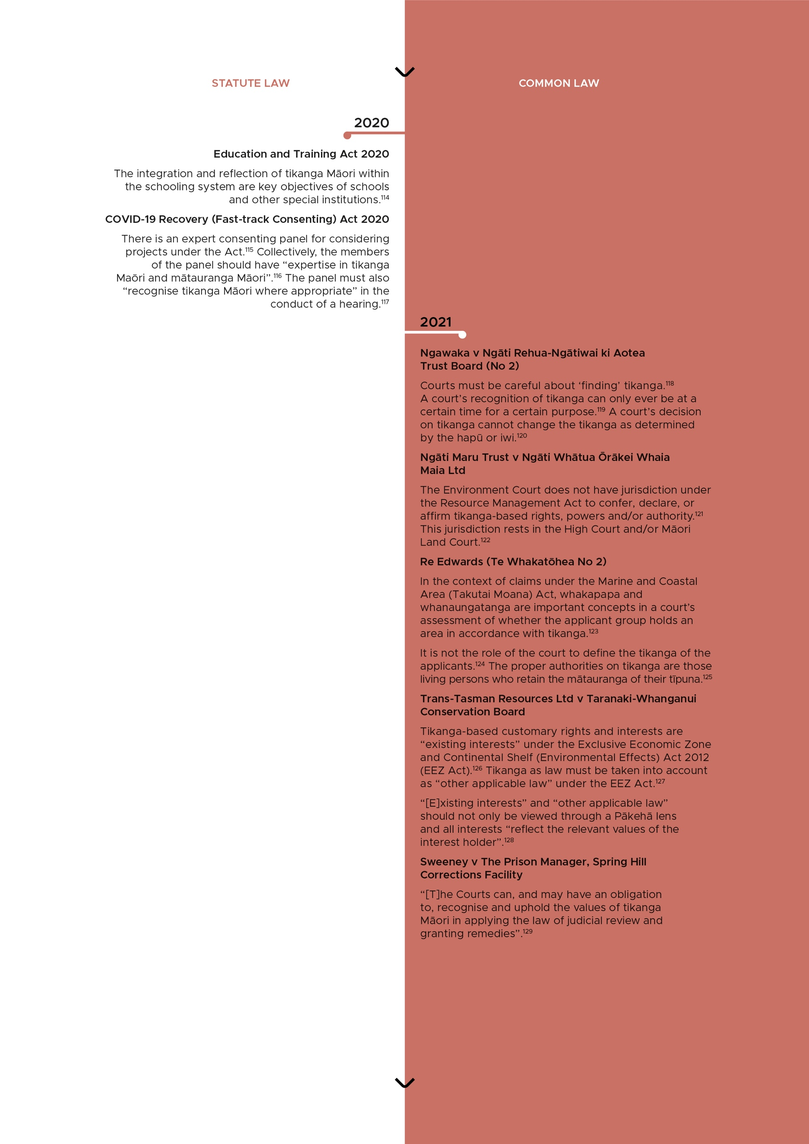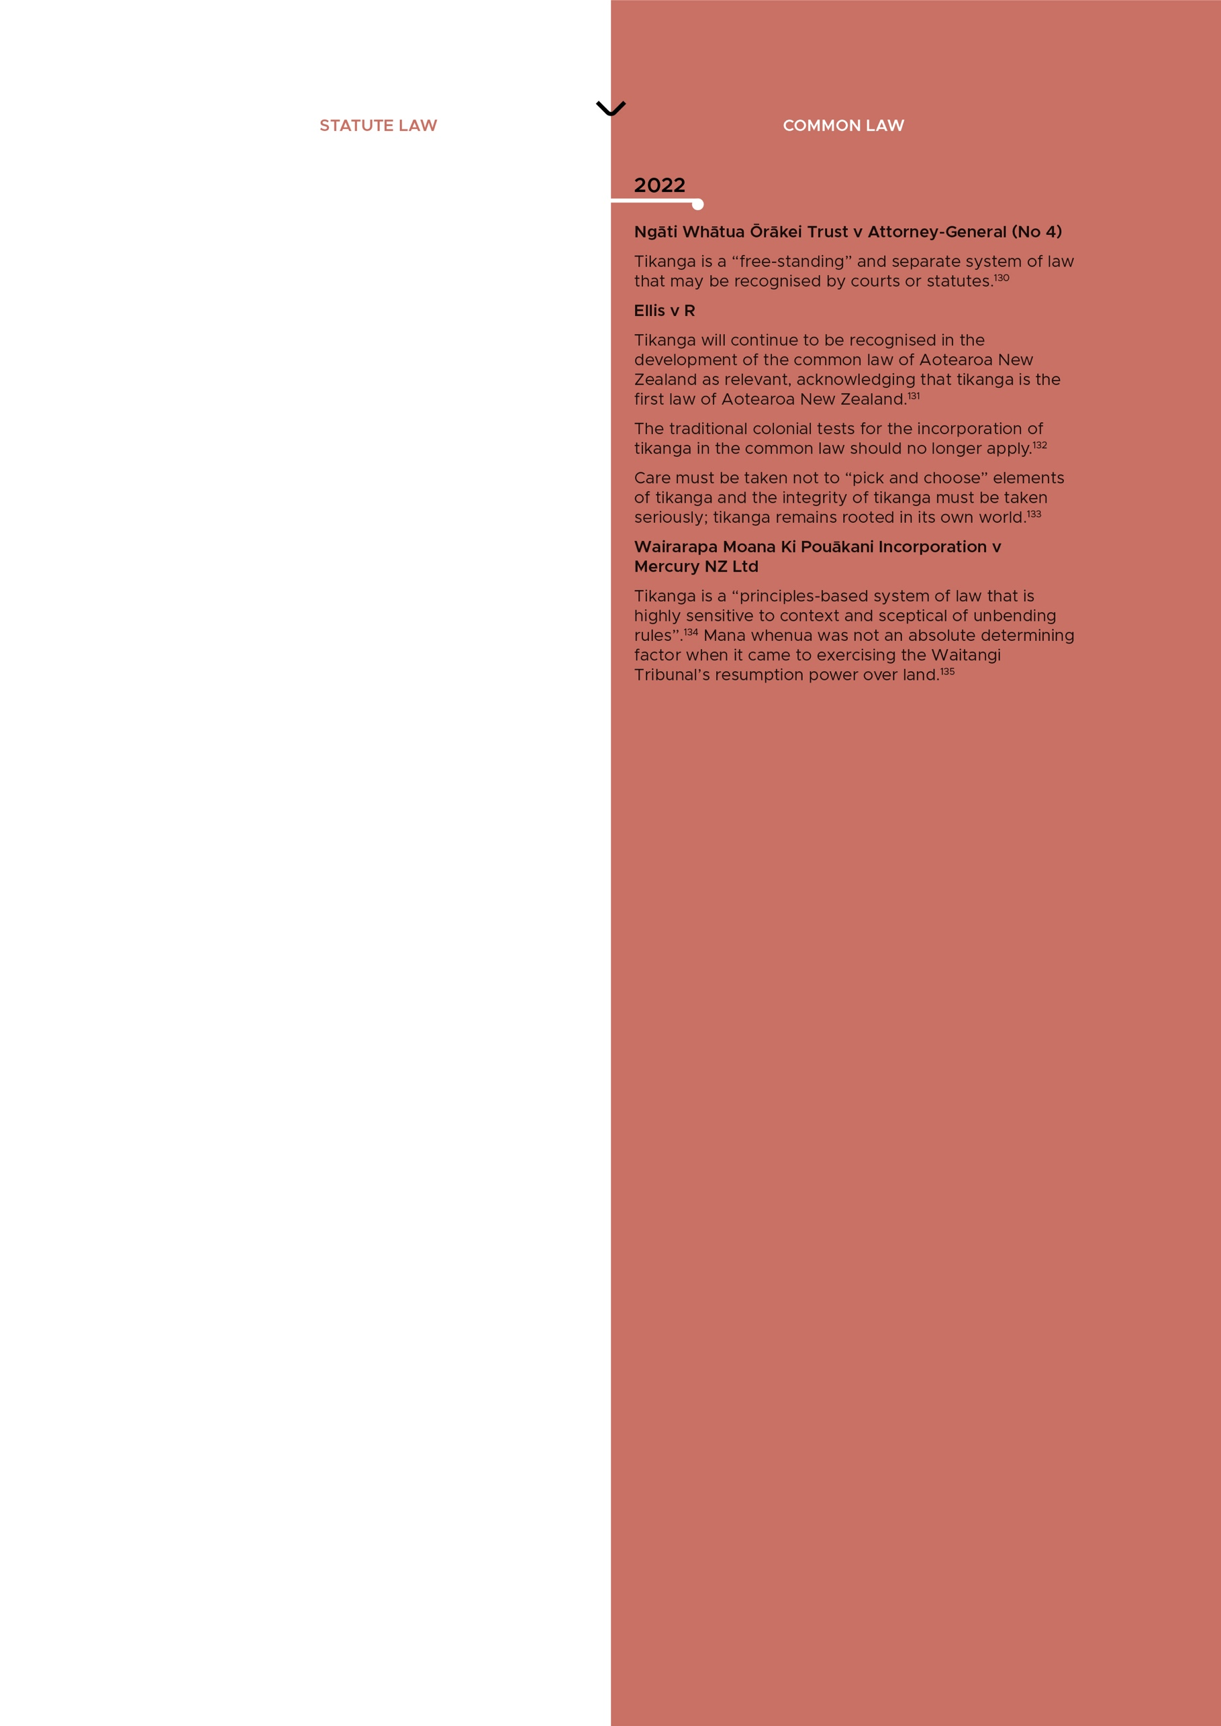

## Endnotes

1 *Attorney-General v Ngati Apa* [2003] 3 NZLR 643 (CA) at [36].

2 Native Exemption Ordinance 1844, s 7.

3 Native Exemption Ordinance 1844, s 7.

4 Residents Magistrates Courts Ordinance 1846, s 19.

5 *R v Symonds* (1847) NZPCC 387 (SC).

6 *R v Rangatapiripiri* [1847] NZSC; and *R v Native (Ratea)* [1849] NZSC. Both cases can be found as part of the New Zealand Lost Cases project run by Victoria University of Wellington. See <www.wgtn.ac.nz/law/nzlostcases>.

7 New Zealand Constitution Act 1852, s 71.

8 English Laws Act 1858, s 1.

9 Native Districts Regulation Act 1858, s 2(16).

10 Native Circuit Courts Act 1858, s 1.

11 Native Circuit Courts Act 1958, s 2.

12 Native Circuit Courts Act 1958, s 32.

13 Native Lands Act 1862, Preamble.

14 Native Lands Act 1862, s 4.

15 Native Lands Act 1865, Preamble.

16 Native Rights Act 1865, s 4.

17 Native Schools Act 1867, s 21.

18 “Papakura — claim of succession” (12 April 1867) New Zealand Gazette 19.

19 Alex Frame “Kauwaeranga judgement law in the Pacific” (1984) 18 Victoria University of Wellington Law Review 227 at 244.

20 Re the Lundon and Whitaker Claims Act 1871 (1872) 2 NZCA 41 at 49.

21 *Attorney-General v Ngati Apa* [2003] 3 NZLR 643 (CA) at [18].

22 Fish Protection Act 1877, s 8.

23 *Wi Parata v Bishop of Wellington* (1877) 3 NZ Jur (NS) SC 72.

24 The Native Succession Act 1881, s 3.

25 The Native Succession Act 1881, s 3.

26 *Mangakahia v New Zealand Timber Co Ltd* (1881) 2 NZLR 345 (SC) at 350.

27 Native Committees Act 1883, s 4.

28 Native Committees Act 1883, s 11.

29 *Rira Reti v Ngaraihi Te Paku* (1888) 7 NZLR 235 (CA) at 238–240.

30 Native Land Court 1894, s 14.

31 Native Land Laws Amendment Act 1895, s 33.

32 Maori Councils Act 1900, s 15.

33 *Mueller v Taupiri Coal-Mines Ltd* (1900) 20 NZLR 89 (CA).

34 *Nireaha Tamaki v Baker* [1901] AC 561 (PC) at 382–383.

35 *Wallis v Solicitor-General* [1903] AC 173 (PC) at 179.

36 Tohunga Suppression Act 1907, Preamble.

37 *Public Trustee v Loasby* (1908) 27 NZLR 801 (SC) at 806.

38 Native Land Act 1909, ss 161 and 165.

39 *Attorney-General v Ngati Apa* [2003] 3 NZLR 643 (CA) at [47].

40 Native Land Act 1909, s 84.

41 Native Land Act 1909, s 85.

42 *Baldick v Jackson* (1910) 30 NZLR 343 (HC).

43 *Tamihana Korokai v Solicitor-General* (1912) 32 NZLR 321 (CA) at 345.

44 *Waipapakura v Hempton* (1914) 33 NZLR 1065 (HC) at 1067 and 1068.

45 War Pensions Act 1915, s 8 and War Pensions Act 1943, s 44.

46 *Tua Hotene v Morrinsville Town Board* [1917] NZLR 936 (HC) at 945.

47 *Hineiti Rirerire Arani v Public Trustee of New Zealand* [1920] AC 198 (PC).

48 Maori Social and Economic Advancement Act 1945, ss 11 and 14–21.

49 *R v Morison* [1950] NZLR 247 (SC) at 256–257.

50 Maori Purposes Act 1951, s 8.

51 Maori Affairs Act 1953, ss 79 and 80.

52 Maori Affairs Act 1953, pt 11.

53 Adoption Act 1955, s 19.

54 *Re the Bed of the Wanganui River* [1955] NZLR 419 (CA).

55 *Inspector of Fisheries v Ihaia Weepu* [1956] NZLR 920 at 928.

56 *Re the Bed of the Wanganui River* [1962] NZLR 600 (CA) at 618–620.

57 *Re the Ninety Mile Beach* [1963] NZLR 461 (CA).

58 *Keepa v Inspector of Fisheries* [1965] NZLR 322 (HC) at 326–327.

59 Maori Affairs Amendment Act 1967, s 6.

60 Maori Affairs Amendment Act 1967, s 76.

61 Guardianship Act 1968, s 6.

62 *Re Chief Executive of the Ministry for Culture and Heritage* (2017) 71 Tairāwhiti MB 267 (71 TRW 267) at [35].

63 Property (Relationships) Amendment Act 2001, s 8.

64 Town and Country Planning Act 1977, s 3(1)(g).

65 Criminal Justice Act 1985, s 16.

66 Law Commission Act 1985, s 5(2)(a).

67 *Te Weehi v Regional Fisheries Officer* [1986] 1 NZLR 680 (HC) at 686–693.

68 *Huakina Development Trust v Waikato Valley Authority* [1987] 2 NZLR 188 (HC) at 206 and 210.

69 *Huakina Development Trust v Waikato Valley Authority* [1987] 2 NZLR 188 (HC) at 215.

70 *The Royal Forest and Bird Protection Society v W A Habgood Ltd* (1987) 12 NZTPA 76 (HC) at 7.

71 Coroners Act 1988, s 8.

72 Children, Young Persons and Their Families Act 1989 (now Oranga Tamariki Act 1989), s 5.

73 Children, Young Persons and Their Families Act 1989 (now Oranga Tamariki Act 1989), ss 20–38 and 187.

74 Resource Management Act 1991, s 6(e).

75 Resource Management Act 1991, s 7.

76 Resource Legislation Amendment Act 2017.

77 Treaty of Waitangi (Fisheries Claims) Settlement Act 1992.

78 Treaty of Waitangi (Fisheries Claims) Settlement Act 1992.

79 Mental Health (Compulsory Assessment and Treatment) Act 1992, s 5.

80 See for example Ngai Tahu Claims Settlement Act 1998; Ngāti Awa Claims Settlement Act; Affiliate Te Arawa Iwi and Hapu Claims Settlement Act 2008; and Tūhoe Claims Settlement Act 2014.

81 *Barton-Prescott v Director-General of Social Welfare* [1997] 3 NZLR 179 (HC) at 185, 189 and 191.

82 *Watercare Services Ltd v Minhinnick* [1998] 1 NZLR 294 (CA).

83 *McRitchie v Taranaki Fish and Game Council* [1999] 2 NZLR 139 (CA) at 153.

84 *Te Waka Hi Ika o Te Arawa v Treaty of Waitangi Fisheries Commission* [2000] 1 NZLR 285 (HC).

85 Climate Change Response Act 2002, s 5H.

86 Climate Change Response Act 2002, s 5M.

87 Sentencing Act 2002, s 8(i).

88 Sentencing Act 2002, s 27.

89 *Attorney-General v Ngati Apa* [2003] 3 NZLR 643 (CA) at [32]–[34].

90 *Proprietors of Parininihi ki Waitotara Block v Ngaruahine Iwi Authority* [2004] 2 NZLR 201 (HC) at [18].

91 Coroners Act 2006, ss 25 and 26.

92 *R v Iti* [2007] NZCA 119, [2008] 1 NZLR 587 at [46]–[47].

93 Marine and Coastal Area (Takutai Moana) Act 2011.

94 *Paki v Attorney-General* [2012] NZSC 50, [2012] NZLR 277 at [18].

95 *R v Mason* [2012] NZHC 1361 at [37].

96 *R v Mason* [2012] NZHC 1361, [2012] 2 NZLR 695 at [38].

97 *Mason v R* [2013] NZCA 310, (2013) 26 CRNZ 464 at [41].

98 *Takamore v Clarke* [2012] NZSC 116, [2013] NZLR 733 at [91]–[100].

99 Te Urewera Act 2014, s 3.

100 Heritage New Zealand Pouhere Taonga Act 2014, s 4.

101 Te Ture mō Te Reo Māori 2016, s 5.

102 *Fenwick v Naera* [2015] NZSC 68, [2016] 1 NZLR 354 at [97]–[101].

103 *Fenwick v Naera* [2015] NZSC 68, [2016] 1 NZLR 354 at [125].

104 *Re Tipene* [2016] NZHC 3199, [2017] NZAR 559 at [153]–[154].

105 *Re Tipene* [2016] NZHC 3199, [2017] NZAR 559 at [10].

106 Te Awa Tupua (Whanganui River Claims Settlement) Act 2017, s 14.

107 Children, Young Persons, and Their Families (Oranga Tamariki) Legislation Act 2017, ss 5 and 13.

108 *Tukaki v Commonwealth of Australia* [2018] NZCA 324, [2018] NZAR 1597 at [38].

109 *Ngāti Whātua Ōrākei Trust v Attorney-General* [2018] NZSC 84, [2019] 1 NZLR 116 at 119.

110 *Ngāi Tai ki Tāmaki Tribal Trust v Minister of Conservation* [2018] NZSC 122, [2019] 1 NZLR 368 at [89]–[100].

111 *Kusabs v Staite* [2019] NZCA 420, [2023] 2 NZLR 144 at [124].

112 Kāinga Ora — Homes and Communities Act 2019, s 4.

113 Kāinga Ora — Homes and Communities Act 2019, s 4.

114 Education and Training Act 2020, ss 32 and 268.

115 COVID-19 Recovery (Fast-track Consenting) Act 2020, s 14.

116 COVID-19 Recovery (Fast-track Consenting) Act 2020, sch 5 cl 17.

117 COVID-19 Recovery (Fast-track Consenting) Act 2020, sch 6, pt 1, cl 21(7)(b).

118 *Ngawaka v Ngāti Rehua-Ngātiwai ki Aotea Trust Board (No 2)* [2021] NZHC 291, [2021] 2 NZLR 1 at [58].

119 *Ngawaka v Ngāti Rehua-Ngātiwai ki Aotea Trust Board (No 2)* [2021] NZHC 291, [2021] 2 NZLR 1 at [58].

120 *Ngawaka v Ngāti Rehua-Ngātiwai ki Aotea Trust Board (No 2)* [2021] NZHC 291, [2021] 2 NZLR 1 at [58].

121 *Ngāti Maru Trust v Ngāti Whātua Ōrākei Whaia Maia Ltd* [2020] NZHC 2768, [2021] 3 NZLR 352 at [67].

122 *Ngāti Maru Trust v Ngāti Whātua Ōrākei Whaia Maia Ltd* [2020] NZHC 2768, [2021] 3 NZLR 352 at [67].

123 *Re Edwards (Te Whakatōhea No 2)* [2021] NZHC 1025, [2022] 2 NZLR 772 at [301].

124 *Re Edwards (Te Whakatōhea No 2)* [2021] NZHC 1025, [2022] 2 NZLR 772 at [272].

125 *Re Edwards (Te Whakatōhea No 2)* [2021] NZHC 1025, [2022] 2 NZLR 772 at [272].

126 *Trans-Tasman Resources Ltd v Taranaki-Whanganui Conservation Board* [2021] NZSC 127, [2021] 1 NZLR 801 at [139]–[174].

127 *Trans-Tasman Resources Ltd v Taranaki-Whanganui Conservation Board* [2021] NZSC 127, [2021] 1 NZLR 801 at [9].

128 *Trans-Tasman Resources Ltd v Taranaki-Whanganui Conservation Board* [2021] NZSC 127, [2021] 1 NZLR 801 at [297].

129 *Sweeney v The Prison Manager, Spring Hill Corrections Facility* [2021] NZHC 181, [2021] 2 NZLR 27 at [75].

130 *Ngāti Whātua Ōrākei Trust v Attorney-General (No 4)* [2022] NZHC 843, [2022] 3 NZLR 601 at [355] and [570].

131 *Ellis v R (Continuance)* [2022] NZSC 114, [2022] 1 NZLR 239 at [172].

132 *Ellis v R (Continuance)* [2022] NZSC 114, [2022] 1 NZLR 239 at [113]–[116] per Glazebrook J, [177] per Winkelmann CJ and [260] per Williams J.

133 *Ellis v R (Continuance)* [2022] NZSC 114, [2022] 1 NZLR 239 at [180].

134 *Wairarapa Moana Ki Pouākani Inc v Mercury NZ Ltd* [2022] NZSC 142, [2022] 1 NZLR 767 at [76].

135 *Wairarapa Moana Ki Pouākani Inc v Mercury NZ Ltd* [2022] NZSC 142, [2022] 1 NZLR 767 at [74].